


ARISE Project Work Package 2

Pedagogical Framework

Module 5: ARISE AI-Assisted Tools
BEST CYBERNETICS, Greece

This project has been funded with support from the European Commission. This publication reflects the views only of the author, and the Commission cannot be held responsible for any use which may be made of the information contained therein.

This work is licensed under a Creative Commons Attribution-NonCommercial 4.0 International License. In addition, an acknowledgement of the authors of the document and all applicable portions of the copyright notice must be clearly referenced. All rights reserved.


Module Title | Module 5: ARISE AI-ASSISTED TOOLS
Learning Objectives | Module 5 aims to:  - Develop practical skills for using digital and AI-assisted tools during the job-search process.  - Enable learners to identify suitable job opportunities and prepare tailored application documents.  - Strengthen interview preparation skills, including structured responses and accommodation planning.  - Introduce the effective and accessible use of the ARISE Career Guidance Toolkit.  - Promote the safe, critical and responsible use of AI.  - Build confidence, independence and accessible participation in recruitment.
Learning Outcomes | Through Module 5, learners will be able to:  - Navigate job-search portals and professional networking platforms using appropriate keywords, filters and alerts.  - Assess job advertisements by identifying essential requirements, warning signs and their own suitability for the role.  - Use AI-assisted tools to develop and personalise CVs and Cover Letters based on truthful skills and experience.  - Prepare structured interview answers using the STAR method and plan reasonable accommodations where needed.  - Use the ARISE Career Guidance Toolkit to support job searching, application preparation and interview practice.  - Critically evaluate AI-generated outputs for accuracy, relevance, accessibility and potential bias.  - Make informed decisions about disability disclosure and reasonable accommodation requests.  - Use AI responsibly while maintaining authentic self-representation and independent judgement.

1. Introduction
Finding meaningful employment is one of the most important steps towards social inclusion, financial independence and personal development. Employment offers opportunities to develop skills, participate in society, build confidence and improve quality of life. However, for many people with disabilities, finding and maintaining employment continues to present additional challenges that extend beyond education, qualifications or work experience.
Across Europe, recruitment has changed significantly over the past decade. Most employers now advertise vacancies on digital platforms, receive applications electronically and increasingly rely on Artificial Intelligence (AI) to support recruitment processes. AI-powered systems are used to screen CVs, recommend candidates, analyse job descriptions and even support interview preparation.
These technological developments present both opportunities and challenges.
On the one hand, AI can make job searching faster, more personalised and more accessible. Intelligent systems can recommend vacancies, improve application documents, identify transferable skills and offer personalised interview practice. For many job seekers, particularly those who require flexible or self-paced support, AI can be an important career development assistant.
On the other hand, AI is not perfect. Recruitment algorithms are often trained on historical recruitment data and may not recognise non-traditional career pathways, transferable skills, or alternative ways of presenting qualifications. Digital recruitment platforms may also create accessibility barriers if they are not designed with universal accessibility principles in mind. For job seekers with disabilities, these challenges highlight the importance of using AI as a supportive tool rather than relying solely on automated recommendations.
For people with disabilities, successful participation in today's labour market requires more than technical skills. It also requires confidence in using digital technologies, an understanding of recruitment practices, recognition of accessibility rights, and the ability to make informed decisions throughout the recruitment journey.
This module has been developed to help learners understand how AI can support career development while preserving personal autonomy, privacy and authentic self-representation.
The ARISE Project recognises that every learner follows a unique employment journey. Some learners may already have work experience, while others may be preparing their first CV. Some may need support in identifying suitable vacancies, whereas others may require assistance with preparing for interviews or requesting reasonable accommodations.
The ARISE Career Guidance Toolkit is an AI-supported digital platform that helps people with disabilities navigate the employment journey, from career profiling and job searching to CV development and interview preparation. With features including the AI Profile Builder, Job Search, Recommended Jobs, AI-assisted CV Optimisation, and Interview Preparation, the Toolkit helps job seekers with disabilities develop their career profiles, identify suitable opportunities, and prepare successful job applications.
The Toolkit has been developed through a co-design process that includes people with disabilities, vocational education providers, career guidance professionals, employers and technical experts. This collaborative approach ensures that accessibility and inclusion are considered throughout the design of every feature.
The ARISE Toolkit does not make employment decisions on users' behalf. All AI-generated outputs remain editable and under the learner's control, supporting informed decision-making rather than replacing it. It supports learners by helping them:
- identify their strengths, interests and career goals;
- build a personalised career profile;
- search for suitable employment opportunities;
- prepare professional CVs and cover letters;
- practise interview skills;
- reflect on AI-generated suggestions before making their own decisions.
Throughout the recruitment process, learners remain responsible for reviewing, editing and approving every output generated by AI. Human judgement, lived experience and personal choice remain central.
This module introduces learners to the practical use of the ARISE Career Guidance Toolkit throughout the recruitment journey. Following the typical employment journey, learners progressively build a career profile, search for suitable opportunities, prepare application documents and practise interview skills, all while learning to use AI responsibly. Throughout the module, particular emphasis is placed on accessibility, privacy, critical thinking and learner autonomy, ensuring that AI supports informed decision-making without replacing personal judgement.
By the end of this module, learners will be able to use the ARISE Career Guidance Toolkit effectively and responsibly, recognising when AI-assisted guidance can support their employment journey while maintaining personal control over every important decision.

2. Building your Career Profile
A successful job search begins with a clear understanding of who you are, what you can offer and the type of work you are seeking. Before searching for vacancies or creating application documents, it is important to build a structured career profile that reflects your skills, experience, interests and career goals.
Within the ARISE Career Guidance Toolkit, learners create their career profile through a guided conversation with the AI chatbot rather than by completing a traditional registration form. During onboarding, the chatbot asks one structured question at a time, gradually gathering information about the learner's education, work experience, skills, interests, career goals and work preferences. Optional questions can be skipped or completed later, allowing learners to progress at their own pace. Throughout the conversation, the chatbot explains the purpose of each question group and whether the information is required or optional. Learners may skip optional questions, return to them later and update their profile at any time. Once onboarding is complete, the information becomes part of the learner's career profile, which can be reviewed, updated or expanded at any time from the user's account. The ARISE Toolkit then uses the completed profile to support job searching, CV and cover letter development, interview preparation and personalised learning recommendations.
The onboarding conversation has been designed in line with accessibility and inclusive design principles. Questions are presented one at a time in clear language, allowing learners to progress at their own pace. Optional questions can be skipped and completed later, and all information remains editable from the learner's account. This approach reduces cognitive load and supports users with different accessibility needs.
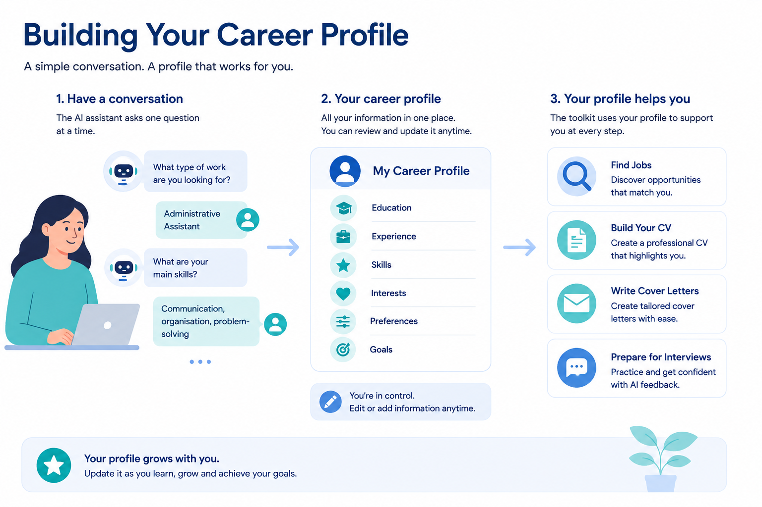

EXAMPLE: INFORMATION COLLECTED DURING ONBOARDING
During the onboarding conversation, the ARISE chatbot gradually builds the learner's career profile by asking questions such as:
- What type of job are you looking for?
- What are your main skills and strengths?
- What education, training or certifications have you completed?
- Have you gained experience through work, volunteering or community activities?
- What type of working arrangement do you prefer (on-site, hybrid or remote)?
- Are there any accessibility preferences or reasonable accommodations you would like to record?
The learner can review, edit or complete this information later through their account.
A complete profile is also important because AI-assisted career guidance depends on the quality of the information provided. If important skills, experiences or career goals are missing, recommendations may be less relevant or incomplete. For this reason, learners are encouraged to describe their qualifications and experience as accurately and comprehensively as possible.
For many people with disabilities, valuable experience may have been gained through non-traditional pathways such as volunteering, caring responsibilities, community participation, independent learning or personal projects. These experiences often demonstrate important transferable skills that employers value, even if they were not gained through paid employment.
The ARISE Career Guidance Toolkit adopts a skills-first approach. Rather than focusing on disability, diagnosis or limitations, it encourages learners to present their strengths, abilities and aspirations. Learners remain in control of the information they choose to include and decide whether any accessibility preferences or reasonable accommodations during the recruitment process.
Building Your Profile Gradually
Rather than completing all information at once, learners can progressively enrich their career profile as they gain experience, develop new skills, or update their employment preferences. This allows the Toolkit to provide increasingly relevant recommendations over time.

2. a. Information to prepare
Before using the ARISE Career Guidance Toolkit or any AI-assisted career guidance tool, learners should prepare the information that best describes their career profile.
The following information is recommended:
- Target job title or occupational field
- Preferred sectors or organisations
- Preferred location and travel distance
- Preferred working arrangement (remote, hybrid or on-site)
- Preferred working hours (full-time, part-time or flexible)
- Education, vocational training and certifications
- Work experience, volunteering and project experience
- Technical, digital, communication and transferable skills
- Languages
- Accessibility preferences or reasonable accommodations, where the learner chooses to record them

Good Practice
Accessibility preferences belong to the learner. They should be recorded or shared only when relevant to the learner's career planning, or when the learner decides that sharing them may support workplace accessibility or reasonable accommodations.

2. b. Identifying interests, abilities and transferable skills
Building a career profile is more than listing previous jobs or qualifications. It is also about recognising the interests, abilities and transferable skills that can support future employment.
Interests are the activities or subjects that motivate and engage a person. They often provide useful indications about suitable career paths. Examples include working with technology, helping people, creative activities, gardening, science or sports.
Abilities are the natural or developed capacities that make certain tasks easier to perform. These may include solving problems, communicating effectively, organising information, using technology, working with numbers or creating practical solutions. Abilities can continue to develop through education, work experience and everyday life.
Transferable skills are skills that can be applied across different jobs, industries and life situations. They are often developed through education, volunteering, caring responsibilities, hobbies, community participation and managing everyday responsibilities. Recognising these skills helps learners present a more complete picture of their capabilities, particularly when they have limited formal work experience.
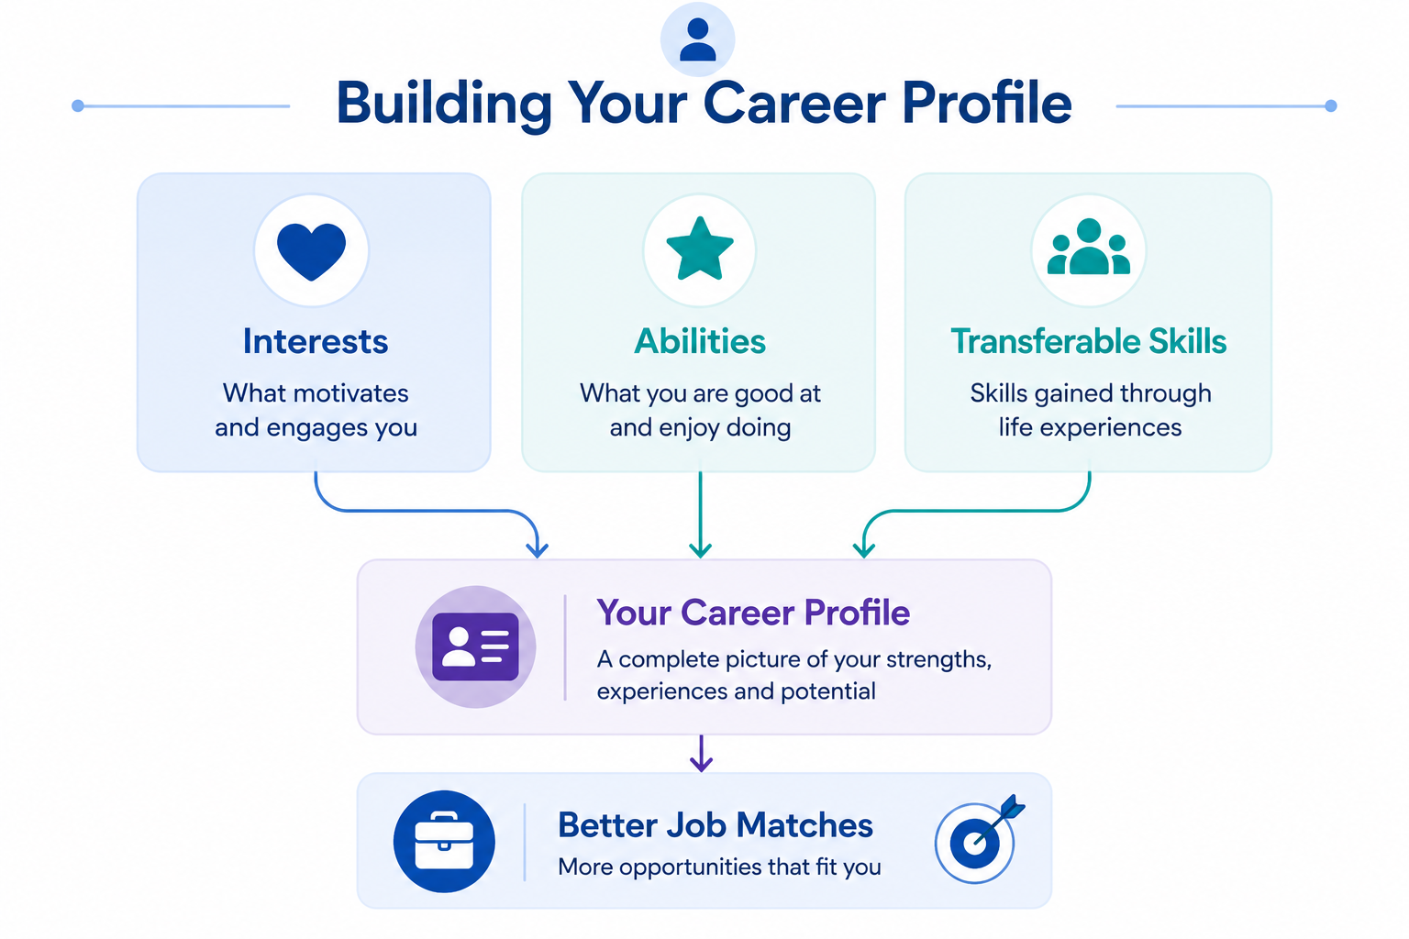
The ARISE Career Guidance Toolkit encourages learners to identify these strengths before beginning their job search. A well-developed career profile enables the Toolkit to generate more personalised and relevant guidance throughout the recruitment journey.
EXPERIENCE | POSSIBLE TRANSFERABLE SKILLS
Organising personal appointments and transport | Planning, time management, problem-solving
Volunteering at an event | Teamwork, communication, reliability
Using assistive technology | Digital competence, adaptability, troubleshooting
Caring responsibilities | Organisation, responsibility, prioritisation
Completing an online course | Independent learning, digital literacy, persistence

Remember
Valuable skills are not developed only through paid employment. Education, volunteering, hobbies, family responsibilities, community participation and everyday experiences can all demonstrate abilities that employers recognise and appreciate.

3. Job search tools
Once the career profile has been created, learners can begin searching for employment opportunities using the ARISE Career Guidance Toolkit. The Toolkit combines the learner's profile with AI-assisted career guidance to support a more personalised job search.
Rather than requiring learners to manually search through hundreds of vacancies, the Toolkit helps organise relevant opportunities based on learners' skills, qualifications, career goals and work preferences. At the same time, learners remain responsible for reviewing each opportunity and deciding whether it matches their interests and aspirations.
Although AI-assisted career guidance can simplify the job-search process, it should not replace critical thinking. Learners are encouraged to explore different sources of information, compare opportunities and independently verify job advertisements before submitting an application.
For people with disabilities, digital recruitment may present additional challenges. Some recruitment platforms may not be fully accessible, information about workplace accessibility may be limited, and recruitment algorithms may not always recognise non-traditional career pathways or transferable skills. The ARISE Toolkit supports learners by encouraging a skills-based approach while helping them identify suitable employment opportunities in an accessible, structured way.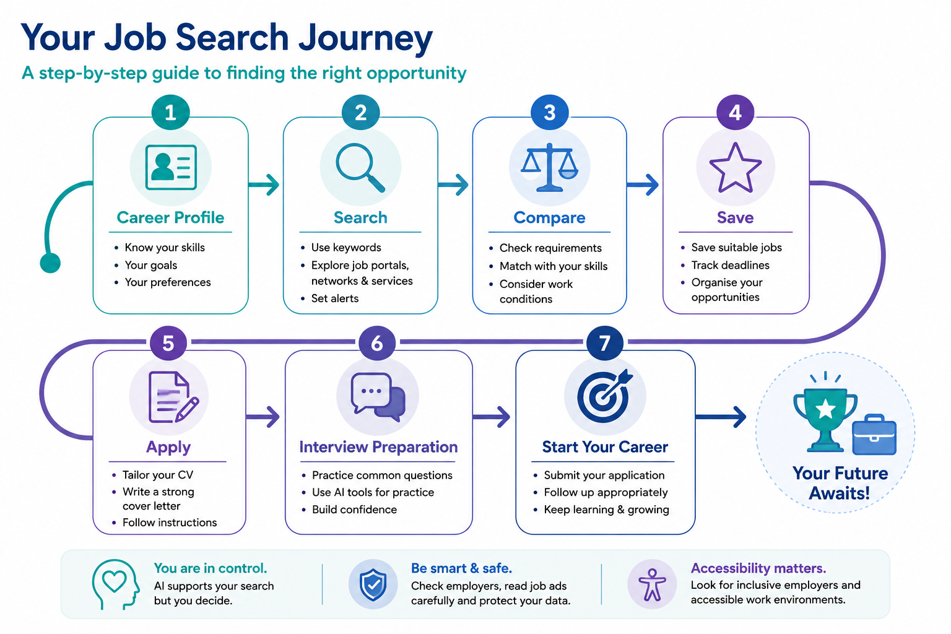

3. a. Navigating job portals and professional networks

The ARISE Career Guidance Toolkit supports learners in organising their job search. However, learners should also explore external job portals, professional networks and trusted employment services to maximise their opportunities.
- Use several relevant keywords, including alternative job titles.
- Apply filters for location, contract type, schedule, and remote or hybrid work.
- Set job alerts but also perform manual searches.
- Keep profile information accurate and up to date.
- Follow relevant employers and professional groups.
- Use national employment services, EURES, disability-inclusive employment organisations and other trusted recruitment sources where appropriate.
- Check whether the platform provides accessibility features and whether employers mention reasonable accommodations or inclusive recruitment practices.
- Keep a record of saved vacancies and application deadlines.

CASE STUDY 1 – ANNA BUILDS HER JOB SEARCH PROFILE
Anna is 27 years old and recently completed a vocational education programme in office administration. She is looking for her first paid job.
She knows she would like to work in an administrative role, but she is unsure which job titles to search for. She also prefers a hybrid working arrangement because it offers greater flexibility. Instead of searching for only one job title, Anna uses the ARISE Career Guidance Toolkit to explore alternative job titles and search keywords.
She writes the following prompt:
AI Prompt
I am looking for entry-level administrative work in Athens. I prefer hybrid work and full-time hours. Suggest alternative job titles and useful search keywords. Do not make assumptions about my disability or qualifications.
The AI suggests several additional search terms, including:
- Administrative Assistant
- Office Administrator
- Reception Administrator
- Operations Assistant
- Customer Support Administrator
- Office Coordinator
Anna realises that many suitable vacancies use different job titles. By expanding her search, she discovers opportunities she would not have found otherwise.

What can we learn?
The ARISE Career Guidance Toolkit can help learners:
- identify alternative job titles;
- discover useful search keywords;
- broaden their search strategy;
- organise relevant vacancies.
However, learners should always review AI suggestions and decide which options best match their own interests, skills and career goals.
Reflection
- Why did Anna find more opportunities after changing her search strategy?
- Which alternative job titles could describe the type of work you are looking for?
- How could AI help you improve your own job search?
 Common mistake
- Searching for only one job title.
- Different employers may advertise similar roles using different titles. Try several keywords to discover more opportunities.

3. b. Assessing a job advertisement
Read the complete advertisement before deciding whether to apply. Distinguish essential requirements from preferred qualifications. A learner should not automatically rule themselves out if not all preferred qualifications are met. Essential legal, licensing, or safety requirements may still be mandatory.
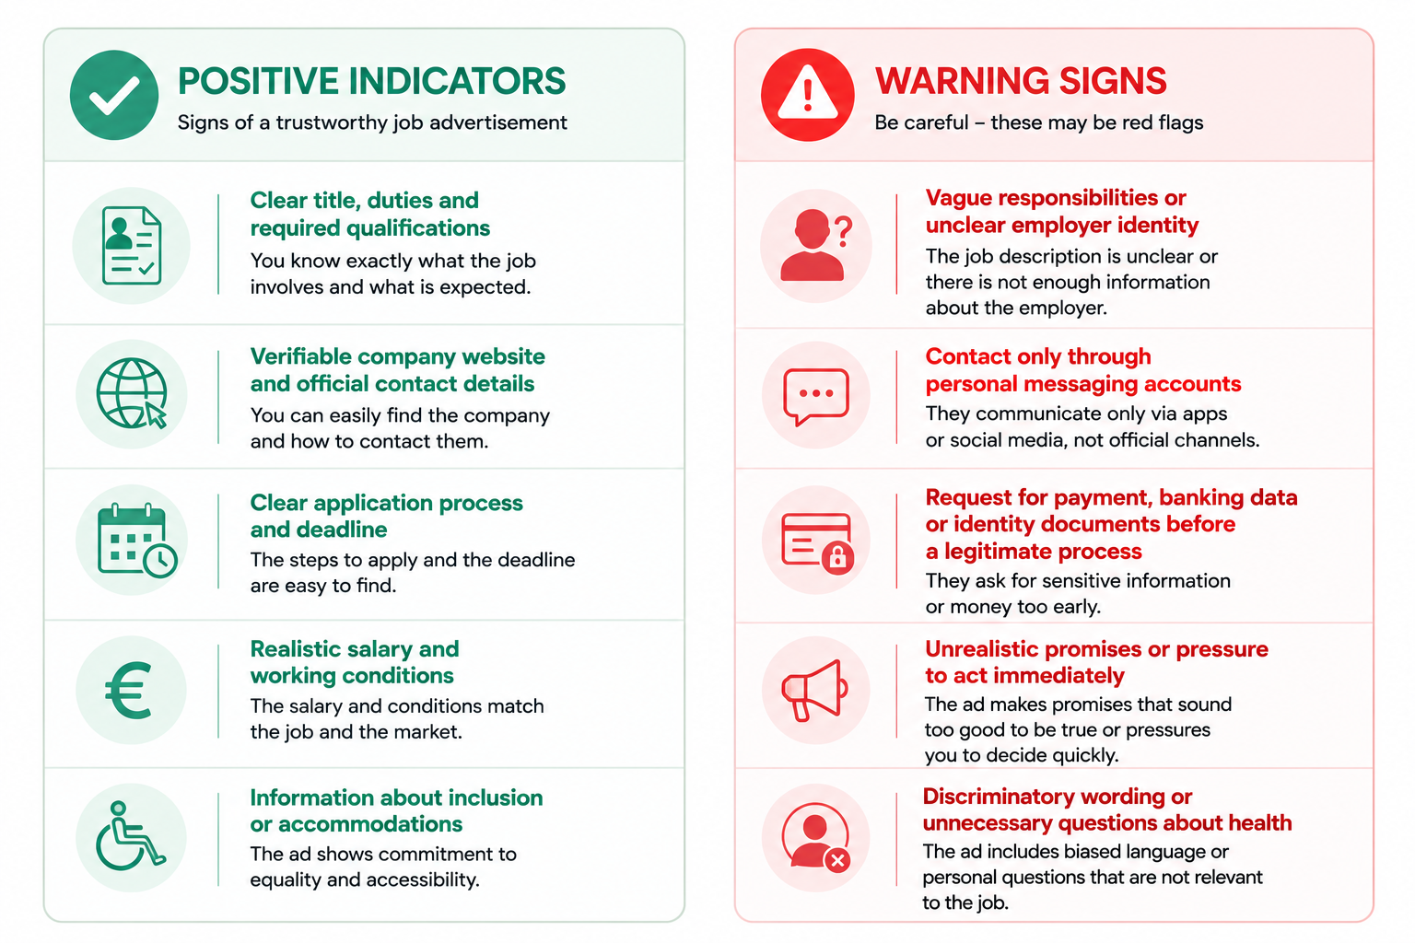
CASE STUDY 2: RECOGNISING WARNING SIGNS IN A JOB ADVERTISEMENT
George is interested in customer service positions and regularly searches online job portals.
One advertisement immediately caught his attention because it promised a high salary, flexible hours and immediate recruitment. However, the advertisement contained very little information about the employer and required applicants to send copies of identity documents before any interview took place.
Instead of applying immediately, George used the job posting assessment worksheet introduced in this module. He compared the advertisement against the checklist and identified several warning signs.
He decided to research the company further but could not find an official website or verified contact details. As a result, he chose not to submit his personal information.
George later explained that understanding how to evaluate job advertisements helped him feel more confident and protected during his job search.

Reflection
- Which warning signs did George identify?
- Why is it important to verify employer information independently?
- What would you do before sharing personal information online?
Common mistake
- Applying immediately without reading the full advertisement.
- Always check the employer, responsibilities, application process and any warning signs before sharing personal information.

3. c. Using the ARISE career guidance toolkit to search for jobs
After completing their career profile, learners can use the ARISE Career Guidance Toolkit to organise and support their job search. The Toolkit guides learners through a structured process that combines their career profile with AI-assisted career guidance while ensuring that all application decisions remain under the learner's control.
A typical job-search journey within the ARISE Toolkit includes the following steps:
- Review your career profile to ensure that your skills, qualifications, work experience and career goals are up to date.
- Search for job opportunities using the Toolkit together with trusted employment platforms, employer websites and public employment services.
- Review recommended vacancies and compare the job requirements with your own skills, experience and work preferences.
- Evaluate each job advertisement carefully, paying particular attention to essential requirements, accessibility information and the credibility of the employer.
- Save suitable opportunities and prepare your application using the ARISE CV Builder and Cover Letter tools.
- Prepare for interviews using the AI-assisted interview preparation features before submitting your application.
Throughout this process, learners remain responsible for evaluating every recommendation and deciding which opportunities best match their own interests, abilities and career goals.

Good Practice
AI-assisted recommendations should be treated as guidance rather than final decisions. Always read the original job advertisement, verify employer information independently and use your own judgement before applying.

4. Job search AI-assisted CV development
Many employers use Applicant Tracking Systems (ATS) — software that automatically scans and organises CVs before they are reviewed by a recruiter. These systems identify skills, qualifications and keywords that match the job description. For people with disabilities, valuable experience gained through non-traditional career pathways may not always be recognised if it is not clearly described. AI tools can help organise information and improve wording, but they must never fabricate qualifications, responsibilities or achievements. Learners remain responsible for reviewing all AI-generated content before submitting a job application.
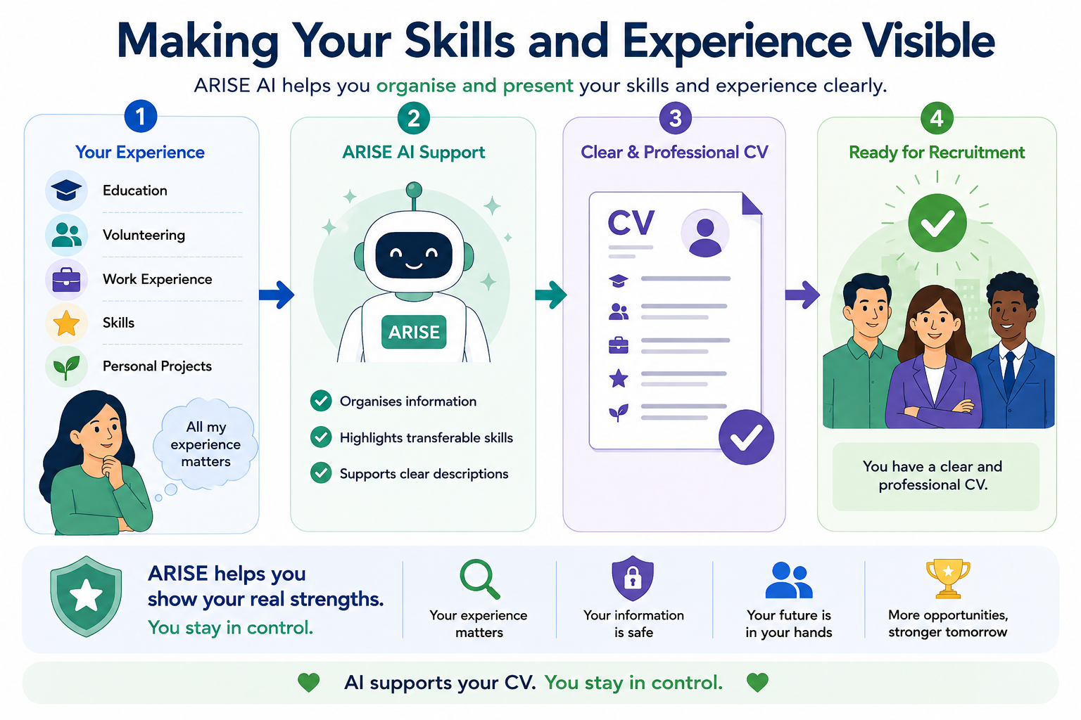

4. a. Core CV sections
- Your name
- Contact details (email/phone number) – οnly the contact information needed for the application should be included. A full home address, date of birth, photograph, marital status or health information is usually not required unless there is a specific and lawful reason.
- Professional profile or summary
- Work history, work experience or voluntary work
- Education, training and qualifications
- Skills (computer skills, communication skills)
- Languages
- Certifications, projects or volunteering, where relevant
- Relevant interests or activities (optional)

4. b. Tailoring a CV
- Identify the most relevant duties and keywords in the advertisement.
- Move the most relevant evidence higher in the CV.
- Use similar terminology only when it truthfully describes your experience.
- Provide short evidence-based statements.
- Quantify results only when the figures are accurate and can be explained.
- Remove irrelevant information that distracts from the application.

CASE STUDY 3: CREATING A PROFESSIONAL CV PROFILE WITH AI
John's Story
John recently completed his vocational education programme in Business Administration. Although he has participated in volunteer activities and completed a work placement, he has never written a professional CV before. When he opened a CV template, he was unsure what to write in the Professional Profile section. He worried that his lack of paid work experience would make him appear unqualified. Instead of asking AI to write his entire CV, John first collected accurate information about himself, including his education, volunteering experience, digital skills and career interests. He then used an AI tool to help transform these facts into a short professional summary.
AI Prompt: Using only the information below, draft a professional CV profile of 60–80 words for the role of Administrative Assistant. Use clear, natural and professional language. Do not add skills, experience, achievements or qualifications that I have not provided.
Information:
- Recently completed a VET programme in Business Administration
- Completed a three-month work placement in a municipal office
- Volunteer at a local youth organisation
- Good knowledge of Microsoft Office
- Strong organisational and communication skills
- Interested in administrative support roles
AI Output (Example)
Motivated Business Administration graduate with practical experience gained through vocational training, a municipal work placement and community volunteering and organised, reliable and confident using Microsoft Office applications, with strong communication and administrative support skills. Eager to contribute to a professional team while continuing to develop knowledge and experience in office administration.
What happened next?
John carefully reviewed the AI-generated text. He removed one sentence that sounded too generic and replaced it with wording that better reflected his own personality. He also checked that every statement could be supported by evidence during an interview. The final profile was concise, accurate and authentically represented his experience.

Reflection
- Why did John prepare accurate information before using AI?
- Which parts of the AI-generated profile required personal review?
- Why is it important that every statement in a CV can be supported with evidence?
Collect your information before asking AI to write.
AI produces better CV content when you first prepare accurate facts about your education, skills and experience.

4. c. Accessibility and CV formatting

- Use clear headings and a logical reading order.
- Use a legible font and adequate text size.
- Use a simple layout; complex columns, graphics and decorative elements may not be processed reliably by every recruitment system.
- Do not communicate important information only through colour.
- Use meaningful link text.
- Add alternative text to any necessary image.
- Use an accessible Word document or properly tagged PDF where possible.
- Use a descriptive file name, for example: Maria_Papadopoulou_CV_Administration.docx.
♿ ACCESSIBILITY REMINDER
Accessibility and ATS compatibility are related but different concepts.
A CV should be easy to read both for people using assistive technologies and for recruitment software whenever possible.

5. AI cover letter development
A Cover Letter connects the learner's skills, experience and motivation to a specific vacancy. Many AI tools can generate a first draft quickly, but effective Cover Letters require personalisation and careful review. Generic AI-generated text may fail to explain why the learner is interested in a particular organisation or role. Learners should therefore review every suggestion to ensure that the final letter accurately reflects their own motivation and experience.

5. a. Recommended structure

1. Opening: identify the position and reason for applying.
2. Match: connect two or three relevant skills or experiences to the vacancy.
3. Motivation: explain why the role or organisation is relevant to you.
4. Closing: express interest in discussing the application and provide a professional sign-off.

Common mistake
- Sending the same Cover Letter to every employer.
- Recruiters quickly recognise generic applications. Personalising your Cover Letter shows genuine interest in the role.
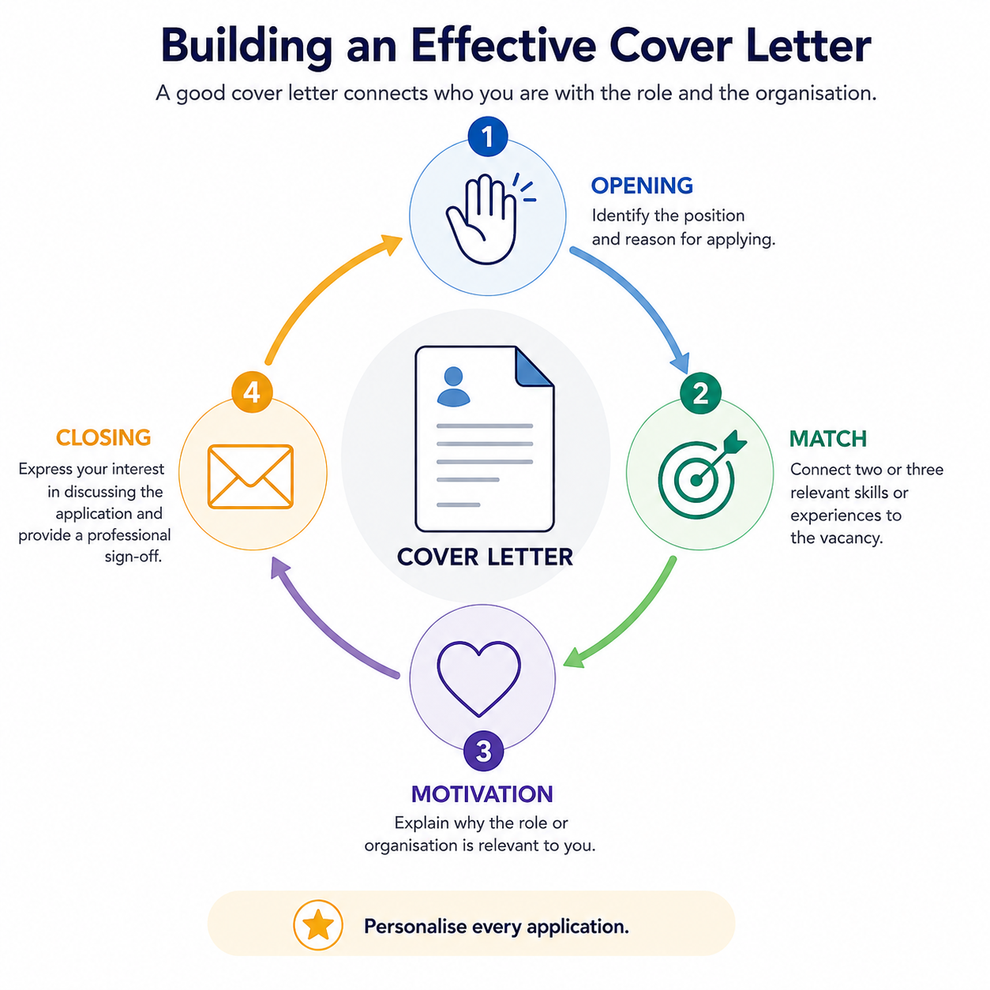

5. b. Typical workflow for preparing application documents
- Review or update your skills-first Portfolio Profile.
- Add an existing CV or enter the required information into the Toolkit.
- Paste the selected job advertisement or enter the role requirements.
- Generate AI-assisted suggestions or a first draft.
- Review each section for accuracy, relevance and tone.
- Remove unsupported statements and correct any errors.
- Personalise the final document.
- Save or export the final version using the available Toolkit options.

6. AI-assisted interview preparation
Interview preparation reduces uncertainty and helps learners select evidence before they are under pressure. AI-assisted mock interviews can provide repeated practice, but automated feedback may not fairly interpret every communication style, disability, or use of assistive technology.

6. a. Before the interview
- Research the organisation and role.
- Review the job advertisement and identify the main requirements.
- Prepare examples that demonstrate relevant skills.
- Prepare questions to ask the employer.
- Confirm the interview format, time, location and technology.
- Plan transport and access arrangements.
- Request a reasonable accommodation where needed.

6. b. Disability disclosure and accommodation
A learner may request an adjustment by explaining the support required. In many cases, detailed medical or diagnostic information is not necessary. The learner should decide what to disclose, when to disclose it, and to whom, taking into account national rules and available professional advice.
EXAMPLES OF INTERVIEW ACCOMMODATIONS
An accessible location; additional time for a written task; sign-language interpretation; questions provided in writing; a short break; use of assistive technology; or an alternative interview format.

6. c. Using the STAR method

STAR is a simple structure for answering competency-based questions:
SITUATION | Briefly explain the context.
TASK | Explain what you needed to achieve.
ACTION | Describe what you personally did.
RESULT | Explain the outcome and what you learned.

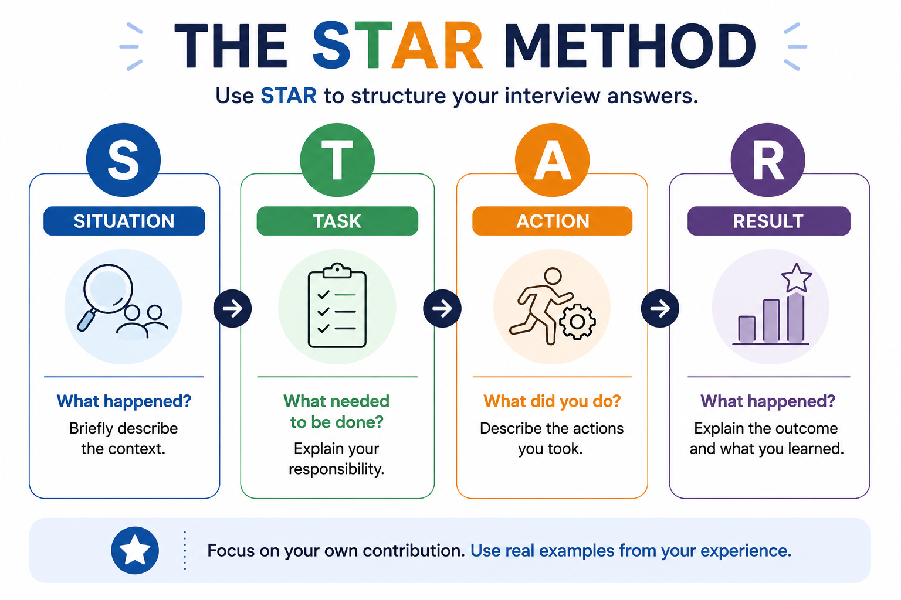

STAR EXAMPLE
Question: “Tell me about a time you solved a problem.” Situation: During a volunteering event, two team members were absent. Task: I needed to help complete participant registration. Action: I reorganised the tasks and created a simple checklist. Result: All participants were registered on time, and the checklist was reused at the next event.

6. d. Interpreting AI feedback critically

AI-generated feedback can be useful, but it is not always accurate, fair or appropriate for every learner. AI systems are trained on existing data and may reflect assumptions about communication, behaviour or workplace expectations. Learners should use AI feedback as guidance rather than as a final judgement of their abilities.

Why should AI feedback be reviewed critically?
AI feedback may:
- focus on common communication patterns rather than individual strengths;
- misunderstand disability-related communication styles;
- encourage generic or overly standardised responses;
- overlook the value of assistive technologies or reasonable accommodations;
- occasionally produce inaccurate or irrelevant suggestions.
For these reasons, learners should always review AI-generated feedback before deciding whether to use it.

Good practices when reviewing AI feedback
- Give greater weight to feedback about content, relevance and structure.
- Treat feedback about eye contact, facial expression, pace, tone or body language with caution.
- Ignore suggestions that encourage you to hide or change an authentic disability-related communication style.
- Discuss unclear or conflicting feedback with a career counsellor, trainer or trusted person.
- Remember that the goal is to communicate your experience clearly—not to appear "perfect".
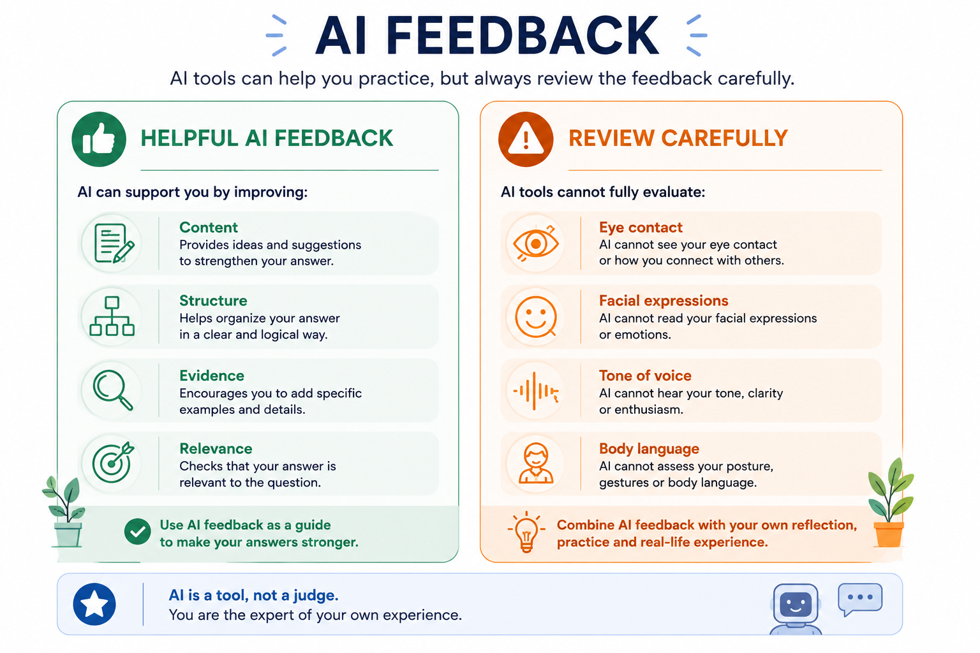
♿ ACCESSIBILITY REMINDER
AI should help you communicate your strengths, not change who you are.
Your communication style may differ from others' and can still be professional, effective, and appropriate.

EXAMPLE – AI FEEDBACK
AI feedback:
"Maintain constant eye contact and smile more often to appear confident."
Critical review:
This suggestion may not be appropriate for every learner. Some disabilities or neurodivergent communication styles naturally affect eye contact or facial expression. Confidence should be demonstrated through clear, relevant and truthful answers rather than by copying behaviours that may feel uncomfortable or inauthentic.
Reflection
- Which AI feedback would help you improve the content of your answer?
- Which suggestions might not suit your own communication style?
- How can you decide whether an AI recommendation is useful for you?

6. e. Preparing for an accessible and effective interview

Preparing in advance can reduce uncertainty and help you communicate relevant evidence about your skills and experience. The aim is not to produce a “perfect” performance, but to participate in the interview in a way that is accurate, accessible and authentic.
Research the organisation and the role.
Before the interview:
- Review the organisation’s main activities, values and services.
- Read the job advertisement again and identify the essential requirements.
- Prepare examples showing how your skills and experience relate to the role.
- Write down any questions you would like to ask the employer.
- Check the interview format, location, time and expected duration.
- Use reliable sources such as the organisation’s official website, the original job advertisement and verified professional profiles. AI tools may help organise publicly available information, but important details should be checked against the source.
Plan for accessibility
Consider whether any barriers could affect your participation in the interview. These may relate to:
- the physical location;
- transport or building access;
- the interview platform or digital technology;
- communication format;
- written or timed activities;
- sensory conditions;
- the need for breaks, assistive technology or additional time.
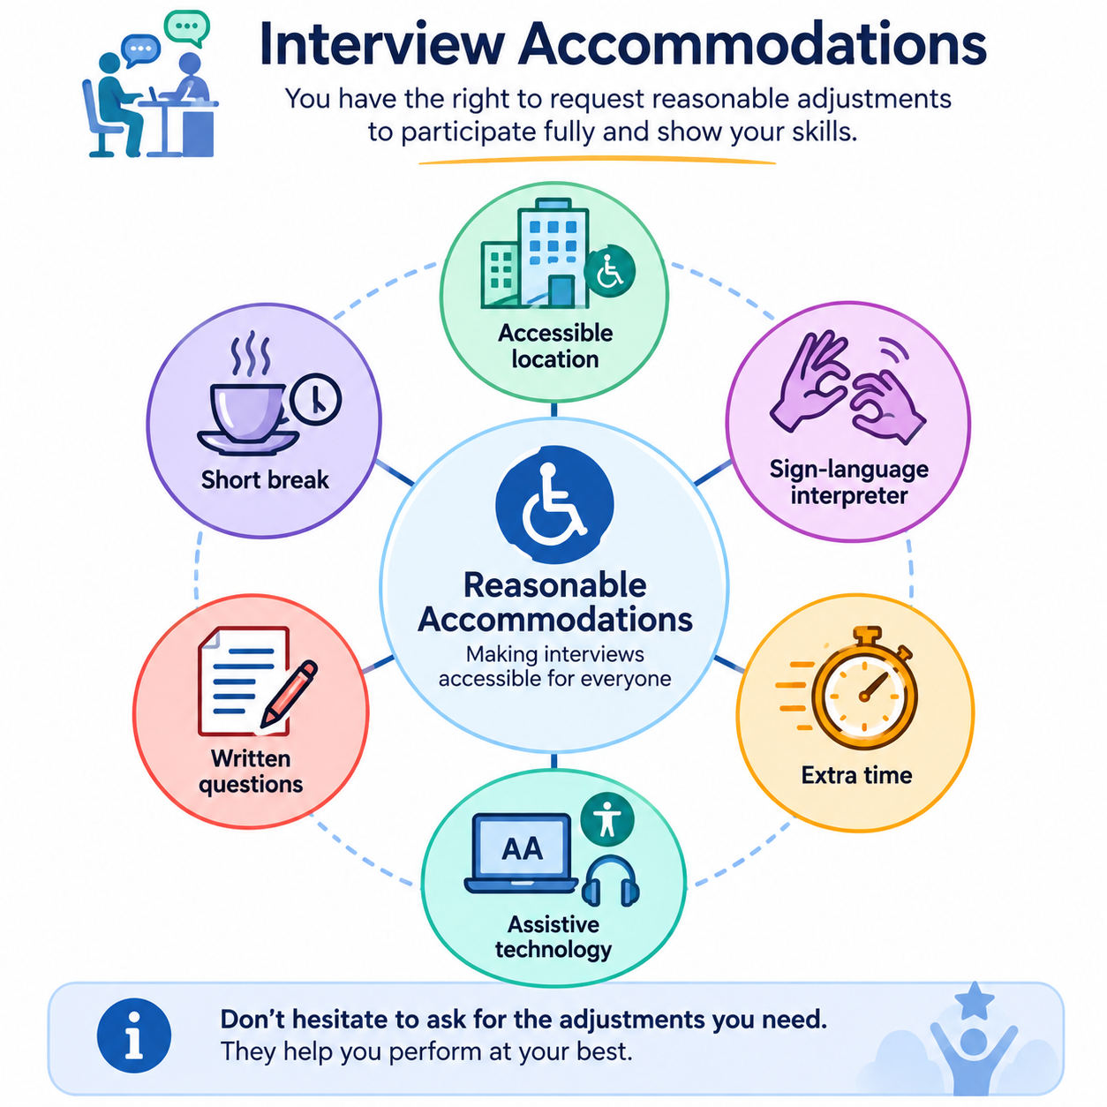

Where appropriate, contact the employer in advance and describe the adjustment you require. You do not normally need to provide more personal or medical information than is necessary to explain the practical support required.

During the interview
- Listen to or review each question carefully.
- Ask for clarification or repetition when needed.
- Take time to think before answering.
- Use specific and truthful examples.
- Use the communication method or assistive technology that supports you.
- Explain what you personally did and what the outcome was.
- Ask your prepared questions at the end of the interview.
- Do not feel pressured to follow advice that conflicts with your access needs or authentic communication style.
Disability disclosure remains a personal decision.
Disclosure should not be treated as a standard interview requirement. The learner decides whether, when, and how to disclose disability-related information, taking into account the role, the support required, national legislation, and trusted professional advice.
When requesting an accommodation, it is often sufficient to focus on the barrier and the practical adjustment.
♿ ACCESSIBILITY REMINDER
A professional interview does not require every candidate to communicate, move or respond in the same way.
Reasonable accommodations are intended to remove barriers and support fair participation.

6. f. Practising with the ARISE Interview Simulator
The ARISE Interview Simulator supports structured interview practice linked to a selected role. A typical practice process may include:
- Review or update your skills-first Portfolio Profile.
- Select a job role or provide the relevant job requirements.
- Choose an available practice format that meets your access needs.
- Practise one interview question at a time.
- Review feedback primarily on the relevance, evidence and structure of your answer.
- Identify useful suggestions and reject those that are inaccurate, inappropriate or inconsistent with your communication style.
- Revise the answer without changing the facts.
- Save useful notes where this option is available.
- Repeat the practice when helpful and take breaks when needed.

♿ ACCESSIBILITY REMINDER
Use the practice format that works best for you.
Written, audio, video, assistive or supported communication may all be valid ways to prepare, depending on the available Toolkit options.

Working together with a career counsellor
The ARISE Career Guidance Toolkit is designed to support—not replace—career counsellors. With the learner's permission, selected information may be shared with a counsellor to provide more personalised guidance and discuss future career decisions.

7. Assessment and reflection

7. a. Practical assessment

The learner completes the following tasks:
- A Job Search Criteria Worksheet
- A Job Posting Assessment
- Three evidence-based CV statements or one tailored CV section
- One personalised Cover Letter paragraph
- One STAR interview answer
- A review of at least one AI-generated output, identifying one strength and one correction

7. b. Self-reflection
Rate each statement from 1 (not yet confident) to 5 (very confident): (a) I can identify suitable job-search keywords; (b) I can distinguish between essential and preferred requirements; (c) I can review and improve AI-generated application content; (d) I can prepare a structured interview response; and (e) I know when to ask for support.

7. c. Good practice checklist
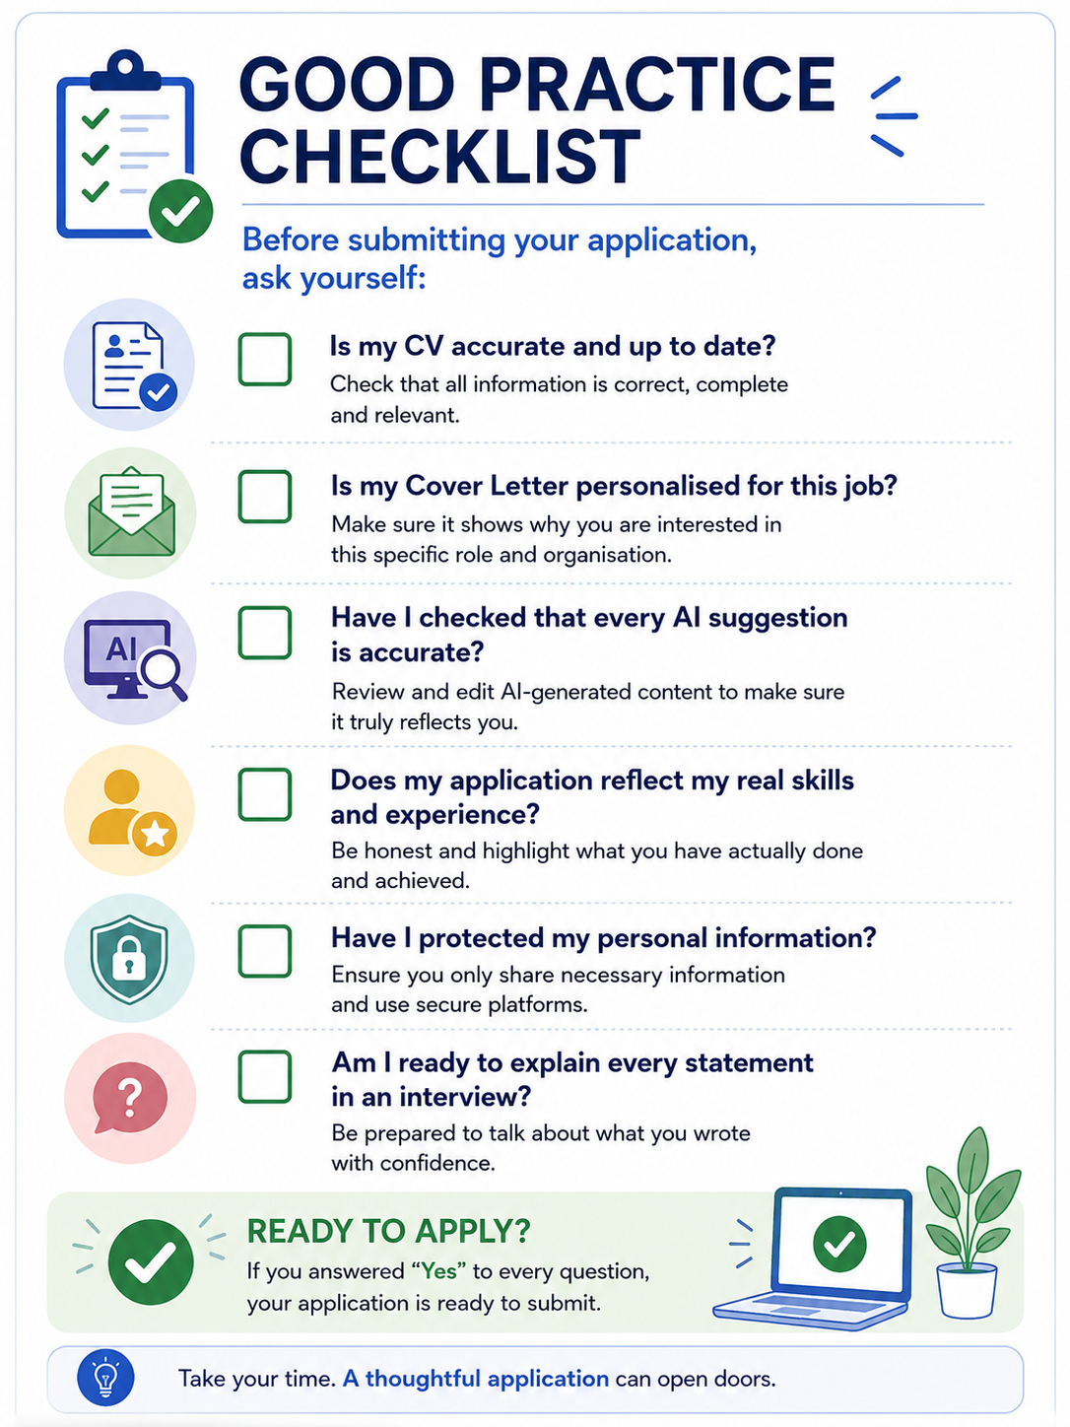

8. Summary
This module introduces learners to the practical use of AI-assisted tools throughout the job application process, from identifying suitable employment opportunities to preparing application documents and practising for interviews. Learners explored how to search for vacancies effectively, evaluate job advertisements critically, and use AI responsibly to support the development of a skills-first Portfolio Profile, tailored CV content and personalised Cover Letters.
The module emphasised that AI can improve efficiency and provide useful suggestions, but it cannot replace the learner's judgement, experience or authentic voice. Learners were encouraged to review every AI-generated output critically, recognising that automated systems may contain errors, bias or generic recommendations that are not appropriate for everyone, particularly for people with disabilities or different communication styles.
Special attention was paid to inclusive recruitment practices, reasonable accommodations and informed decisions about disability disclosure. Learners also developed structured interview responses using the STAR method. They practised critically evaluating AI-generated interview feedback, focusing on evidence, relevance and accessibility rather than trying to conform to standardised communication expectations.
By the end of the module, learners should feel more confident using AI as a supportive tool for career development while maintaining control over their applications and ensuring that all submitted information is accurate, truthful, personalised, and representative of their abilities. The overall aim is to empower learners to participate in recruitment processes with greater confidence, autonomy and awareness of both the opportunities and the limitations of AI.

9. References
Cedefop (2024) Skills Intelligence. Available at: https://www.cedefop.europa.eu (Accessed: 14 July 2026).
European Commission (2021) Union of Equality: Strategy for the Rights of Persons with Disabilities 2021–2030. COM(2021) 101 final.
European Commission, EURES (n.d.) Job seekers and EURES services. Available at: https://eures.europa.eu (Accessed: 14 July 2026).
European Network of Public Employment Services (2022) Practitioner Toolkit on Strengthening Public Employment Services to Improve the Labour Market Outcomes of Persons with Disabilities. Brussels: European Commission.
European Parliament and Council of the European Union (2024) Regulation (EU) 2024/1689 laying down harmonised rules on artificial intelligence (Artificial Intelligence Act). Official Journal of the European Union.
European Union, Europass (n.d.) Create your Europass CV and guidance for job applications. Available at: https://europa.eu/europass (Accessed: 14 July 2026).
International Labour Organisation (ILO) (2024) Disability Inclusion in Employment. Available at: https://www.ilo.org (Accessed: 14 July 2026).
Ιnternational Labour Organisation (ILO) (2007) Getting Hired: A Guide for Job-Seekers with Disabilities. Geneva: International Labour Office.
OECD (2024) OECD Principles on Artificial Intelligence. Available at: https://oecd.ai (Accessed: 14 July 2026).
United Nations (2006) Convention on the Rights of Persons with Disabilities (CRPD). New York: United Nations.
World Wide Web Consortium (W3C) (2024) Web Content Accessibility Guidelines (WCAG) 2.2. W3C Recommendation.

