


ARISE Project Work Package 2

Pedagogical Framework

Module 3: Self-Care
Latvijas autisma apvienība, Latvia

This project has been funded with support from the European Commission. This publication reflects the views only of the author, and the Commission cannot be held responsible for any use which may be made of the information contained therein.

This work is licensed under a Creative Commons Attribution-NonCommercial 4.0 International License. In addition, an acknowledgement of the authors of the document and all applicable portions of the copyright notice must be clearly referenced. All rights reserved.


Module Title | Module 3: Self-care
Learning Objectives | Module 3 aims to:  - Educate learners on the concept and importance of self-care in professional life  - Educate learners on coping strategies for job search stress and interview anxiety  - Educate learners on coping with repeated job application rejections and maintaining motivation  - Educate learners on inclusive workplace culture, self-advocacy, employee rights and responsibilities  - Educate learners on zero-tolerance principles towards abuse, harassment and discrimination  - Educate learners on managing workplace pressure, stress and work-life balance
Learning Outcomes | Through Module 3, learners will be able to:  - Explain the concept and importance of self-care in professional contexts  - Apply strategies for managing job search stress and interview anxiety  - Demonstrate resilience in coping with repeated job application rejections and maintaining motivation  - Demonstrate understanding of inclusive workplace culture, including self-advocacy principles  - Recognise employee rights, employer responsibilities and zero-tolerance principles in the workplace  - Apply appropriate procedures for handling and reporting workplace incidents  - Apply techniques for managing workplace stress, pressure and work-life balance

1. Introduction
People with different types of disabilities often face additional daily challenges in maintaining their mental and physical well-being. Therefore, self-care represents a fundamental component of daily life, where meaningful engagement in safe and appropriate environments can also be considered part of self-care itself. As highlighted by international research, decent work supports good mental health by providing a livelihood, a sense of confidence, purpose and achievement, opportunities for positive relationships and social inclusion, as well as structured routines and stability in daily life.
For people with disabilities, access to appropriate employment significantly enhances self-confidence, fosters social inclusion, and improves overall social functioning. Countries are therefore encouraged to strengthen the skills and employability of individuals facing health-related challenges and to support them in obtaining and maintaining quality employment opportunities.
However, the entire employment cycle - from job search to workplace participation - is associated with multiple challenges. These include increased levels of stress and anxiety, the need for self-discipline and organisational skills, as well as the ability to advocate for one’s own rights. As a result, individuals with disabilities may face a higher risk of experiencing mental health-related challenges such as burnout, insomnia, and anxiety. To successfully navigate this process, job seekers need to recognise the importance of self-care, be provided with appropriate coping strategies, and integrate these strategies into their daily lives.
Evidence also shows that people with health conditions are more likely to experience barriers to employment and workplace inequality. It is therefore essential to equip job seekers with appropriate tools to maintain motivation throughout the job search process. In addition, once employment is secured, both employees and employers must be informed about inclusive workplace principles, including zero-tolerance policies towards abuse, harassment and discrimination, as well as awareness of employee rights. Only under these conditions can a healthy and sustainable employment cycle for people with disabilities be achieved.
To further support individuals in managing these challenges and maintaining their well-being throughout the employability process, modern digital solutions offer valuable assistance. Artificial intelligence also plays an increasingly significant role in self-care during the job search process. AI-based tools can support candidates with CV preparation, interview training, and job matching, while also improving self-management by increasing organisation, reducing cognitive load, enhancing perceived control, and lowering the risk of burnout during employability processes. However, it is also important to acknowledge the potential drawbacks of AI technologies, as they may simultaneously introduce new stressors such as algorithmic evaluation, uncertainty, and increased competition. This dual impact highlights the growing importance of self-care and resilience strategies within digital employability contexts, particularly for vulnerable groups such as people with disabilities.

2. Understanding Self-Care in Professional Life

2. a What is Self-Care?
According to the World Health Organisation (WHO), self-care is defined as:
"The ability of individuals, families and communities to promote and maintain health, prevent disease, and cope with illness and disability, with or without the support of a health or care worker."
The WHO emphasises that self-care enables individuals to take an active role in managing their own health and well-being. Self-care interventions may include evidence-based medicines, medical devices, diagnostic tools, digital technologies, and other resources that support health promotion, disease prevention, self-management, and well-being.
In the context of the job search and employment process, this broad definition translates into daily habits and coping mechanisms that help individuals sustain their well-being while navigating professional challenges.
In simple terms, self-care refers to any action that helps individuals maintain or improve their well-being, both in the short term and over the long term. Effective self-care can help reduce stress, strengthen self-confidence, improve resilience, and increase overall life satisfaction.
It is important to recognise that self-care is not always associated with immediate comfort or pleasure. In some cases, self-care requires individuals to challenge themselves, establish healthy boundaries, or engage in activities that may initially feel difficult or uncomfortable. For example, attending therapy sessions, learning to say no, setting personal and professional boundaries, seeking support, or beginning a regular exercise routine can all be considered forms of self-care.

2 .b Physical, Emotional, Social and Professional Self-Care
Self-care is a wide concept that extends across several areas of life. To maintain overall well-being, individuals should consider their needs in each of these areas and adopt appropriate self-care practices accordingly.
Each dimension contributes to overall well-being and influences an individual's ability to live and work well in daily life and professional settings. Neglecting one area can negatively affect others, while maintaining balance across different dimensions promotes resilience, good health, and long-term personal and professional success.
Key Principle of Self-Care
One fundamental principle of self-care is that it should support overall well-being rather than contribute to harmful or destructive behaviours. It is important to distinguish self-care from behaviours that may provide temporary relief or pleasure but have negative long-term consequences. Genuine self-care contributes positively to an individual's overall health, functioning, and personal development.
The chart below provides an overview of the key dimensions of self-care and examples of activities associated with each area.
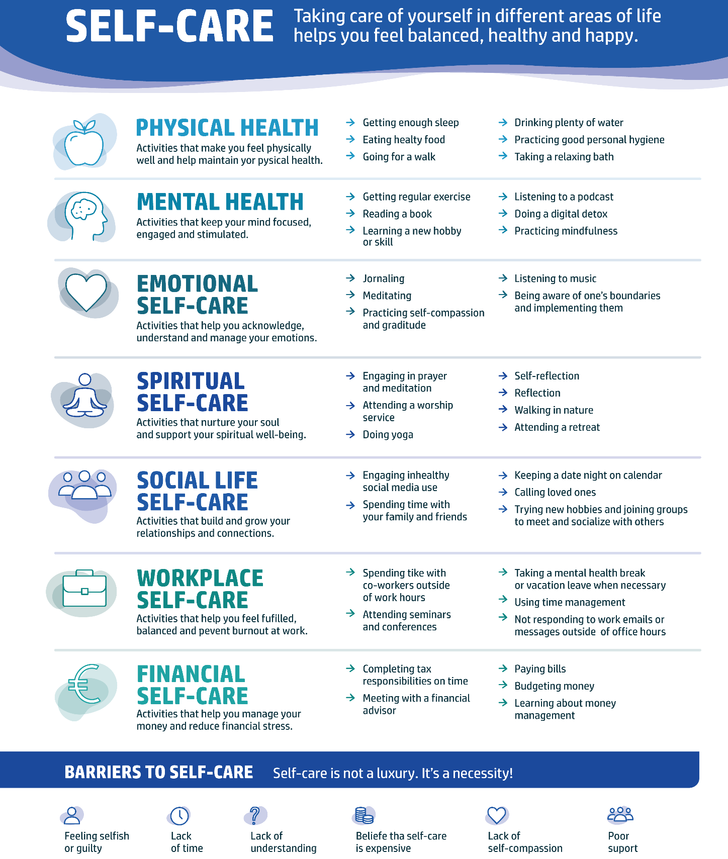

2. c. Common Myths About Self-Care
Although self-care is widely known, it is often misunderstood. Common myths and misconceptions can stop people from prioritising their well-being or building healthy habits. The following section looks at some of the most common myths about self-care.
One of the most common misconceptions is that self-care is selfish. Many people feel guilty about spending time on their own well-being, especially when they have responsibilities to family, colleagues, or others who depend on them. In reality, self-care helps people keep the physical and emotional energy needed to support others. By taking care of themselves, they are often better able to handle their daily responsibilities.
Another widespread belief is that self-care is a luxury that requires significant financial resources or large amounts of free time. However, many effective self-care practices are simple, affordable, and easily fit into everyday life. Getting adequate sleep, maintaining a balanced diet, engaging in physical activity, spending time outdoors, and nurturing social relationships are all examples of accessible self-care practices.
Some people also assume that self-care requires a lot of effort or that its benefits are limited. Research has consistently demonstrated that regular self-care practices contribute to improved physical and mental health, reduced stress levels, enhanced resilience, better emotional regulation, and increased overall well-being. Even small actions, such as taking short breaks, practising relaxation techniques, or maintaining healthy daily routines, can have a positive impact over time.
Finally, it is important to recognise that self-care is not the same for everyone. Individual needs, preferences, lifestyles, and circumstances vary considerably. Effective self-care therefore requires self-awareness and a personalised approach. Activities that support one person's well-being may not be equally beneficial for another. The key is to identify and maintain practices that contribute positively to one's own health, well-being, and quality of life.

2. d. Why Self-Care Matters During Job Search and Employment
Self-care plays a crucial role throughout the employment journey, from searching for a job and preparing for interviews to adapting to a new workplace and managing professional responsibilities. Each stage involves uncertainty, pressure, and stress, which can negatively affect physical and mental well-being if not managed well.
During stressful times, self-care is often neglected. People may skip meals, reduce physical activity, forget medication, lack proper hydration, or overlook emotional needs. Over time, these habits lead to fatigue, reduced concentration, lower motivation, and greater vulnerability to health problems.
In employment, self-care refers to the actions people take to protect their physical, emotional, and mental well-being while working or searching for work. Effective self-care supports resilience, productivity, job satisfaction, and overall quality of life.
While work can give purpose, achievement, financial security, and social connection, finding a job and working can also bring a lot of stress. Long-term pressure or uncertainty at work can lead to burnout. This means feeling emotionally exhausted, losing motivation, and feeling disconnected from your work. Burnout can also lead to mental and physical health problems.
Individuals vary in their knowledge, experience, and confidence regarding self-care practices. Some may already have well-established routines that support their well-being, while others may require additional guidance and encouragement to develop sustainable self-care habits.

2. e. Practical Self-Care Strategies during Job Search and Employment
Self-care is not limited to occasional activities; rather, it consists of small actions and habits that can be integrated throughout the day. Developing healthy routines can help individuals manage stress, maintain energy levels, and prevent burnout during both job searching and employment.
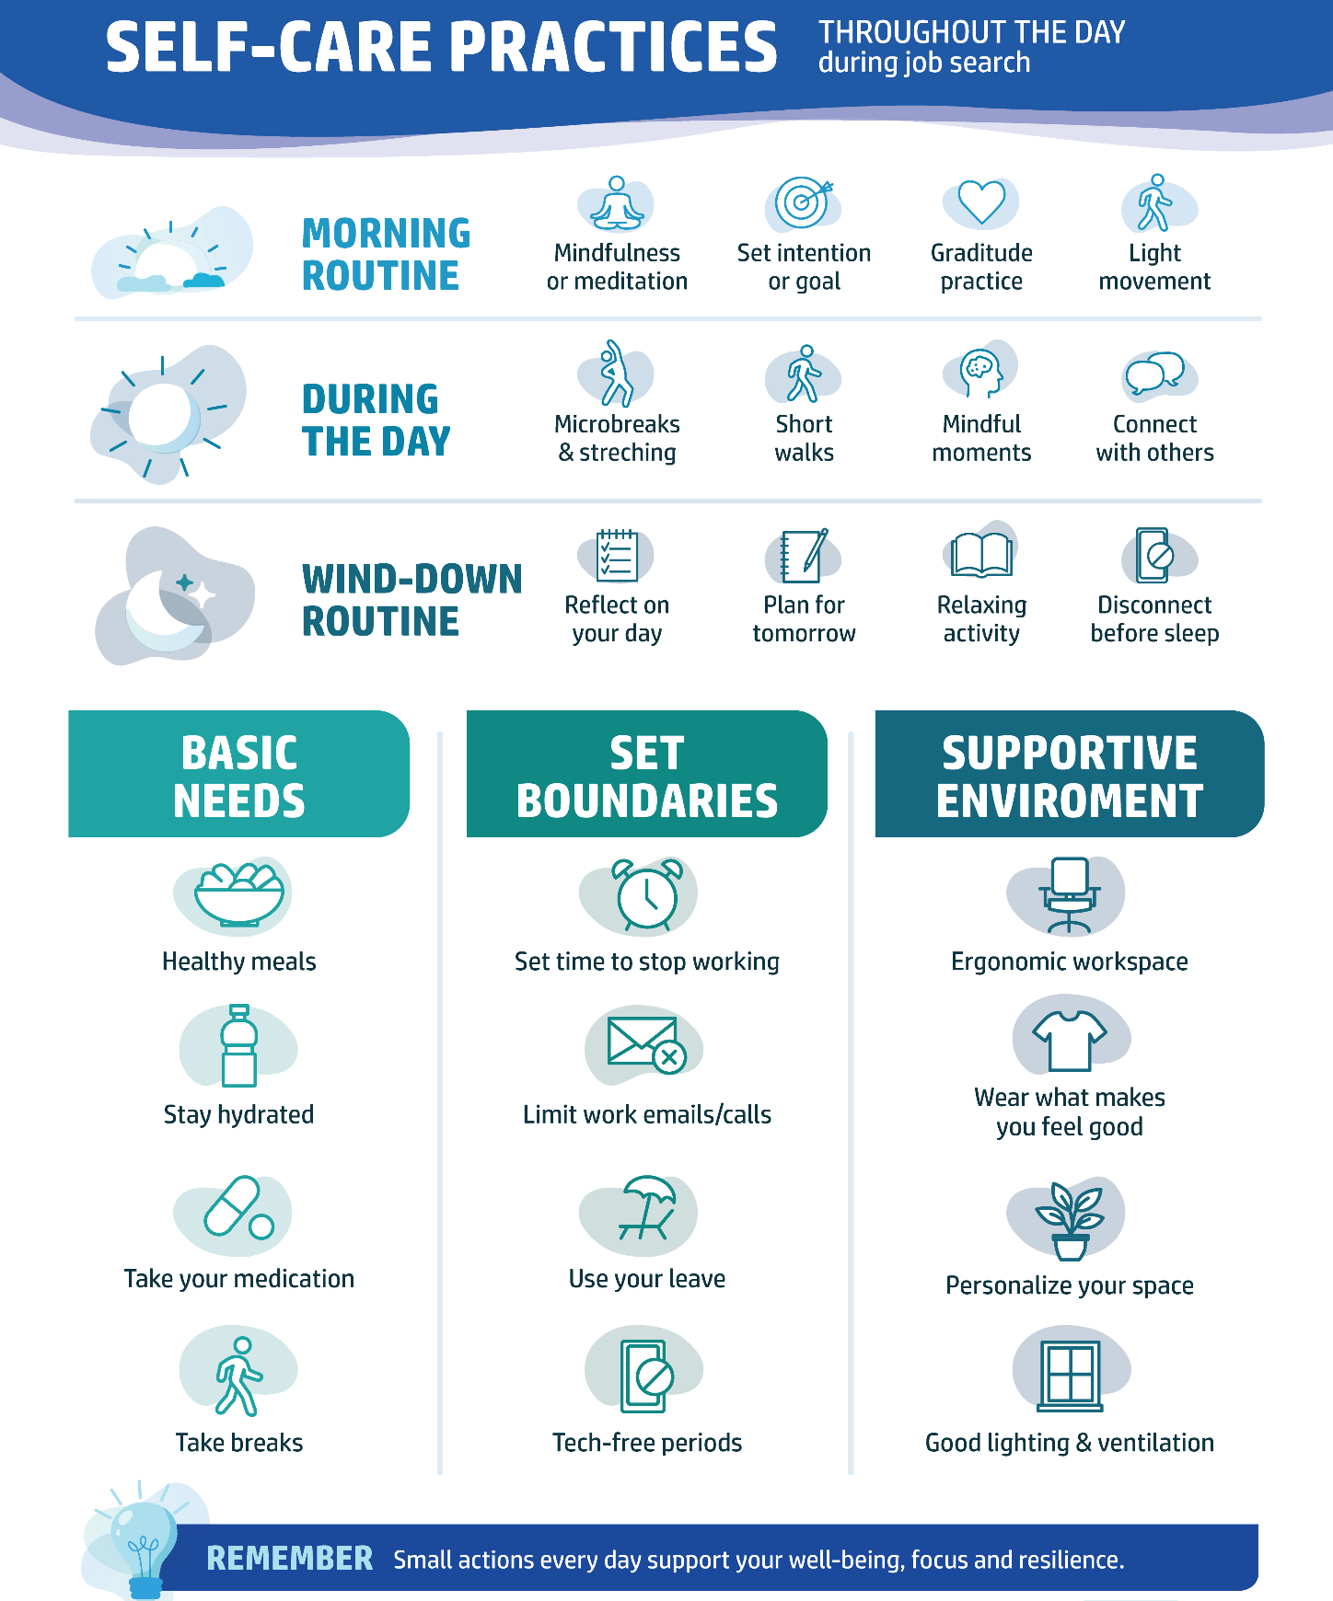

Start the Day Mindfully
A positive morning routine can help establish focus and emotional balance for the day ahead.
Incorporate Regular Microbreaks
Short breaks throughout the day can help reduce mental fatigue, improve concentration, and support physical well-being. Engage in a short non-work-related conversation with a colleague, mentor, family member, or friend.
Prioritise Basic Needs
When individuals become highly focused on job searching or work-related tasks, they may unintentionally neglect their basic needs. However, maintaining these needs is essential for sustained performance and well-being.
Establish Healthy Boundaries
Maintaining clear boundaries between work and personal life is an important aspect of self-care. Without boundaries, individuals may find themselves working excessively, remaining constantly connected to technology, or struggling to disengage from work-related concerns.
Creating a Supportive Environment
A comfortable and organised environment can positively influence well-being, motivation, and productivity. Whether working from home, in an office, or engaging in job-search activities, individuals should consider how their surroundings support their needs.
End the Day with a Wind-Down Routine
Establishing an evening routine can help individuals transition from work-related activities to rest and recovery. This can improve sleep quality and support long-term well-being.
Regular self-care practices do not need to be time-consuming or complex. Small, consistent actions can significantly improve well-being, resilience, and the ability to cope with the challenges associated with job searching and employment.
Reflection Activity
Assess Your Current Self-Care Practices
Reflect on your daily routine and consider the following questions:
- Which self-care practices do you currently use regularly?
- Which areas of self-care (physical, emotional, social, or professional) receive the least attention?
- What are the main barriers that prevent you from practising self-care consistently?
- Identify one self-care habit you would like to strengthen during the next week and describe how you will implement it.

3. Managing Job Search Stress and Interview Anxiety

3. a. Common Sources of Job Search Stress
Job searching is often viewed as a practical process involving the preparation of application documents, finding suitable vacancies, and participation in interviews. However, it is also an emotional experience that can significantly affect an individual's well-being.
Stress during the job-search process is common and can arise at different stages, from preparing application materials and waiting for employer responses to attending interviews and coping with uncertainty about the future. For individuals experiencing unemployment, these challenges may be intensified by financial concerns, family responsibilities,or pressure to find a job quickly.
The experience of job-search stress is highly individual. Aspects like personal circumstances, money situation, work experience, support, and goals can change how stress is felt and managed. Also, repeated rejections, little feedback from employers, or a long time without a job can lower self-confidence, motivation, and emotional well-being.
Recognising potential sources of stress is an important first step towards managing them effectively. Understanding these challenges can help individuals develop coping strategies, maintain motivation, and protect their overall well-being throughout the job-search process.
The figure below presents some of the most common stressors experienced by job seekers.

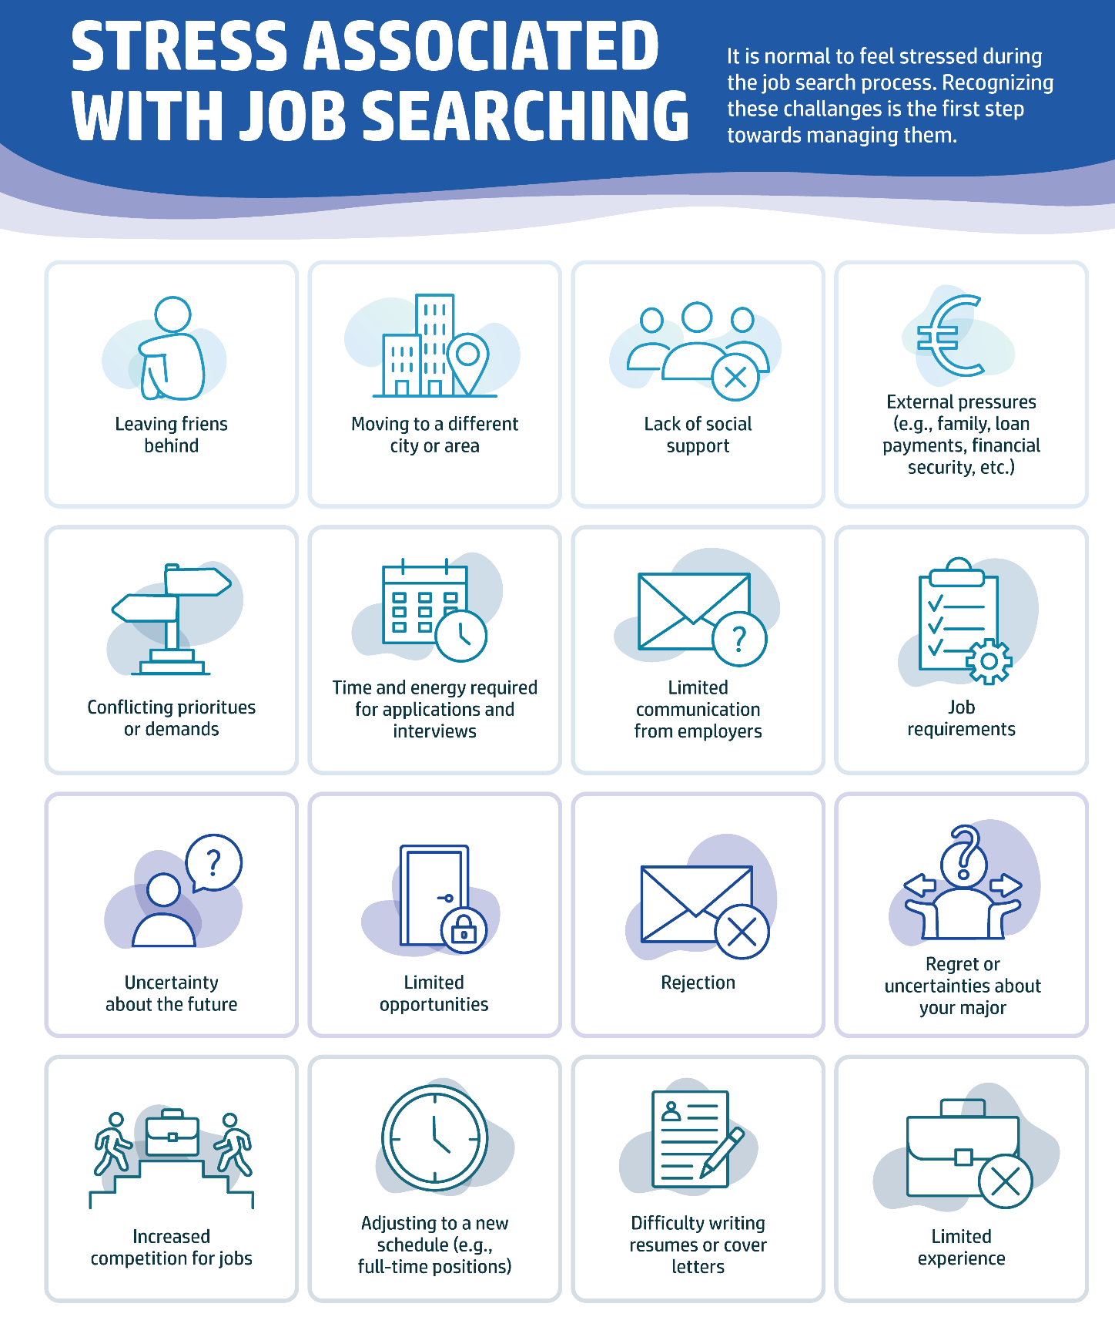
While these stressors are common, one of the most significant sources of anxiety for many job seekers is the job interview itself.

3. b. Understanding Interview Anxiety
While the entire job search process is frequently a source of stress and uncertainty, job seekers often experience a specific form of pressure when moving from applications to the final stages of recruitment. For many, a job interview is both an exciting and stressful experience. After spending time searching for vacancies and submitting applications, an interview is an important opportunity to move forward. At the same time, it can trigger anxiety, self-doubt, and worries about performance.
Interview anxiety is a normal response to situations involving evaluation and uncertainty. Most people do not attend job interviews regularly, which makes them unfamiliar and potentially intimidating experiences. Common concerns include fear of saying the wrong thing, making a poor impression, forgetting important information, or being judged by the interviewer.
Three common causes of interview anxiety include:
- Fear of the unknown – uncertainty about the interview process, questions, or expectations;
- Pressure to perform – concerns about demonstrating competence and making a positive impression;
- Self-doubt – questioning one's qualifications, skills, or suitability for the role.
Interview anxiety may manifest through physical, cognitive, and behavioural symptoms. Individuals may experience a racing heartbeat, sweating, dry mouth, muscle tension, or difficulty concentrating. Some may speak too quickly, avoid eye contact, or struggle to organise their thoughts.
It is important to remember that a moderate level of anxiety is normal and does not prevent a person from performing well. Understanding and managing anxiety can help job seekers approach interviews with greater confidence and resilience.
3. c. Coping Strategies for Interview Anxiety
Although interview anxiety cannot always be eliminated, it can be managed effectively through preparation and self-care.
Some helpful strategies include:
- Prepare in advance by researching the employer and practising common interview questions.
- Use relaxation techniques, such as deep breathing or mindfulness exercises, before and during the interview.
- Challenge negative thoughts and focus on your skills, achievements, and previous successes.
- Plan by organising transportation, testing technology for online interviews, and arriving on time.
- Maintain positive body language, including good posture and appropriate eye contact.
- Be authentic and remember that interviewers understand that candidates may feel nervous.
- Practice self-compassion after the interview by focusing on what you learned rather than only on perceived mistakes.
Interview skills improve with experience. Every interview provides an opportunity to learn, develop confidence, and strengthen communication skills for future employment opportunities.
Practical Exercise
Create Your Personal Interview Preparation Plan
- Identify three actions you will take before your next interview, two techniques you will use to manage anxiety, and one self-care activity you will do afterwards.
- Reflect on how these steps can help you feel more confident and prepared.
- Which way of doing this do you think would help you feel calmer? Why?

4. Building Resilience and Coping with Rejection
Job rejection is one of the most challenging parts of the job-search process. While some individuals may secure employment quickly, most job seekers will experience rejection, receive no response to applications, or face multiple unsuccessful interviews before finding a suitable opportunity.
Although rejection can feel personal, it is important to remember that it is a common and often unavoidable part of the employment journey. Learning how to cope with setbacks, maintain motivation, and keep moving forward is an essential skill for long-term career development.

4.1. Understanding Rejection
Receiving a rejection can be disappointing, particularly when significant time and effort have been invested in preparing an application or attending an interview. However, rejection does not necessarily reflect an individual's abilities, potential, or professional value.
Employers make hiring decisions based on many factors, including organisational needs, team fit, timing, available resources, and the qualifications of other candidates. As a result, even highly qualified applicants may not be selected for a particular role.
Understanding that rejection is a normal part of the job-search process can help individuals manage expectations and maintain a balanced perspective. Instead of viewing rejection as a personal failure, it can be seen as part of finding the right opportunity.

4.2. Emotional Impact of Rejection
Job rejection can affect both emotional well-being and self-confidence. Common reactions include disappointment, frustration, sadness, anxiety, self-doubt, and reduced motivation. Repeated rejections or prolonged periods without employment may intensify these feelings and make it more difficult to remain optimistic.
In some cases, individuals may experience reactions like the stages of grief, including denial, frustration, sadness, and eventual acceptance. These responses are normal and reflect the importance people place on employment, financial security, and personal achievement.
While negative emotions are a natural response to rejection, developing emotional resilience can help individuals recover more quickly and continue pursuing their goals. Resilience is the ability to adapt to challenges, learn from setbacks, and maintain hope during difficult periods.
It can be helpful to remember that every unsuccessful application brings valuable experience and may move an individual closer to a suitable opportunity.

4.3. Building Resilience
Resilience is not a fixed trait; it is a skill that can be developed through practice and experience. The following strategies can help people cope with rejection and stay motivated during the job search.
Acknowledge and Manage Emotions
Allow yourself time to recognise and process emotions following a rejection. Feelings of disappointment or frustration are normal and should not be ignored. Speaking with trusted friends, family members, mentors, or support workers can help provide perspective and emotional support.
Developing a Growth Mindset
Rather than viewing rejection as evidence of failure, try to view it as an opportunity to learn and improve. Ask yourself:
- What can I learn from this experience?
- What aspects were within my control?
- What can I do next time?
A growth mindset encourages continuous learning and helps reduce the tendency to personalise setbacks.
Reflect and Improve
Rejection can provide an opportunity to review and strengthen job-search strategies. Consider whether improvements could be made to your CV, cover letter, interview preparation, or job-search approach. Small adjustments can increase confidence and improve future outcomes.
Maintain Supportive Relationships
Staying connected with supportive people can help reduce feelings of isolation and maintain motivation. Friends, family, mentors, career advisers, and support groups can offer encouragement, practical advice, and emotional reassurance.
Maintain Healthy Routines
A structured daily routine supports both mental and physical well-being. Regular sleep, healthy nutrition, physical activity, hydration, and time for rest can improve resilience and help individuals cope more effectively with stress.
Focus on What You Can Control
Not every aspect of the recruitment process is within your control. While you cannot control employer decisions, you can control the quality of your applications, your preparation, your effort, and your self-care practice. Focusing on controllable factors can reduce stress and increase feelings of empowerment.
Most importantly, remember that finding employment is often a process that requires persistence, patience, and flexibility. Many successful professionals experienced numerous rejections before finding opportunities that matched their skills and aspirations.
Reflection Exercise: Learning from Setbacks
Reflect on a setback, rejection, or challenge you have experienced during your job search.
- What happened?
- What did you learn from the experience?
- What strengths helped you cope with the situation?
- How can this experience support your future job-search activities?
Key Takeaway
Identify one lesson you learned from this experience and one action you will apply in the future.

5. Inclusive Workplaces and Self-Advocacy
An inclusive workplace is an environment where all individuals, regardless of their age, ethnicity, race, religion, gender, sexual orientation, disability, or other personal characteristics, are respected, valued, and given equal opportunities to participate and succeed. In today's fast-changing labour market, workplace inclusion is not only a matter of social responsibility but also an important factor for employee well-being, innovation, company performance, and long-term success.
For many people, especially those from underrepresented groups or people with disabilities, inclusion means more than just being present in the workplace. It requires access to opportunities, proper support, meaningful participation, and the ability to contribute fully to work life. Creating inclusive workplaces is therefore a shared responsibility between employers, managers, and employees.

5.1. What Makes a Workplace Inclusive?
An inclusive workplace is built on respect, fairness, and belonging. Employees feel safe sharing their views and skills without fear of discrimination or prejudice. Diversity is valued, and different perspectives contribute to company success.
Inclusion should be part of the entire employment cycle, from recruitment and onboarding to career development and daily interactions. Organisations that promote inclusion attract and retain diverse talent while boosting employee engagement.
A key step toward an inclusive workplace is ensuring fair and accessible recruitment. Job ads, selection criteria, and procedures should encourage diverse applications. Unnecessary restrictions or biased language can discourage qualified candidates and create barriers.
Accessibility is also essential. This includes physical accessibility, such as accessible spaces and facilities, and digital accessibility, meaning tools and technologies that can be used by individuals with different abilities and support needs.
Inclusive organisations also recognise the importance of psychological safety and trust. Employees are more likely to contribute fully when they feel respected, heard, and supported. Creating opportunities for open dialogue and providing safe spaces for discussion can encourage individuals to express concerns, share ideas, and seek support without fear of negative consequences. Building trust requires consistent actions, respectful communication, and a commitment to ensuring that all employees feel valued and included.
The figure below summarises key areas that contribute to an inclusive workplace across the employment cycle, from recruitment and onboarding to workplace culture, accessibility, professional development, and employee well-being.
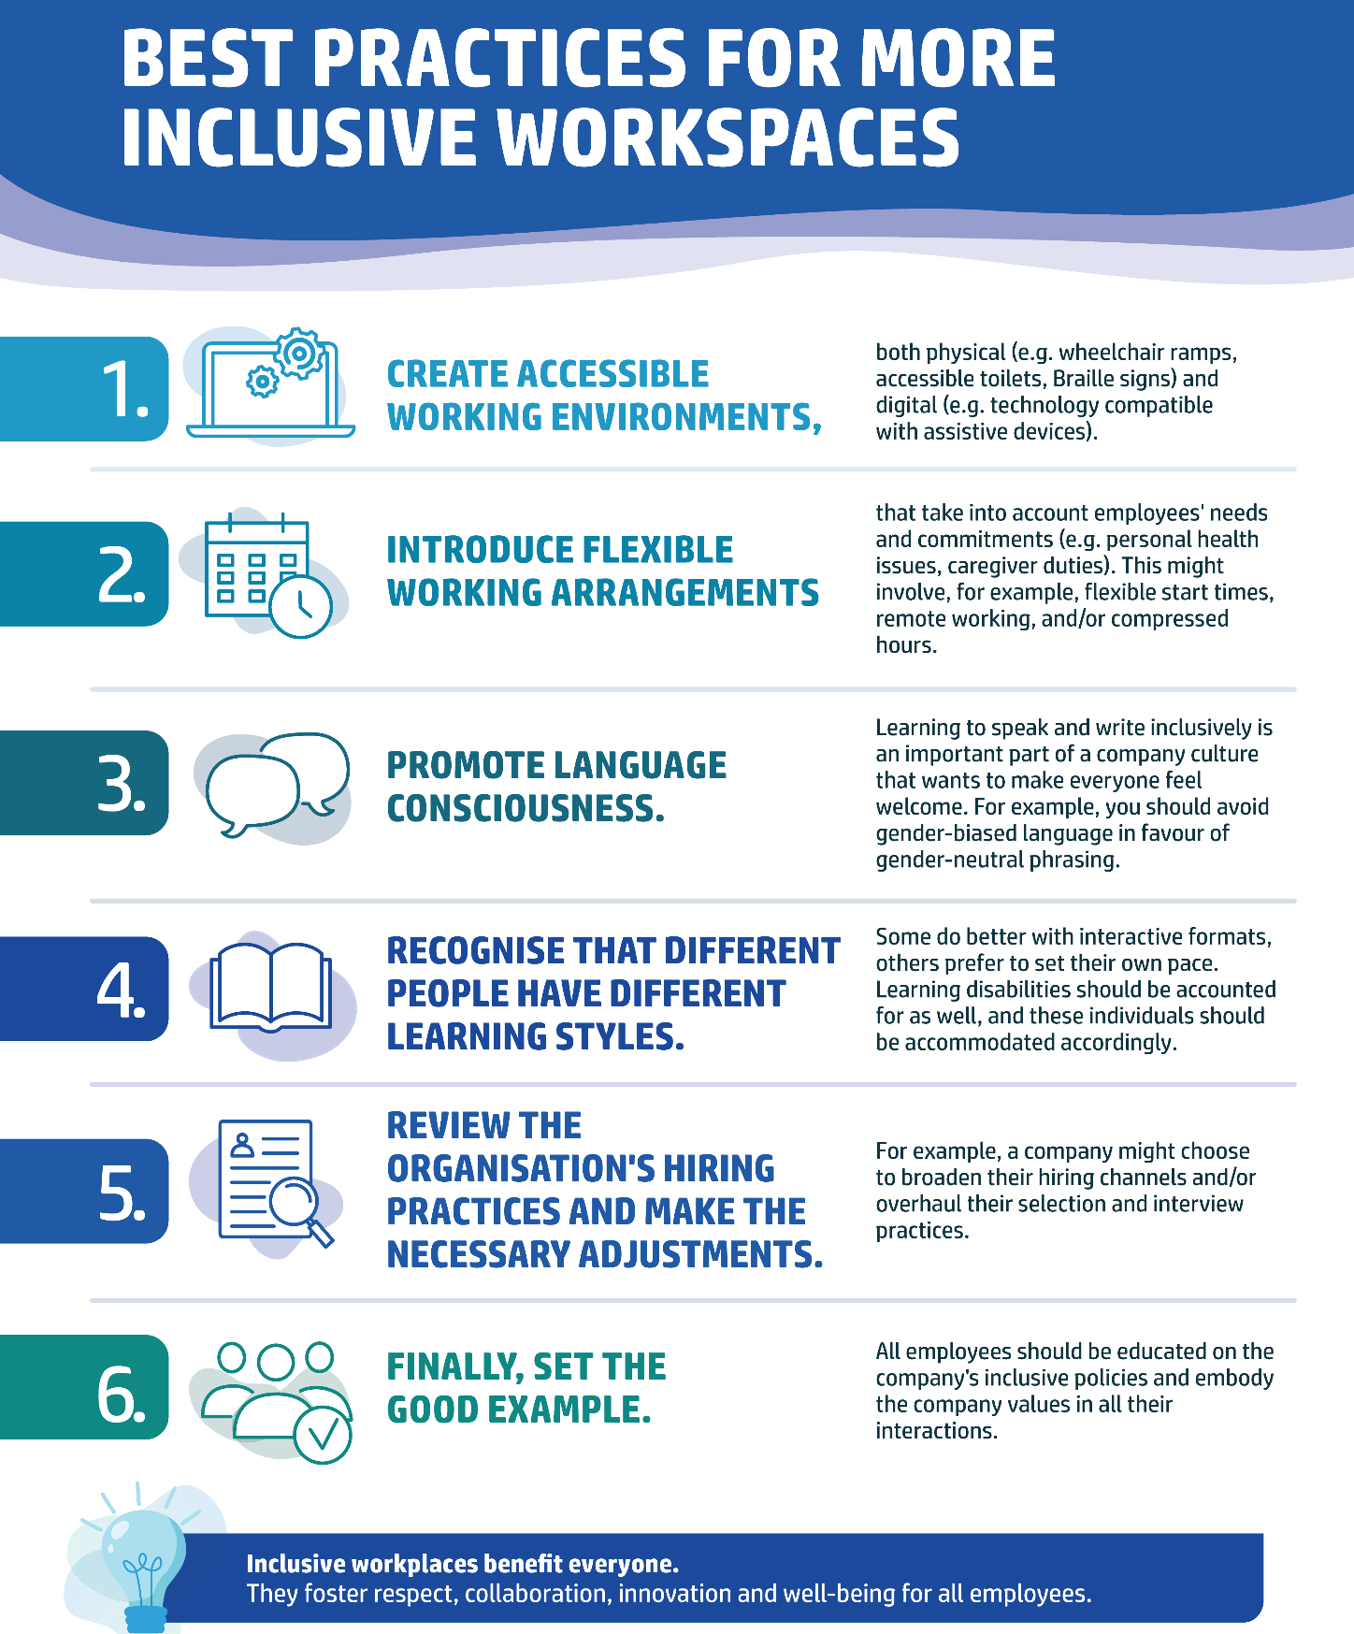
The practices above show that inclusion is not achieved through a single policy. Instead, it requires ongoing effort to create an environment where all employees feel respected, supported, and able to contribute fully. While employers play a key role in removing barriers and equal opportunities, employees also have an important part in sharing their needs, preferences, and goals.
For many people, especially those from underrepresented groups or with disabilities, active workplace participation may involve asking for support, seeking reasonable accommodation, sharing feedback, or raising concerns. This process is known as self-advocacy.

5.2. Self-Advocacy Skills
Self-advocacy is the ability to communicate your needs, rights, opinions, and goals clearly, respectfully, and confidently. It is a key skill that enables individuals to take part in workplace decisions, get proper support, and contribute fully.
In practice, self-advocacy may involve asking for task clarification, seeking feedback, discussing career growth, requesting reasonable accommodations, or sharing ideas and concerns. It is not about demanding special treatment; rather, it is about knowing your strengths and communicating your needs constructively.
Self-advocacy is especially important in inclusive workplaces where individuals are encouraged to share perspectives and join in decision-making. Individuals who advocate for themselves are better equipped to overcome barriers and achieve their professional goals.
When looking at a potential employer, it helps to check if the organisation truly promotes inclusion and accessibility. The following questions can be useful during recruitment or when evaluating a workplace:
- Is the workplace physically accessible?
- Does the organisation demonstrate a commitment to diversity, inclusion, and accessibility?
- Are employees encouraged to discuss and request workplace adjustments when needed?
- Can all employees participate fully in training, meetings, and workplace events?
- Does the organisation use respectful and inclusive language?
- Are there equal opportunities for professional development and career progression?
Self-advocacy remains important after securing employment. Workplace challenges, misunderstandings, and changing circumstances may arise, making it necessary to communicate needs, seek support, and establish healthy professional boundaries.
Practising self-advocacy can help individuals:
- communicate their needs and expectations effectively;
- establish healthy boundaries and reduce the risk of burnout;
- obtain feedback that supports learning and professional growth;
- ensure that their ideas and contributions are recognised;
- participate actively in shaping their career development.
Ultimately, self-advocacy is based on the understanding that every employee's voice, needs, and contributions matter. Developing this skill can increase confidence, support workplace inclusion, and contribute to long-term professional success.
The figure below presents five practical strategies for strengthening self-advocacy skills in the workplace.
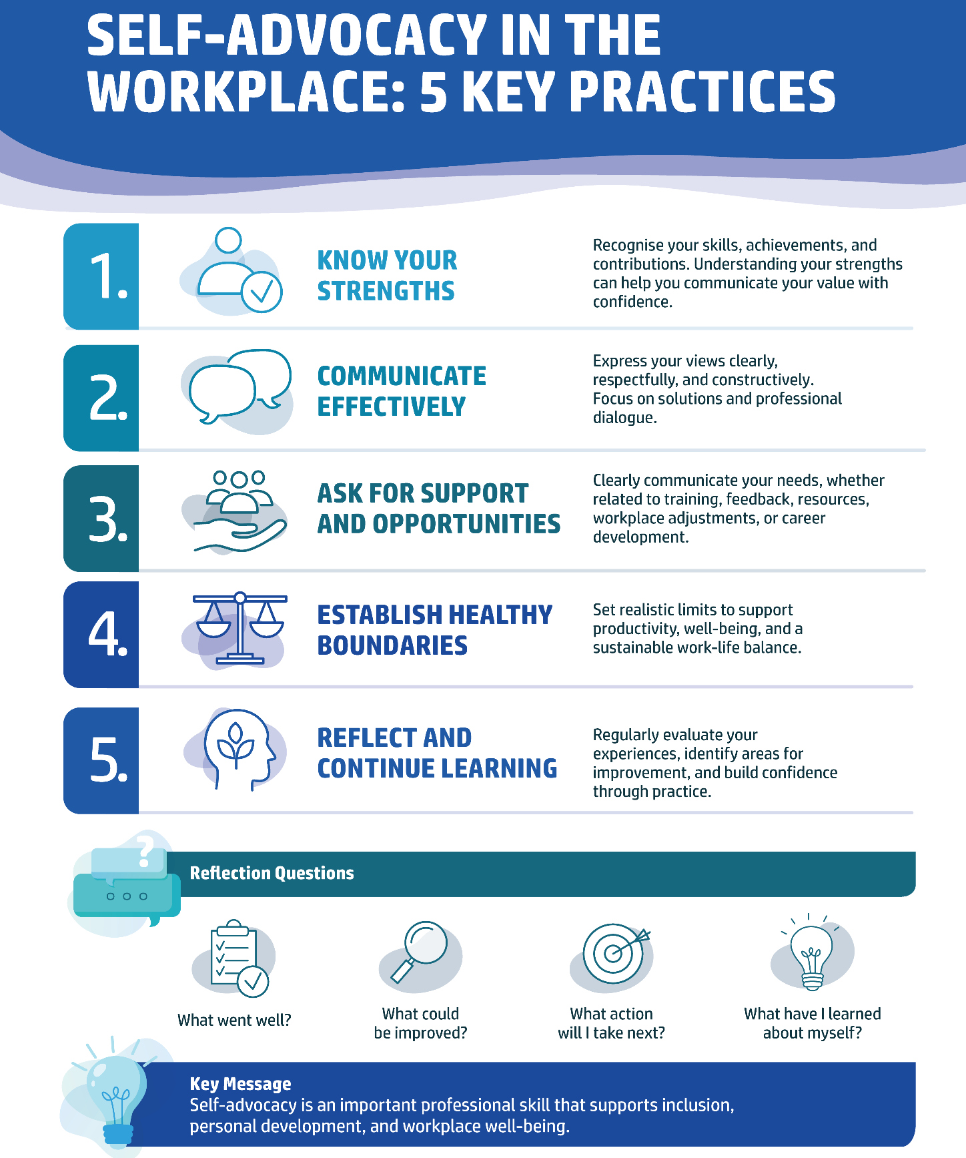

5.3. Respectful Workplace Behaviour
Creating an inclusive workplace requires commitment from both employers and employees. While organisations are responsible for establishing policies, procedures, and support systems that promote inclusion, every employee contributes to the workplace culture through their daily behaviour and interactions.
People spend a significant proportion of their lives at work. For this reason, workplaces should be environments where individuals feel safe, respected, and able to contribute fully. Every employee has the right to work in an environment free from bullying, harassment, discrimination, and other forms of inappropriate behaviour. At the same time, all employees share a responsibility to ensure that their actions contribute to a positive and respectful workplace culture.
Respectful workplace behaviour involves treating colleagues, managers, clients, and other stakeholders with courtesy, fairness, and consideration, regardless of their role, background, personal characteristics, or abilities. It also involves recognising the value of diversity and appreciating the different experiences, perspectives, skills, and strengths that individuals bring to the workplace.
A respectful workplace culture supports employee well-being, collaboration, and inclusion. Research consistently shows that respectful working environments can improve job satisfaction, strengthen teamwork, reduce workplace conflict, and contribute to higher levels of productivity and engagement.
Respect is demonstrated not only through major actions but also through everyday interactions. The way we communicate, listen, provide feedback, respond to differences of opinion, and interact with others sends important signals about how much we value and respect those around us.
The figure below highlights key behaviours that help individuals demonstrate respect in their daily workplace interactions.

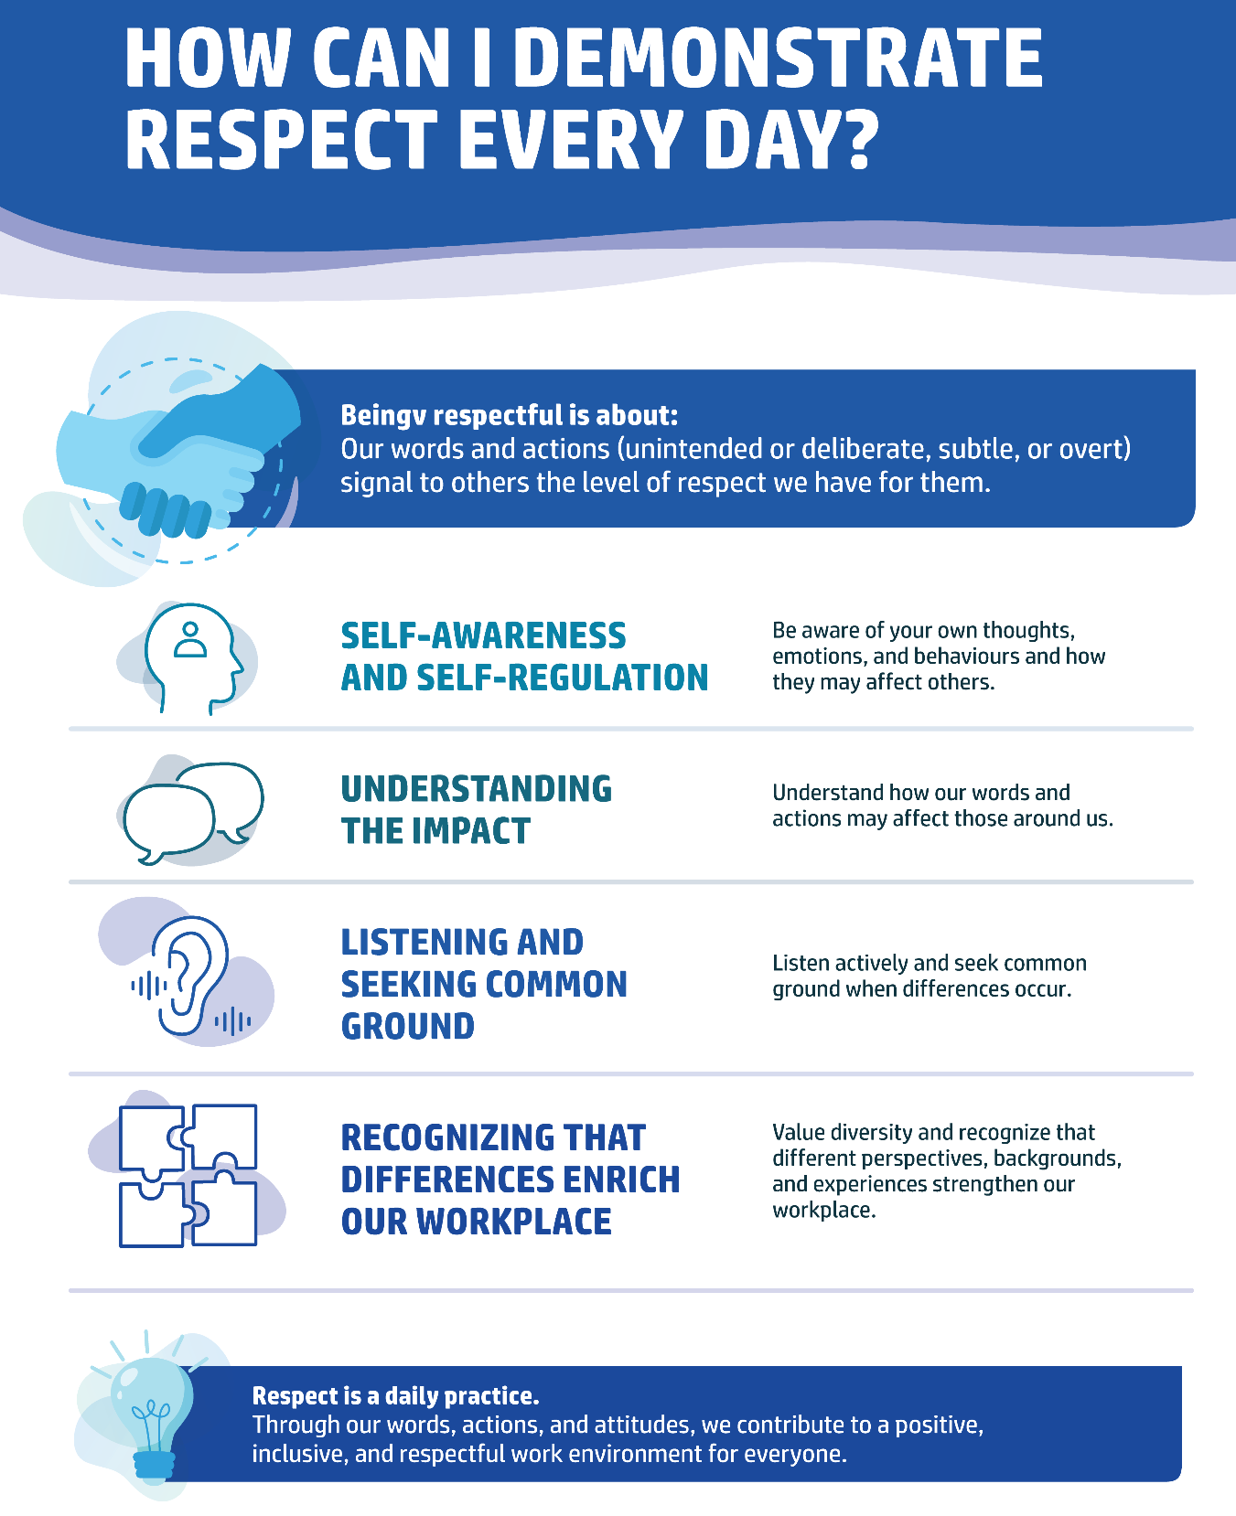

Respectful behaviour is a foundation of inclusive workplace culture. By demonstrating self-awareness, communicating thoughtfully, listening to others, and valuing diversity, employees contribute to a workplace where everyone feels respected, supported, and able to succeed.
Scenario Activity: Requesting Workplace Adjustments
You have started a new job and realise that some aspects of the work environment make it difficult for you to perform your tasks effectively. You would benefit from a small workplace adjustment, but you are unsure how to raise the issue.
Task: Prepare a respectful conversation with your supervisor explaining:
- what challenge you are experiencing;
- what adjustment would help;
- how the adjustment would support your work performance.

6. Rights, Responsibilities and Zero-Tolerance Principles
Knowing your rights and responsibilities is an important part of self-care at work. A safe, respectful, and inclusive workplace lets individuals focus on their work, growth, and well-being instead of coping with fear, discrimination, or barriers.
Employees, especially persons with disabilities and underrepresented groups, may face unfair treatment, inaccessible conditions, bullying, harassment, or discrimination. Understanding your rights and policies empowers individuals to spot inappropriate behaviour, seek support, and take action when needed.
Building a respectful workplace is a shared responsibility. Employers must provide a safe environment, while employees contribute to a culture of dignity and equality. If you are not comfortable raising a concern alone, consider seeking support from a trusted colleague, mentor, representative, or another support person.

6.1. Employee Rights
Every employee has fundamental rights protected by national legislation, international labour standards, and, within the European Union, EU employment and equality legislation. Although specific legal provisions vary between countries, the underlying principles remain consistent: employees have the right to fair treatment, safe working conditions, equal opportunities, and respect for their dignity.
These rights apply throughout the entire employment journey - from recruitment and hiring to everyday work, professional development, and termination of employment.
Key employee rights include:
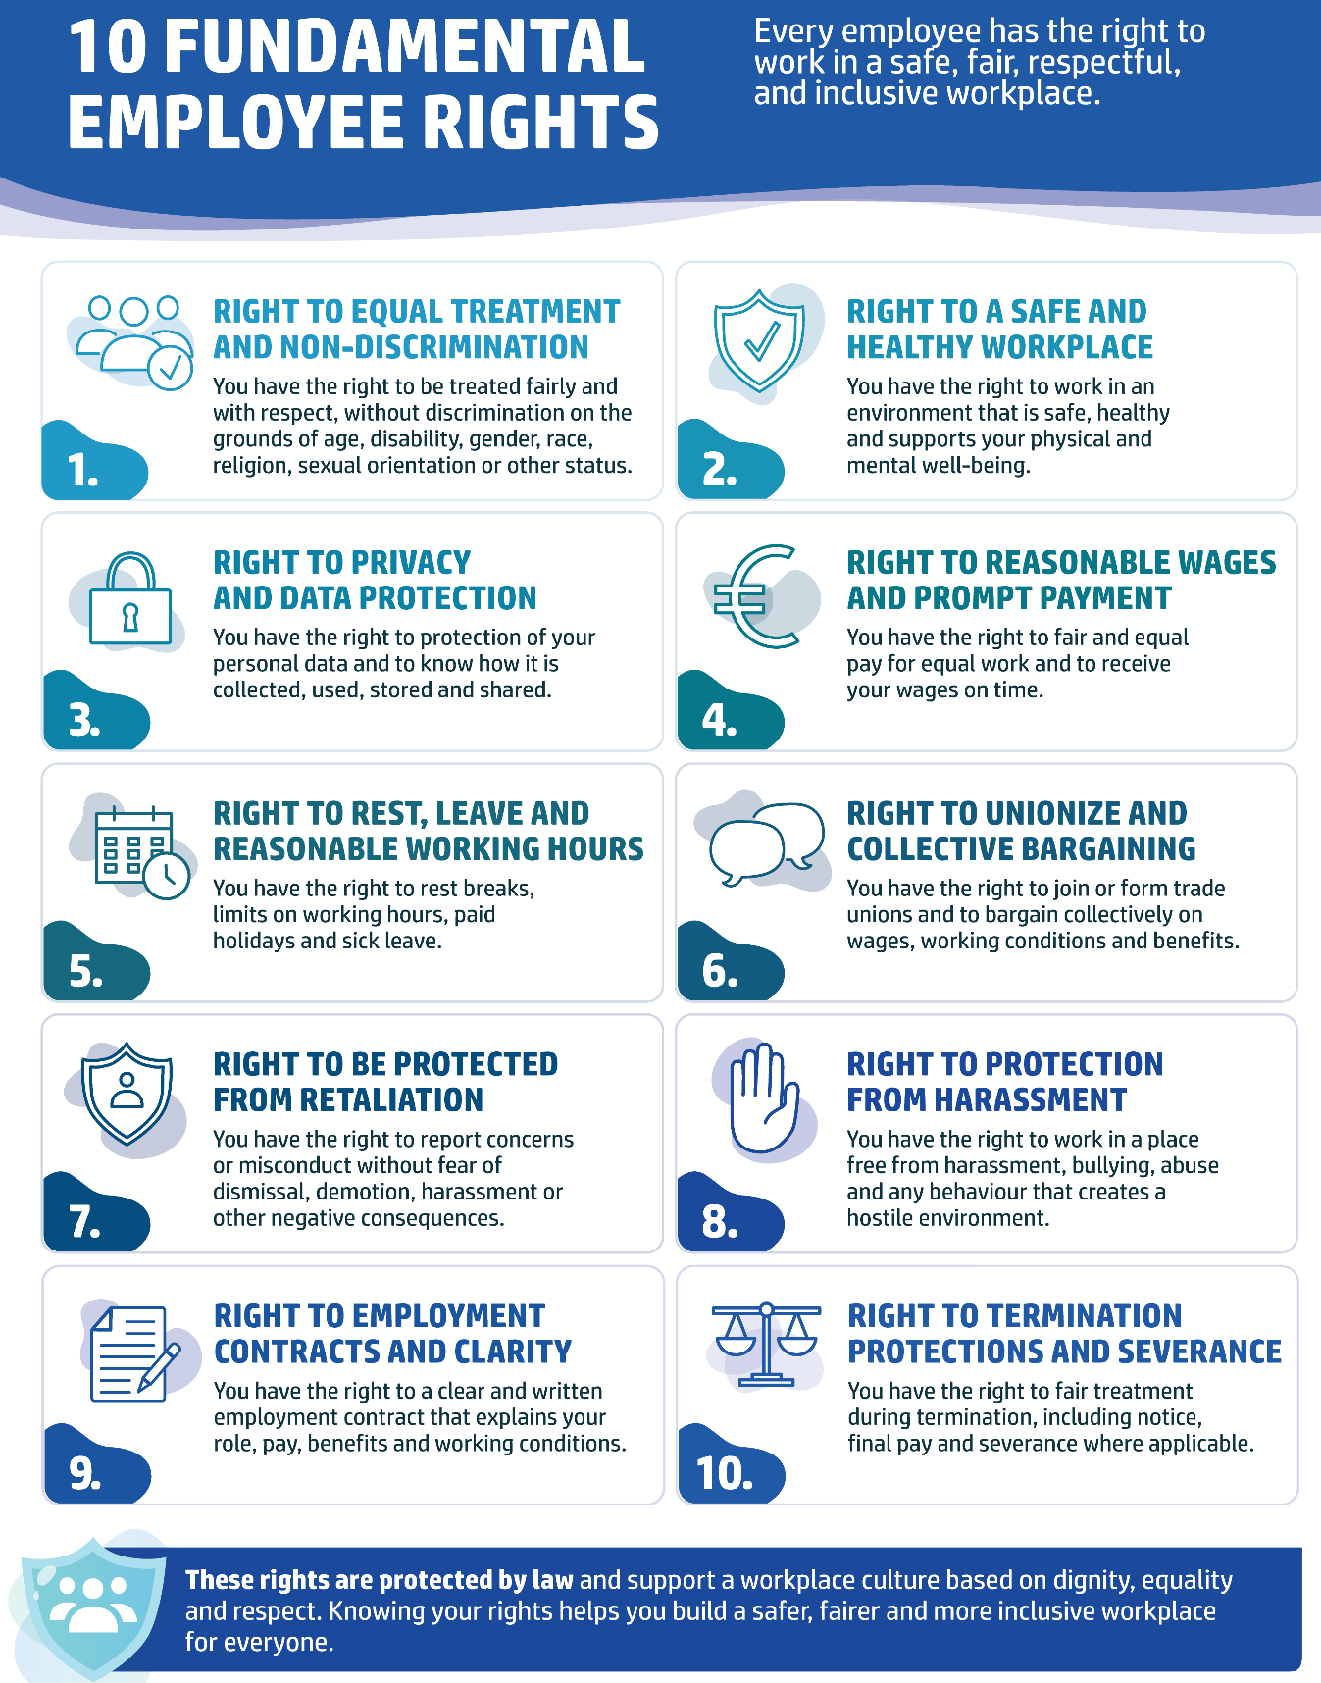

Understanding these rights enables employees to recognise inappropriate practices, protect themselves from unfair treatment, and contribute to a workplace culture built on equality, respect, and inclusion.
With this knowledge, you are better equipped to recognise and challenge workplace discrimination, ensuring a fair and environment for yourself and your colleagues. Remember, knowing your rights is not just about protecting yourself; it's about fostering a workplace culture that values justice, respect, and equality for everyone.

6.2. Employer Responsibilities
Creating a healthy and inclusive workplace is primarily the employer's responsibility. Employers are required to provide a working environment that protects the physical and mental health, safety, and well-being of employees.
An inclusive workplace benefits everyone—not only employees with disabilities or other support needs. Accessible environments, respectful communication, and fair practices improve employee well-being, engagement, and company performance.
Employers should ensure that the workplace provides:
- a safe, healthy, and accessible working environment;
- reasonable workplace adjustments where required;
- clear workplace policies and reporting procedures;
- equal opportunities for recruitment, training, and career development;
- protection from discrimination, harassment, bullying, and retaliation;
- appropriate training on health, safety, diversity, and inclusion.

6.3. Harassment, Abuse and Discrimination
Every employee has the right to work in an environment free from harassment, abuse, and discrimination. These behaviours undermine dignity, damage well-being, and may violate both organisational policies and legal requirements. Although these terms are closely related and may overlap, they describe different forms of inappropriate behaviour.
These behaviours may occur in any work-related setting, including:
- the workplace;
- business trips;
- client or customer premises;
- work-related meetings and social events;
- online communication, including emails, messaging platforms, and social media.
All forms of harassment, abuse, and discrimination should be reported and addressed promptly in accordance with organisational policies.

6.4. Reporting Procedures
Experiencing or witnessing inappropriate behaviour can be distressing. Reporting concerns promptly helps protect both the affected individual and the wider workplace community.
If you experience or witness harassment, abuse, or discrimination:
1. Record the incident. Keep accurate notes, including dates, times, locations, people involved, and any available evidence such as emails, messages, or photographs.
2. Report the concern. Follow your organisation's reporting procedures. Depending on the workplace, this may involve your manager, Human Resources department, a designated safeguarding officer, employee representative, trade union representative, or an anonymous whistleblowing channel.
3. Seek support. Speak to a trusted colleague, mentor, employee assistance service, healthcare professional, or another appropriate support person.
4. Escalate if necessary. If the issue is not resolved internally or involves serious misconduct, seek advice from the relevant external authority, labour inspectorate, equality body, trade union, or legal adviser, in accordance with national legislation.
Reporting inappropriate behaviour is not only about protecting your own rights - but it also contributes to creating a safer, healthier, and more inclusive workplace for everyone.
Practical Exercise: Responding to Workplace Situations
Read the situations below. For each one:
- Identify the type of behaviour.
- Explain why it is inappropriate.
- Describe one respectful action the employee could take.
- Identify one person or service that could provide support.

Situation | Behaviour | Your response
A colleague repeatedly makes offensive jokes about another employee.
Your manager ignores your request for reasonable workplace adjustments.
A client sends abusive messages after a meeting.
You witness a colleague being excluded because of their age.

Reflection
Which of these situations have you encountered, witnessed, or heard about?
What would help create a more respectful and inclusive workplace?

7. Managing Workplace Pressure, Stress and Work–Life Balance

7.1. Understanding Workplace Stress
Experiencing some work pressure is normal and can be motivating. Moderate pressure may improve focus, productivity, and performance. However, when demands consistently exceed a person's ability or resources to cope, pressure turns into workplace stress.
Work-related stress is a common occupational health challenge worldwide. It affects employees across all sectors and can arise from organisational changes, heavy workloads, unclear expectations, interpersonal conflicts, job insecurity, or poor work-life balance. For employees with disabilities or health conditions, inaccessible workplaces or inadequate accommodations may create extra stress.
While stress is not a medical condition, prolonged exposure can severely impact physical and mental health. If unmanaged, workplace stress may contribute to:
- burnout (physical and emotional exhaustion);
- anxiety and depression;
- sleep disturbances;
- headaches and other physical symptoms;
- reduced concentration and productivity;
- increased risk of long-term health conditions, including cardiovascular disease.
Work-related stress often extends beyond working hours. Without effective recovery and healthy coping strategies, its effects may influence family life, relationships, sleep quality, and overall well-being.
The diagram below presents some of the most common workplace stressors.
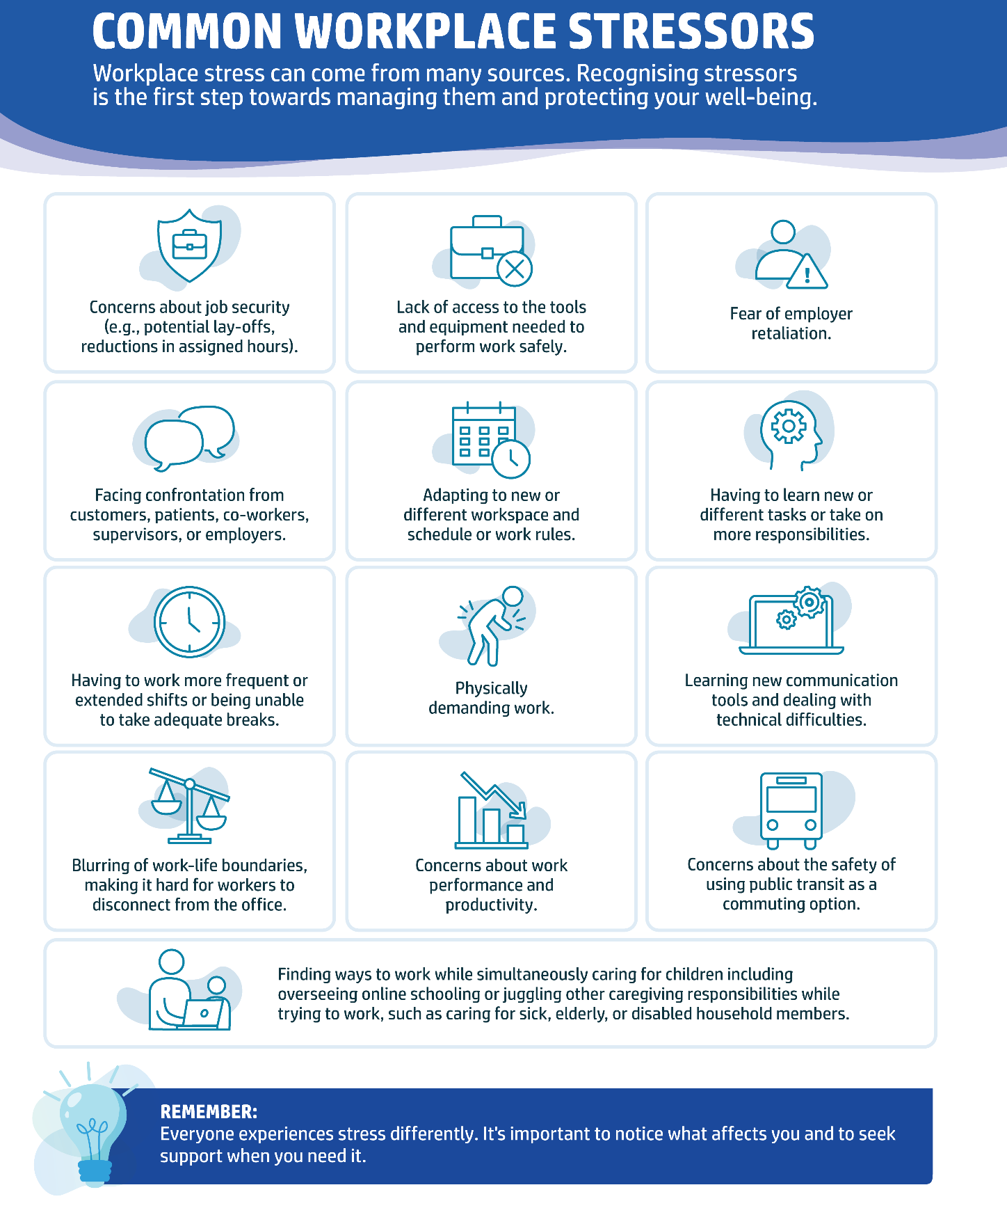

7.2. Practical Strategies for Managing Workplace Stress
Although workplace stress cannot always be avoided, individuals can develop practical strategies to reduce its impact and maintain well-being.
One of the first steps is identifying personal stressors. Understanding which situations, tasks, or conditions create the greatest pressure makes it easier to create an individual Wellness Action Plan. Such a plan may include better time management, realistic goal setting, regular breaks, healthy boundaries, and strategies for maintaining work-life balance.

Other helpful strategies include:
- practising mindfulness, breathing exercises, or short relaxation techniques;
- taking regular breaks throughout the working day and using annual leave for recovery;
- discussing workload concerns with a manager or supervisor before they become overwhelming;
- organising tasks according to priority rather than trying to multitask constantly;
- incorporating movement into the working day through stretching, short walks, or light exercise;
- seeking support from colleagues, supervisors, or trusted individuals when needed.
Managing workplace stress is not about eliminating all challenges. Rather, it involves developing healthy habits that improve resilience and help maintain long-term physical and mental well-being.

7.3. Maintaining Work–Life Balance
Work-life balance refers to maintaining a healthy relationship between professional responsibilities and personal life. Achieving balance does not mean dividing time equally between work and leisure, but rather making sure work does not constantly interfere with health, relationships, or personal interests.
Setting clear boundaries between work and personal time is one of the most effective ways to prevent chronic stress and burnout. Employees should feel able to disconnect from work outside agreed working hours and prioritise enough time for rest and recovery.
Practical ways to maintain a healthy work–life balance include:
- planning and organising the working week in advance;
- establishing clear working hours and digital boundaries;
- avoiding work-related emails or phone calls outside working hours whenever possible;
- engaging in hobbies and leisure activities unrelated to work;
- spending quality time with family and friends;
- maintaining healthy sleep habits and using digital tools, where appropriate, to monitor sleep quality;
- recognising the early warning signs of stress and burnout and seeking support before symptoms become severe.
Maintaining work–life balance is an ongoing process that requires regular reflection and adjustment as personal and professional circumstances change.
The checklist below summarises simple habits that support a healthy work–life balance.
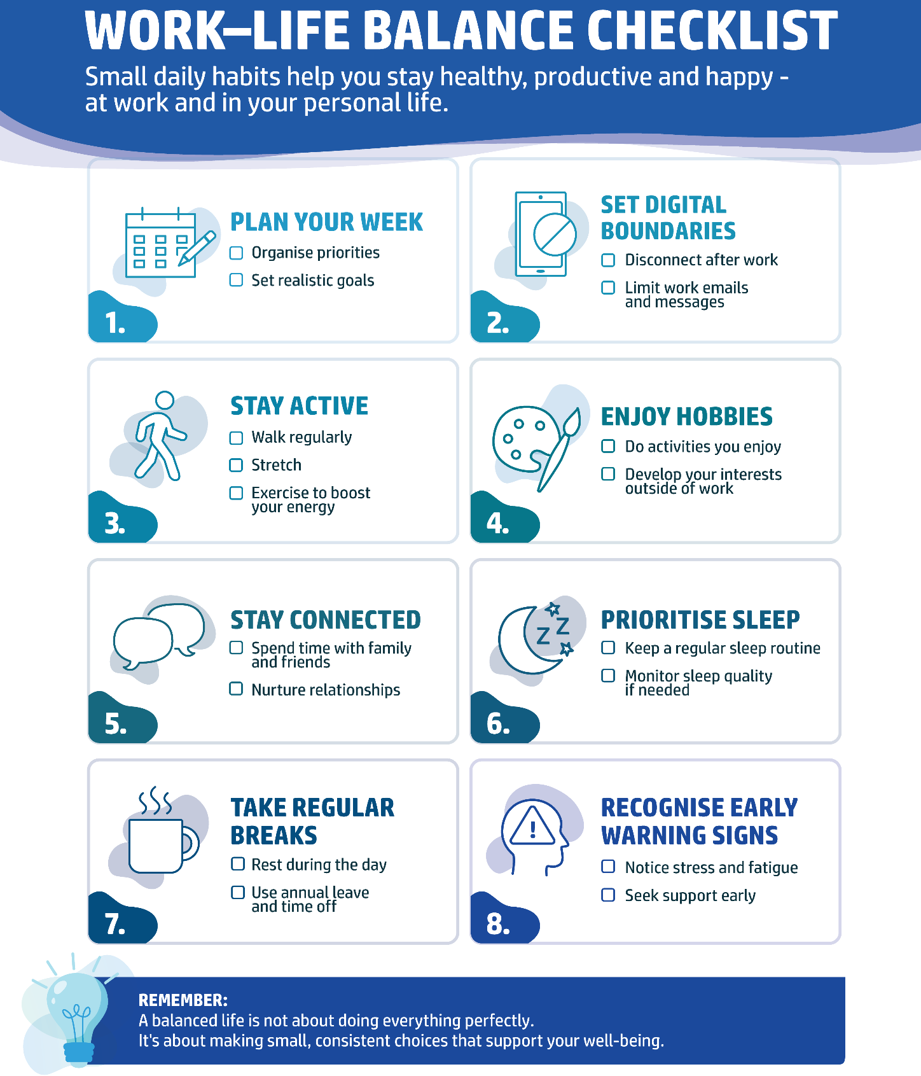
Reflection Exercise
My Work–Life Balance
Reflect on your current work habits.
- Which situations at work create the most stress for you?
- How well do you separate work from your personal life?
- Which healthy habits already support your well-being?
- What is one practical change you could make this week to improve your work–life balance?
Key takeaway
Choose one new habit that you will implement over the next week to protect your well-being at work better.

7.4. How AI Can Support Wellbeing
AI can support everyday well-being in several ways:
- Daily organisation and planning. AI assistants can help create to-do lists, organise schedules, prepare meal plans, and break complex tasks into manageable steps, reducing cognitive overload and improving productivity.
- Health and wellness routines. Smart devices and AI-supported applications can provide reminders for medication, hydration, physical activity, appointments, and sleep routines. Wearable devices may also monitor physical activity, sleep quality, heart rate, and other health indicators that support healthy lifestyle choices.
- Accessibility and independent living. Voice assistants, speech-to-text technology, text-to-speech applications, and AI-supported reading tools can make information and everyday tasks more accessible for people with physical, sensory, or cognitive disabilities.
- Mental well-being. AI-powered wellbeing applications may support mood tracking, mindfulness exercises, stress management techniques, and guided relaxation activities. Some digital assistants also provide evidence-based self-help exercises based on cognitive behavioural therapy (CBT) principles, while encouraging users to seek professional support when needed.
Although AI can be a valuable source of support, it should not replace healthcare professionals or emergency services when specialised care is required.

8. Summary
For many people, especially those with disabilities, managing health and support needs is part of everyday life, but entering the labour market introduces new challenges. Alongside learning how to search for employment and adapt to a new workplace, it is equally important to maintain the self-care routines that support long-term well-being.
Throughout this module, self-care has been presented as an essential professional skill rather than a luxury. Job searching and employment can be demanding, and increased stress often leads people to neglect basic needs like healthy eating, rest, or emotional well-being. Maintaining self-care habits helps individuals protect their health, improve resilience, and sustain long-term employability. Having the support of a trusted person—such as a family member, friend, mentor, or job coach—can also provide valuable encouragement.
Searching for a job, attending interviews, and starting a new role are significant transitions that naturally involve uncertainty and stress. For people with disabilities, these experiences may be further influenced by accessibility barriers or social attitudes. Experiencing stress is a normal response, and the goal is to develop practical strategies to manage it effectively. Similarly, rejection and setbacks are a normal part of career development; developing resilience allows individuals to learn from experience, maintain motivation, and continue progressing.
An important message of this module is that inclusive workplaces benefit everyone. Accessible environments, respectful communication, equal opportunities, flexible arrangements, and supportive cultures create healthier workplaces for all employees—not only for people with disabilities. Furthermore, understanding employee rights, employer responsibilities, and appropriate procedures empowers individuals to advocate for themselves and contribute to a respectful working environment.
Modern technologies and AI can also play an important role in supporting well-being, assisting with organisation, communication, accessibility, and daily routines. At the same time, AI should be viewed as a supportive tool rather than a replacement for personal judgement, critical thinking, or authentic human interaction.
Building upon the core concepts covered in this module, learners are now fully equipped to manage workplace stress effectively, advocate for their own rights, recognise workplace standards, and use AI-based tools responsibly throughout their professional journey.
Final Reflection
Take a moment to reflect on what you have learned throughout this module.
- What is the most important insight you gained?
- Which self-care practice will you begin applying in your daily life?
- How will you maintain your well-being during future job searches or employment experiences?
- Which workplace strategy or AI tool would you like to explore further?
Personal Commitment
Write down one realistic action you will take this week to support your well-being, professional development, or career goals. Small, consistent steps are the foundation of long-term success.

9. Resources
ADECCO. n.d. How to Conquer Interview Anxiety. Available from: https://www.adecco.com/en-gb/resources/how-to-conquer-interview-anxiety
ALTIUS GROUP. n.d. Why Employee Self-Care Should Be Practised in Every Organisation. Available from: https://altius.au/news-and-research/why-employee-self-care-should-be-practised-in-every-organisation
AMERICAN PSYCHOLOGICAL ASSOCIATION (APA). n.d. Healthy Workplaces: Work Stress. Available from: https://www.apa.org/topics/healthy-workplaces/work-stress
AT WORK AUSTRALIA. n.d. Guide to Inclusive Work Practices: Tips for Employers. Available from: https://www.atworkaustralia.com.au/guide-to-inclusive-work-practices-tips-for-employers/
AUSTRALIAN PUBLIC SERVICE COMMISSION. 2022. Diversity and Inclusion Report 2022: Inclusive Workplaces. Available from: https://www.apsc.gov.au/working-aps/diversity-and-inclusion/diversity-and-inclusion-report-2022/inclusive-workplaces
BETA U.S. DEPARTMENT OF LABOR. n.d. Employer Responsibilities. Available from: https://beta.dol.gov/policy-regulations/pay-benefits/workplace-safety/safety-health/employer-responsibilities
BIOLIFE HEALTH CENTER. n.d. My Top 5 AI Tools for a Healthier Life. Available from: https://www.biolifehealthcenter.com/post/my-top-5-ai-tools-for-a-healthier-life
BOUNDLESS HQ. n.d. Employee Rights. Available from: https://boundlesshq.com/glossary/employee-rights/
CLEAR TALENTS. n.d. What Is an Inclusive Workplace? Available from: https://cleartalents.com/blog/what-is-an-inclusive-workplace/
COLORADO UNIVERSITY – STUDENT LIFE. n.d. Job Internship Stress. Available from: https://www.colorado.edu/studentlife/job-internship-stress
COLORADO UNIVERSITY – STUDENT LIFE. n.d. Using AI During Your Job Search. Available from: https://www.colorado.edu/studentlife/job-search-tips-ai
CONTACT MAGAZINE, UNIVERSITY OF QUEENSLAND. n.d. How to Bring Self-Care into Your Workday. Available from: https://stories.uq.edu.au/contact-magazine/how-to-bring-self-care-into-your-workday/index.html
CONTINUING EDUCATION, TORONTO METROPOLITAN UNIVERSITY. n.d. Artificial Intelligence in the Workplace. Available from: https://continuing.torontomu.ca/contentManagement.do?method=load&code=CM000435
COURSERA. n.d. AI Tools for Work. Available from: https://www.coursera.org/articles/ai-tools-for-work
COURSERA. n.d. Work-Life Balance. Available from: https://www.coursera.org/articles/work-life-balance
DREXEL UNIVERSITY. n.d. Interview Stress: Professional Resources. Available from: https://drexel.edu/scdc/professional-resources/interviewing/stress
EDUCATION VICTORIA. n.d. Respectful Workplaces Policy and Guidance. Available from: https://www2.education.vic.gov.au/pal/respectful-workplaces/policy-and-guidance
EMPLOYMENT HERO. n.d. Best AI Productivity Tools. Available from: https://employmenthero.com/en-ca/blog/best-ai-productivity-tools/
ETHICAL TRADING INITIATIVE. n.d. GAIA Principles to End Gender-Based Violence and Harassment. Available from: https://www.ethicaltrade.org/resources/guidance-and-reports/gaia-principles-to-end-gender-based-violence-and-harassment-7
EURES. 2023. Five Ways AI Can Help Your Job Search. Available from: https://eures.europa.eu/five-ways-ai-can-help-your-job-search-2023-12-19_en
EURES. 2024. Fostering More Inclusive Workplaces. Available from: https://eures.europa.eu/fostering-more-inclusive-workplaces-2024-10-17_en
FAIR WORK OMBUDSMAN. n.d. Bullying in the Workplace. Available from: https://www.fairwork.gov.au/employment-conditions/bullying-in-the-workplace
FAST COMPANY. 2025. Job Hunting 101: Dealing with the Five Stages of Grief After Rejection. Available from: https://www.fastcompany.com/91495943/job-hunting-101-dealing-5-stages-grief-after-rejection-letter
GLOBAL PEOPLE STRATEGIST. n.d. 10 Employee Rights Every Worker Should Know. Available from: https://globalpeoplestrategist.com/10-employee-rights-every-worker-should-know/
GLOBAL SELF-CARE FEDERATION. n.d. What Is Self-Care? Available from: https://www.selfcarefederation.org/what-is-self-care
GOHEATHER. n.d. A Respectful Workplace: What Does It Mean? Available from: https://www.goheather.io/post/a-respectful-workplace-what-does-it-mean
GUIDES LIBRARY, TEXAS TECH UNIVERSITY. n.d. Artificial Intelligence Research Guide. Available from: https://guides.library.ttu.edu/c.php?g=1398509
HAUB SCHOOL OF ENVIRONMENT AND NATURAL RESOURCES, UNIVERSITY OF WYOMING. n.d. Anxiety About Job Search: How to Manage the Stress and Survive Job Hunting. Available from: https://haubcareers.uwyo.edu/resources/anxiety-about-job-search-how-to-manage-the-stress-and-survive-job-hunting/
HEALTH SHIELD. n.d. Six Self-Care Tips for a More Balanced Working Day. Available from: https://www.healthshield.co.uk/blog/six-self-care-tips-for-a-more-balanced-working-day/
HEALTHLINE. n.d. Workplace Stress. Available from: https://www.healthline.com/health/work
IBEC. n.d. Disability in the Workplace. Available from: https://www.ibec.ie/influencing-for-business/diversity-and-inclusion/diversity-inclusion-topics/disability
IGI GLOBAL. n.d. Diversity Management. Available from: https://www.igi-global.com/dictionary/diversity-management/14055
INDEED. n.d. Inclusive Workplace. Available from: https://www.indeed.com/hire/c/info/inclusive-workplace
INDEED. n.d. Self-Care at Work. Available from: https://www.indeed.com/career-advice/career-development/selfcare-at-work
ISLA HEALTH. n.d. Debunking Self-Care Myths. Available from: https://isla.health/resource/debunking-self-care-myths/
JIGSAW AUSTRALIA. n.d. Advocating for Yourself in the Workplace: Why It's Important and 5 Actionable Tips. Available from: https://jigsawaustralia.com.au/news/connect/advocating-for-yourself-in-the-workplace-why-its-important-5-actionable-tips/
JOBHELP (UK GOVERNMENT). n.d. Using Artificial Intelligence (AI) in Your Job Search. Available from: https://jobhelp.campaign.gov.uk/using-artificial-intelligence-ai-in-your-job-search/
KINEXUS. 2024. Turning Job Rejection into Resilience: How to Stay Motivated and Secure the Right Position. Available from: https://www.kinexus.com.au/blog/2024/08/turning-job-rejection-into-resilience-how-to-stay-motivated-and-secure-the-right-position
KINNECT. 2024. Best AI Tools for Workplace Health. Available from: https://www.kinnect.com.au/amanda-highlights-best-ai-tools-for-workplace-health-at-pief-2024/
KLOVER AI. n.d. How AI Tackles Everyday Stress with Smart Management Tools. Available from: https://www.klover.ai/how-ai-tackles-everyday-stress-with-smart-management-tools/
LAW SOCIETY OF ENGLAND AND WALES. n.d. Understanding Workplace Harassment. Available from: https://www.lawsociety.org.uk/topics/hr-and-people-management/understanding-workplace-harassment
LIBERA. n.d. Leveraging AI for Workforce Integration: Tools and Strategies for Individuals with Disabilities. Available from: https://libera.com/leveraging-ai-for-workforce-integration-tools-and-strategies-for-individuals-with-disabilities/
LUNA LEGAL. n.d. Navigating Workplace Discrimination: Steps to Take for Fair Treatment. Available from: https://www.lunalegalfirm.com/post/navigating-workplace-discrimination-steps-to-take-for-fair-treatment
MCATEE PSYCHOLOGY. n.d. Seven Myths About Self-Care. Available from: https://www.mcateepsychology.com/seven-myths-about-self-care/
MEDICAL NEWS TODAY. n.d. Self-Care Examples. Available from: https://www.medicalnewstoday.com/articles/self-care-examples
MENTAL WELLNESS CENTER. n.d. Debunking Self-Care Myths. Available from: https://mentalwellnesscenter.org/blog/resources/debunking-self-care-myths/
MIND. n.d. Mental Health and Working Remotely. Available from: https://www.mind.org.uk/workplace/my-mental-health-at-work/mental-health-and-working-remotely/
NATIONAL ALLIANCE FOR SPECIAL NEEDS PLANNING. n.d. AI Tools Opening New Doors for Adults with Special Needs. Available from: https://www.specialneedsalliance.org/blog/ai-tools-opening-new-doors-for-adults-with-special-needs/
NEELJYM. n.d. Rejection and Mental Health While Job Hunting. Available from: https://neeljym.com/rejection-and-mental-health-while-job-hunting/
NEURONAV. n.d. How AI Can Help People with Disabilities. Available from: https://neuronav.org/self-determination-blog/how-ai-can-help-people-with-disabilities
NILO HEALTH. n.d. Ways to Reduce Workplace Stress. Available from: https://nilohealth.com/blog/ways-to-reduce-workplace-stress/
OCCUPATIONAL SAFETY AND HEALTH ADMINISTRATION (OSHA). n.d. Understanding the Problem: Workplace Stress. Available from: https://www.osha.gov/workplace-stress/understanding-the-problem
OFFICE OF MENTAL HEALTH, NEW YORK STATE. n.d. Self-Care at Work Infographic. Available from: https://omh.ny.gov/omhweb/resources/publications/self-care-at-work-infographic.pdf
PEOPLE MANAGEMENT. n.d. Is AI the Solution for Mental Health Support at Work? Available from: https://www.peoplemanagement.co.uk/article/1916924/ai-solution-mental-health-support-work
POSITIVE DUTY. n.d. Harassment and Discrimination at Work. Available from: https://positiveduty.com.au/sex-discrimination-prevention/harassment-and-discrimination-at-work/
POSITIVE DUTY. n.d. Respect in the Workplace. Available from: https://positiveduty.com.au/sex-discrimination-prevention/respect-in-the-workplace/
PROGRESSIVE PSYCHOLOGY. n.d. 5 Myths About Self-Care. Available from: https://www.progressivepsychology.com.au/news/5-myths-about-self-care
PUBMED CENTRAL. 2014. Self-Care in Health: A Concept Analysis. Available from: https://pmc.ncbi.nlm.nih.gov/articles/PMC3884002/
PUBMED CENTRAL. 2021. Self-Care: A Concept Analysis. Available from: https://pmc.ncbi.nlm.nih.gov/articles/PMC8488814/
PUBMED CENTRAL. 2023. Artificial Intelligence and Mental Health. Available from: https://pmc.ncbi.nlm.nih.gov/articles/PMC10337342/
PUBMED CENTRAL. 2025. Job Search Stress and Mental Well-Being. Available from: https://pmc.ncbi.nlm.nih.gov/articles/PMC12211445/
QANDLE. n.d. Employee Rights. Available from: https://www.qandle.com/glossary-employee-rights
REAN FOUNDATION. n.d. Debunking Self-Care Myths. Available from: https://www.reanfoundation.org/debunking-self-care-myths/
SAFEWORK SA. n.d. Employer Responsibilities. Available from: https://safework.sa.gov.au/workers/employer-responsibilities
SCIENCEDIRECT. 2024. Artificial Intelligence in the Workplace: Opportunities and Challenges. Available from: https://www.sciencedirect.com/science/article/abs/pii/S2352154624001037
SECOND STORY COUNSELING. n.d. Seven Areas of Self-Care. Available from: https://secondstorycounseling.com/seven-areas-of-self-care
SERENDIB LAW. n.d. Understanding Workplace Rights. Available from: https://www.serendiblaw.com/employee-rights-list/#understanding-workplace-rights-basics
SHOPIFY. n.d. 10 Secrets to Achieving Work-Life Balance. Available from: https://www.shopify.com/blog/33618244-10-secrets-to-achieving-the-elusive-work-life-balance
SOCIALLY FEARLESS. n.d. How to Cope with Interview Anxiety. Available from: https://www.sociallyfearless.com/social-anxiety-blog/how-to-cope-with-interview-anxiety
SONSON LAW FIRM. n.d. The 10 Most Common Types of Workplace Harassment. Available from: https://sonsonlawfirm.com/the-10-most-common-types-of-workplace-harassment/
STANTON HOUSE. n.d. How to Handle Rejection. Available from: https://www.stantonhouse.com/career-resources/how-to-handle-rejection
ST. JOHN'S UNIVERSITY. n.d. Advocate for Yourself, Young Professionals. Available from: https://www.stjohns.edu/news-media/johnnies-blog/advocate-for-yourself-young-professionals
STRESS.ORG. n.d. Workplace Stress. Available from: https://www.stress.org/workplace-stress/
TAL. n.d. About Workplace Harassment. Available from: https://www.tal.sg/tafep/employment-practices/workplace-harassment/about
TESTGORILLA. n.d. Life–Work Balance. Available from: https://www.testgorilla.com/blog/life-work-balance/
THE INCLUSIVE WORKPLACE. n.d. Inclusive Workplaces. Available from: https://theinclusiveworkplace.ca/en/tag?q=inclusive_workplaces
TRAINING MAGAZINE. n.d. 10 Workplace Rights and Responsibilities Everyone Should Know. Available from: https://trainingmag.com/10-workplace-rights-and-responsibilities-everyone-should-know/
TUFTS UNIVERSITY. n.d. Resiliency and the Job Search. Available from: https://careers.tufts.edu/resources/resiliency-and-the-job-search/
UNBOUND. n.d. How AI Tools Can Help Support Mental Health at Work. Available from: https://unbound.hubspot.com/blog/how-ai-tools-can-help-support-mental-health-at-work
UNIVERSITY OF PRETORIA. n.d. How to Deal with Job Rejection and Build Resilience. Available from: https://www.up.ac.za/department-of-institutional-advancement/news/how-deal-job-rejection-and-build-resilience
UNIVERSITY OF VICTORIA. n.d. Respectful Workplace. Available from: https://www.uvic.ca/equity/assets/docs/respectful-workplace.pdf
UPWORK. n.d. Job Search Anxiety. Available from: https://www.upwork.com/resources/job-search-anxiety
WEB FIBION. n.d. Stress Monitoring with AI and Advanced Sensors. Available from: https://web.fibion.com/articles/stress-monitoring-ai-advanced-sensors/
WORLD HEALTH ORGANIZATION (WHO). n.d. Preventing and Addressing Abusive Conduct. Available from: https://www.who.int/publications/m/item/preventing-and-addressing-abusive-conduct
YOUNGMINDS. n.d. Coping with Job Rejection: Finding Strength and Moving Forward. Available from: https://www.youngminds.org.uk/young-person/blog/coping-with-job-rejection-finding-strength-and-moving-forward/

