


ARISE Project Work Package 2

Pedagogical Framework

Module 2: Resource Management and Entrepreneurship
JAMBA, Austria

This project has been funded with support from the European Commission. This publication reflects the views only of the author, and the Commission cannot be held responsible for any use which may be made of the information contained therein.

This work is licensed under a Creative Commons Attribution-NonCommercial 4.0 International License. In addition, an acknowledgement of the authors of the document and all applicable portions of the copyright notice must be clearly referenced. All rights reserved.


Module Title | Module #2: Resource Management and Entrepreneurship
Learning Objectives | Module 2 aims to:  - To enable participants to identify and effectively manage seven distinct resource types (human, time, energy, financial, digital, knowledge and skills, and accessibility and support) across both personal and professional contexts.  - To equip participants with the tools and frameworks necessary to develop structured problem-solving approaches in both individual and team settings  - To provide the knowledge and practical tools required for entrepreneurship and self-employment to be considered as realistic and accessible career alternatives  - To support participants in drafting a business plan, shaping their go-to-market strategies and presenting their ideas with confidence
Learning Outcomes | Through Module 2, learners will be able to:  - identify all seven types of resources, explain the function of each within a professional context, and draw up a basic self-management plan based on one’s own resource patterns.  - apply structured problem-solving techniques, including mind mapping and team communication strategies, to a real or simulated workplace challenge  - define a value proposition for a business idea, select an appropriate business model and draw up basic revenue and expenditure projections  - make an informed and reasoned decision as to whether entrepreneurship is a suitable career path for one’s own circumstances, by assessing one’s own strengths, target audience and market opportunities

1. Introduction
Professional and everyday life constantly require us to make decisions, manage resources and find solutions to problems we have never encountered before. These challenges are universal. However, the resources and circumstances used to cope with them vary greatly from person to person. For people with disabilities, this difference often carries decisive weight. The additional demands on time, energy and cognitive capacity directly influence how resources are managed, affecting both professional performance and the quality of personal life.
This module addresses precisely this reality through three interlinked areas.
The first section begins with a question: “How consciously do we use the resources at our disposal?”
Each of the following resource types comes into play in different ways in daily and professional life:
- Time and energy
- Interpersonal relationships and human resources
- Digital tools and financial resources
- Knowledge and skills
- Accessibility systems and support networks
Being aware of these resources and managing them in a planned manner forms the foundation of a more balanced and sustainable working life. The section focuses on concrete habits and strategies that support self-management: setting priorities, establishing routines and utilising tools that reduce the burden of decision-making.
The second section treats problem-solving as a transferable skill. Whether working individually or in a team, being able to analyse a challenge clearly, generate options and make informed decisions is valuable in any professional context. The key focus areas of this section are:
- Mind mapping and structured problem-solving techniques
- Team communication strategies and psychological safety
- The process of learning from mistakes and constructive feedback
The third section raises a different question: could building your own professional path, rather than working within an existing organisation, be a meaningful direction for you? Entrepreneurship and self-employment can offer greater flexibility and control over working conditions, schedules and environments. For some people with disabilities, these features may make entrepreneurship a meaningful career option, depending on their individual circumstances, support needs and business context. The section addresses the steps required to turn an idea, skill or hobby into a sustainable business:
- Defining a value proposition and identifying the ideal customer
- Establishing a business model and developing a go-to-market strategy
- Making financial projections and planning for sustainability
- Presenting your idea clearly and confidently
This module brings together the tools, frameworks and practical exercises you need to gain a clearer understanding of your own situation, evaluate your options more consciously and take better-informed steps in either direction.

2. Understanding Effective Resource Management
Resource management is the practice of using what you have (time, energy, people, tools, money, knowledge etc.) in a planned and purposeful way. In both professional and personal life, the difference between a manageable day and an overwhelming one often comes down to this: not how many resources are available, but how consciously they are used. When approached with intention, resource management becomes the foundation for clearer planning, more realistic goal-setting, and a working life that is sustainable over time.
Throughout the day, everyone utilises different resources depending on their lifestyle. Our time, energy, budget, skills, the technologies we use, our support network and our physical spaces are all part of these resources. Resource management is, in its simplest form, the process of using these resources in a planned and balanced manner. For example, if you have a medical appointment in the afternoon, you may decide to do your most important work in the morning, use a reminder on your phone, and ask a family member or colleague for support if needed. This is also resource management.
In both everyday and professional life, the same seven resource types come into play - though in different forms and at different scales. Time, energy, human connections, financial means, digital tools, knowledge and skills, and accessibility systems each appear in both contexts: a medical appointment and a project deadline both draw on time; a caregiver and a colleague both represent human resources. Recognising these categories across both contexts is the first step towards managing them with greater intention and balance. The main objective in both areas is to use available resources in a way that supports one's quality of life, productivity, and sustainable living.
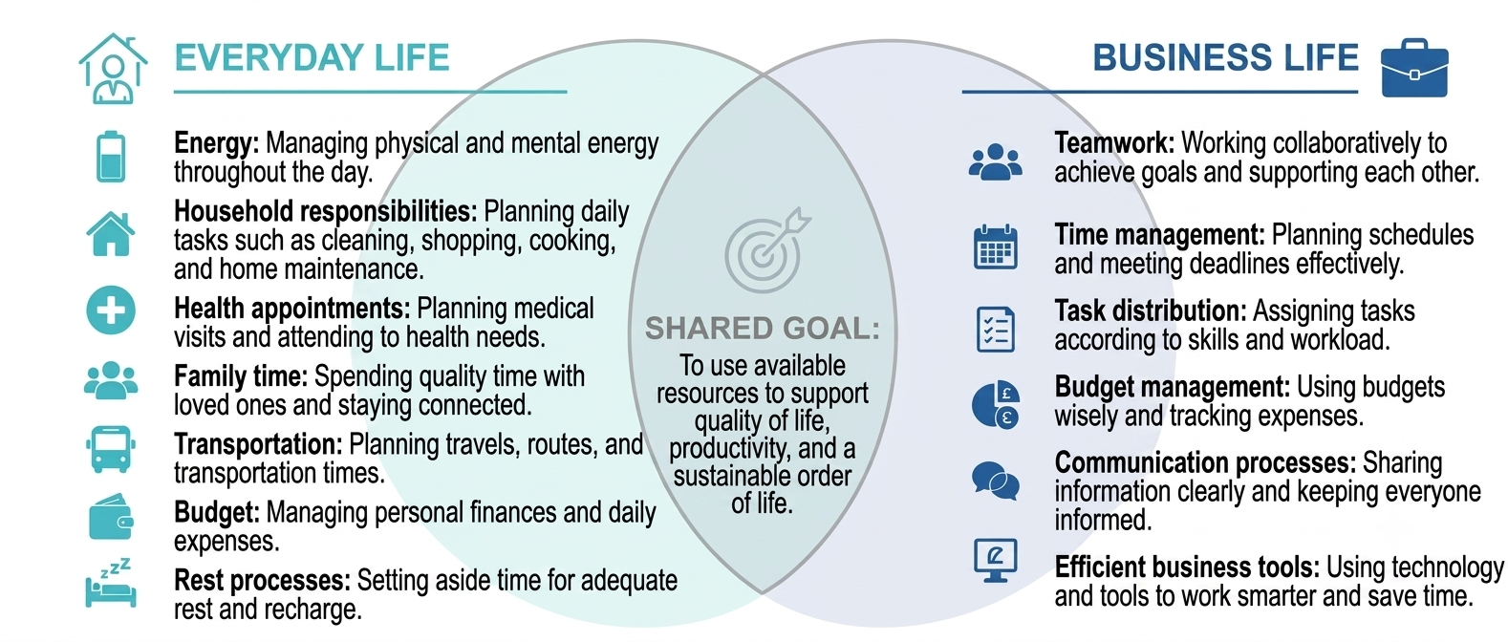
To consider a simple example: a person might need to go to work, attend a medical appointment, spend time with their family, and rest all in the same day. If they act without planning their time and energy, they may feel tired and stressed by the end of the day. However, if they prioritise their tasks, set ‘priorities’ and organise the support they need, daily life becomes more organised and manageable. This is precisely where resource management comes in. And as we mentioned, ‘priorities’ are crucial at this stage. Indeed, deciding what a priority in our lives is can even be the first step in the resource management process.
A similar process exists in the workplace. A team uses human resources, time, budget and technology to complete a specific project or task. Using resources at the right time and in the right way makes tasks easier, increases productivity and balances the workload within the team.

3. Understanding Different Types of Resources
Everything we do in everyday life and in business happens through the use of different kinds of resources together. These resources enable us to complete a job, make decisions, and move forward with our goals. Getting to know the resources correctly is the first step to managing them in a more informed and balanced way!
Resources can be represented in more than one structure. Those that relate to people and express personal capacity, such as time and energy, can be divided into different groups, such as technological means or material means:
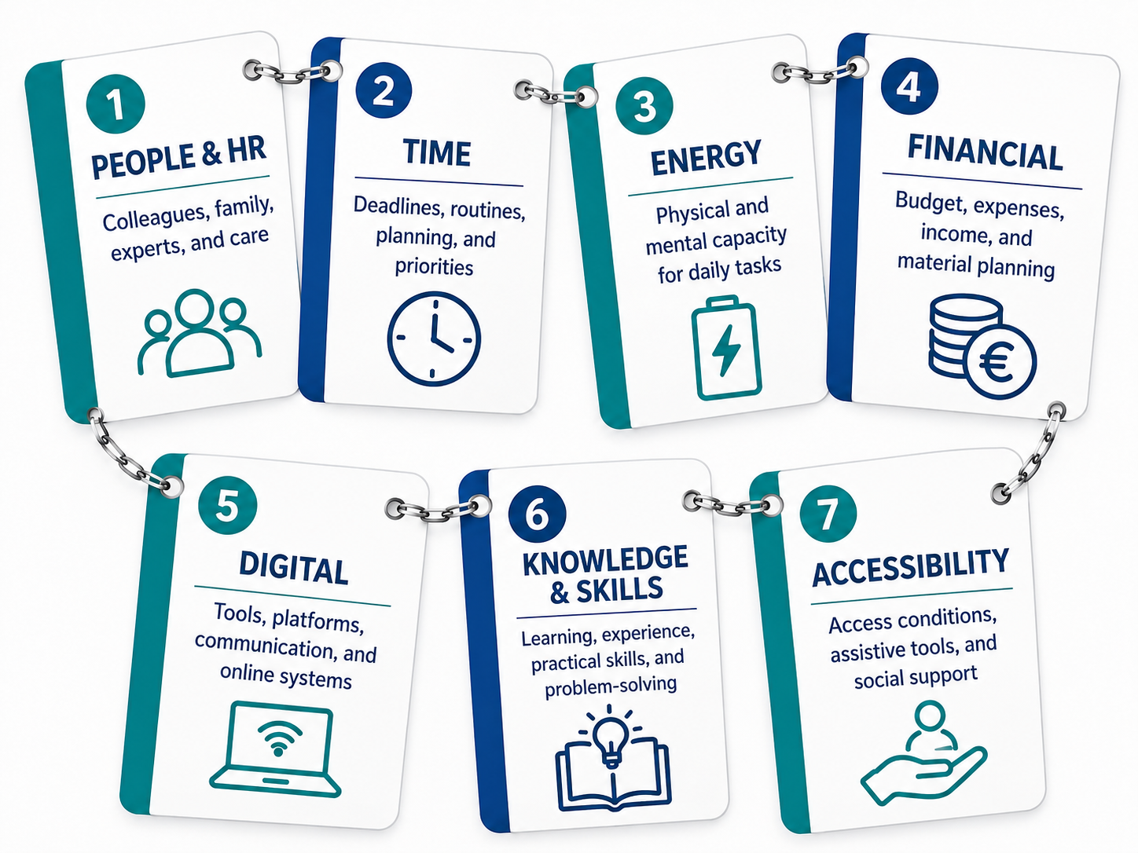

3.a. People/Human Resources
Human resources are one of the most fundamental resources in both business and everyday life.
In the business environment, this includes teammates, managers, collaborating institutions, and experts who provide external support. Each person has different skills, experience and perspective. When these differences are combined, a stronger working process emerges.
In daily life, human resources can be family members, friends, caregivers, or anyone who offers emotional and practical support. For example, getting close support to go to a health appointment or to consult on a subject is an example of using human resources in daily life.

3.b. Time
Time is one of the most basic resources we have in limited quantities.
Time in business life: deadlines are directly related to project plans, meetings, and task sequencing. In daily life, it regulates routines such as sleep, food, transportation, personal care and rest.
Time management isn't really about "doing everything at once"; it's about doing the right things in the right order. Because time cannot be brought back, and therefore how it is used is of great importance.

3.c. Energy
Energy refers to the physical and mental capacity we have to do a job.
While some days may be more focused and productive, sometimes we may feel more tired or less motivated. This is completely natural.
Energy management in business means placing complex or intense tasks in times when we are more energetic. In everyday life, processes such as resting, taking breaks and taking time for yourself help maintain energy balance.
When energy is managed correctly, more effective results can be achieved with less effort in the same time period.

3.d. Financial Resources
Financial resources are material resources that we possess or manage.
In the business environment, the project budget covers salaries, material expenses, service purchases, and operational costs. Proper planning of these resources ensures that projects progress sustainably.
Financial resources in daily life include the budget devoted to income, rent, transportation, food, health, and personal needs. Financial planning makes it easier to build a more secure and balanced life for the future.

3.e. Digital Resources
Digital resources are the tools and systems we access using technology.
In business, project management software, email systems, communication platforms, and data-sharing tools fall into this group. These tools help teams communicate faster and run things more organised.
In everyday life, phone applications, calendars, navigation systems, online banking and education platforms are examples of digital resources. These tools make everyday tasks easier and planning more accessible.

3.f. Knowledge and Skills
While knowledge refers to the theoretical and practical data we have, skill is our ability to apply this knowledge.
These resources in business life include professional experience, training, technical knowledge and problem-solving capacity. For example, a team member's knowledge of project management or ability to use technical software is an important resource.
In everyday life, skills such as cooking, budgeting, communicating, or solving a problem can be examples of this resource.
As knowledge and skills improve, the way we use other resources also becomes more effective.

3.g. Accessibility & Support
This type of resource refers to external conditions and support systems that make an individual's life easier.
Physical accessibility (e.g. appropriate building design, transportation facilities), digital accessibility (easy-to-use applications, screen readers) and social support (family, institutions, counselling services) are all parts of this field.
Accessibility in business ensures that everyone can participate equally in the process. In everyday life, it makes it easier to act independently and helps one to use their potential more easily.
To better understand all these resources, take a look at the following scenario about how we use each of the following resources in our daily life:
Karl works as an assistant at an architectural firm in the centre of Vienna. His task for today is to finish the files for a new park project by the end of the day.
Karl arrives early because he knows he has the most energy before the office becomes busy. He uses his energy resource to complete the difficult calculations and detailed drawings first. He then opens his design tablet, an important digital resource, and transfers his drawings directly to the computer.
While working, Karl is unsure about the cost and suitability of the trees. He asks his colleague Hanna, who has experience in landscape planning, for help. As a human resource, Hanna explains which trees are more suitable and shows him a useful shortcut in the drawing programme. This new knowledge resource helps Karl work more quickly.
Just before lunch, Karl receives an unexpected message from his manager. The client wants an additional shaded seating area in the design. At the same time, Karl’s tablet stops working. Instead of waiting, he uses a spare office computer and opens the latest project file from the shared online folder.
Karl checks his watch and sees that only two hours remain before the meeting. He manages his time resource by prioritising the new seating area and the cost table, leaving the cover-page formatting until the end.
During his short lunch break, Karl uses his financial resource (money) to buy an Apfelstrudel and a coffee. When he returns, the nearest lift is temporarily out of service. However, he follows the signs to another accessible lift. These physical and accessibility resources allow him to reach the office independently.
Despite the unexpected problems, Karl completes the files and delivers them on time by using his available resources effectively.
So, we can summarise the “resources” in this short scenario as follows:
Energy | Karl uses his strongest concentration in the morning to complete the most demanding tasks first.
Digital Resources | He uses a design tablet, a spare office computer and the company’s shared online folder.
Human Resources | Hanna supports Karl by advising him about suitable trees and reviewing his work.
Knowledge & Skills | Karl learns a new shortcut in the drawing programme, which helps him work more efficiently.
Financial Resources | Karl uses the money in his wallet to buy lunch during his short break.
Time | He prioritises the urgent design changes and organises the remaining tasks before the deadline.
Accessibility & Support | The alternative lift and clear signs allow Karl to move around the building independently.
Table summarising the resources identified in Karl's scenario, listing each resource type (energy, digital, human) with a description of how it is used.

4. The Synergy Between Organisation, Productivity and Well-being Through Resource Management
Although well-being may seem like an abstract concept, it is actually based on a very concrete basis: productivity. When an organisation produces value, that value spreads to employees, customers, and society. But there is a critical point here. Increasing productivity is not always the same as increasing real well-being.
We can think of it this way: A company can do more with fewer people. The numbers get better. But in this process, employees get tired, exhausted, and over time, productivity also decreases. What is gained in the short run is lost in the long run. This balance is much more sensitive for people with disabilities. Because sustainability in business life, that is, being able to work long-term, is much more important than instant efficiency.
There are 2 primary sources, and both are directly linked to well-being:
Human capital | Social capital
Knowledge, skills, health and learning capacity. When an employee can develop these resources, they both contribute more to their job and feel more competent and meaningful. Access to educational opportunities is the most basic way for this capital to grow. | Trust, communication and cooperation between people. When people trust each other in a workplace, information is shared more easily, problems are solved faster, and everyone feels better. It's an invisible source, but the impact is enormous.
Table comparing human capital and social capital as the two primary sources of well-being, with a description of each.
For people with disabilities, these two sources are particularly decisive. In the right organisation, these resources are protected and developed. In the wrong organisation, it quickly runs out.
As a fact, an employee who feels good is more productive. A more productive employee contributes more to the organisation. When the organisation rewards this contribution fairly, the employee feels valued, and the cycle continues.
But this cycle can easily be reversed. Excessive workload, feeling undervalued, poor physical conditions and social isolation erode well-being. As well-being declines, so does productivity. If the organisation continues to demand greater productivity without realising this, over time both the employee and the organisation lose out.
It can be said quite clearly that mental health issues are the factor that affects productivity the most among all workplace factors. More so than the physical environment or working conditions. This alone explains why organisations should invest in employee well-being.

4.a. Questions Worth Asking When Making Career Decisions
Finding the right workplace directly determines the sustainability of your career, as it reflects how an organisation manages you, safeguards your resources and values your well-being. The 10 questions below can help you determine whether an organisation is truly the right fit for you:
Inclusion & Accessibility | - Are my strengths being recognised, or is the focus solely on my limitations?  - Does the physical environment meet my basic accessibility needs?  - Can I adjust working conditions such as lighting, noise and temperature, even if only to some extent?
Professional Development | - Is there genuine scope for me to learn and develop?  - Does this organisation view me as a cost, or as a resource worth investing in?
Well-being & Sustainable Working Conditions | - Is there a flexible working schedule or the option to work remotely?  - Is the workload sustainable, or will it constantly push me to my limits?  - When I am having a difficult day or need a break, does the system create pressure or offer support?
Organisational Culture & Support | - Are there people who will listen to me and whom I can turn to for help when I am struggling?  - Is information shared freely, or is it used as a tool of power?
Table listing ten questions to ask when evaluating a workplace, organised into four categories: inclusion and accessibility, professional development, well-being and sustainable working conditions, and organisational culture and support.

5. Prioritising Tasks and Managing Time
Time management is less about controlling time and more about deciding what to do and when to do it. To make sound decisions, you first need to understand which tasks are truly important.
Is it urgent or is it important?
Not every task carries the same weight. Tasks can be categorised as follows:
- Both urgent and important: to be done immediately
- Important but not urgent today: to be planned and scheduled for a specific date
- Feels urgent but does not require priority: to be dealt with quickly or delegated to someone else
This is particularly important for people with disabilities. Additional responsibilities such as medical appointments, managing medication and transport significantly reduce the amount of energy and time available each day. Setting the right priorities ensures that the remaining resources are directed where they are most needed.
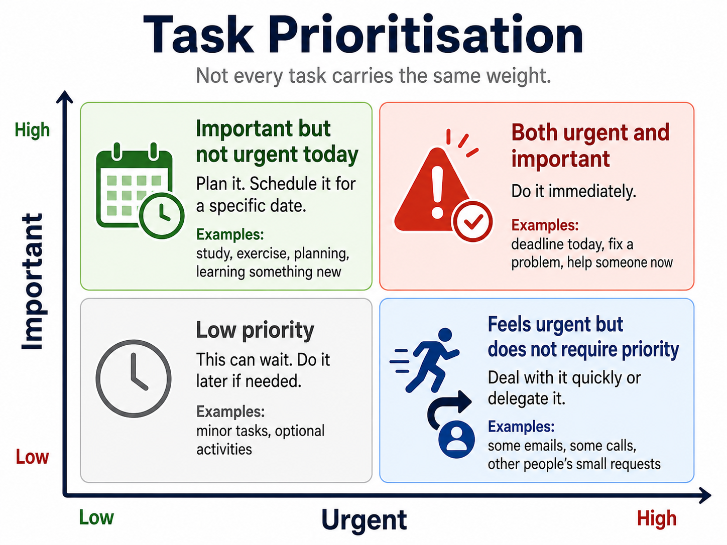
Setting Realistic Goals
Long and vague to-do lists directly trigger procrastination. Setting realistic goals means consciously selecting a few tasks that can actually be completed, taking into account the energy and time available.
📌 A handy rule of thumb: Setting three or four clear goals a day significantly reduces the pressure caused by a long to-do list.
Short-term planning covers the day and the week. Long-term planning, on the other hand, focuses on broader goals. For individuals whose health fluctuates, long-term planning also makes it possible to factor in periods when they may experience low energy levels.
Breaking it down into steps and establishing a routine
When viewed as a whole, a major task tends to invite procrastination. When the same task is broken down into small, concrete steps, it becomes easier to get started - the first step is now a manageable size.
Routines serve a similar purpose. Performing certain actions at the same time every day significantly reduces the energy spent on decision-making regarding those actions over time. A small but consistent habit can act as an anchor for the rest of the day.
Deadlines and Overwhelm
Postponing is often equated with laziness. However, the real reason is that the task feels too big, unclear or overwhelming. This sense of overwhelm usually stems from the to-do list being much longer than what can actually be achieved. Breaking tasks down into steps directly resolves both of these issues.
Remote and Hybrid Working
Remote working offers a particularly valuable degree of flexibility for people with disabilities. Managing medication, attending medical appointments and taking care of personal needs becomes much easier compared to traditional office environments. The home environment provides control over sensory factors such as noise levels and lighting.
To take advantage of this flexibility, it is necessary to establish an individual structure:
- Start the working day at a consistent time
- Plan your breaks carefully
- End the day with a specific action
These small habits can replace the structure naturally provided by the office environment.
Practical Tools
There are many tools available to support the habits described above. In the simplest terms:

Tool | Why is it useful?
Planner and agenda | Allows you to view your tasks in one place
Calendar | Makes time more visual
Checklist | Reduces the burden of remembering things and makes progress tangible
Reminder | Steps in when attention or memory is lacking
Digital Productivity Tools | Combines voice input and accessibility features
Table listing time-management tools, such as a planner, calendar, and checklist, together with why each one is useful.

6. Effective Problem Solving
Imagine that two people working in a workplace face the same situation. One experiences it as a minor setback, while the other faces a real obstacle. The same environment, two very different experiences.
In the simplest terms: the problem is any situation that makes it difficult or hinders the achievement of a goal. But this definition tells only a small part of what actually happens.
The problems vary greatly in size and weight. The inability to access a document is also a problem, as is trying to adapt to standard working hours with chronic fatigue. The limits of some problems are clear - missing information, a tool that stops working, a missed deadline. They are identifiable, and the solution is measurable.
Problem-solving styles vary across working environments. The type of work, pace and relationships between people influence which methods are most effective. However, the following simple framework can support problem-solving in any workplace:
- Identify the problem: Clearly describe what has happened and who is affected.
- Analyse the situation: Explore the causes, available information and possible barriers.
- Generate options: Think of several possible solutions and invite different perspectives.
- Evaluate the options: Compare the benefits, risks, time and resources required.
- Implement the solution: Choose the most suitable option, assign responsibilities and take action.
- Review the outcome: Check whether the solution worked and identify any lessons for the future.
The emphasis placed on each step may vary according to the working environment. For example:
- In fast-paced, high-pressure environments such as hospitals, rapid decision-making and coordination are paramount.
- In creative sectors, flexible thinking and the ability to work with uncertainty become increasingly important.
- In manufacturing and technical fields, standard procedures and systematic interventions take centre stage.
- In academic and research environments, redefining the problem is a key part of the solution process.
- In remote teams, communication and time management play a critical role.
Given these differences, individuals must first recognise their own approach, strengths, and limitations to contribute to effective problem-solving in different work environments. Self-awareness makes it possible to understand how to react to what kinds of problems and to develop strategies accordingly. To develop this skill, various evaluation and self-thinking tests can be used as important tools. One of these types of tests can be shown as the following example:
https://testyourself.psychtests.com/testid/Creative-Problem-Solving-Test
The bigger a problem seems, the harder it is to think about it. Everything feels intertwined. You never know where to start. Anxiety in a corner of the mind leaves no room for clear thinking. At this point, "mind mapping" can stand out as a highly functional tool.

6.a. Mind-mapping as a Practical Problem-Solving Process
Instead of keeping the problem in mind, put it on paper or on a screen. The main subject is written in the centre; from there, branching subheadings are added, and each branch expands in itself. Thus, a problem that looks messy becomes a structure that can be seen and worked on with the eye. Even in Leonardo da Vinci's notebooks, there are traces of visual ways of thinking based on the same principle.
Mind maps are particularly useful in the following situations:
- in problems where multiple factors must be considered together,
- when it is necessary to identify connections between elements that appear unrelated at first glance,
- in situations where it is unclear where to begin.
Beyond all this, for individuals who think in visual form or who struggle with written lists, the mind map can offer a much more natural way of putting ideas in order.
How is it used in practice?
The main problem is written in the centre of the page or in the central area of a digital tool. Each major branch from here represents a different dimension of the problem, its cause or possible solution. Each branch expands within itself. Colours, short keywords, and visual elements can be used as needed. The goal is to display the problem in all its dimensions.
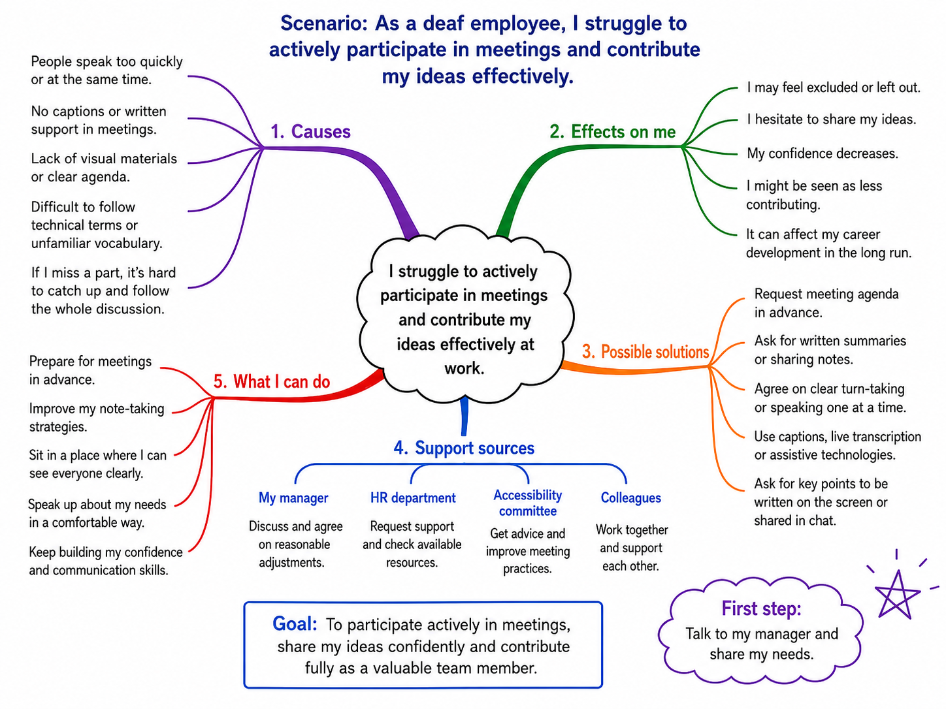

6.b. Problem-Solving in Teamwork Settings
The techniques introduced above can also be used in teamwork. Many workplace problems are easier to solve when people work together. A team brings different knowledge, experience and perspectives. One person may notice a detail that another person misses, while a different viewpoint may lead to a better solution.
However, teamwork works well only when everyone has space to contribute. Stronger voices can dominate the discussion, and the desire to reach agreement quickly may prevent important concerns from being shared. Teams therefore need a safe and respectful atmosphere where people can speak freely, ask questions and share ideas without fear of judgment. Clear and open communication helps the team use everyone’s strengths and make better decisions.
Communication at work is highly likely to be in a potential hierarchy. In this respect, understanding this communication triangle in general is very important, especially in terms of methods and strategies to be applied in problem solving:
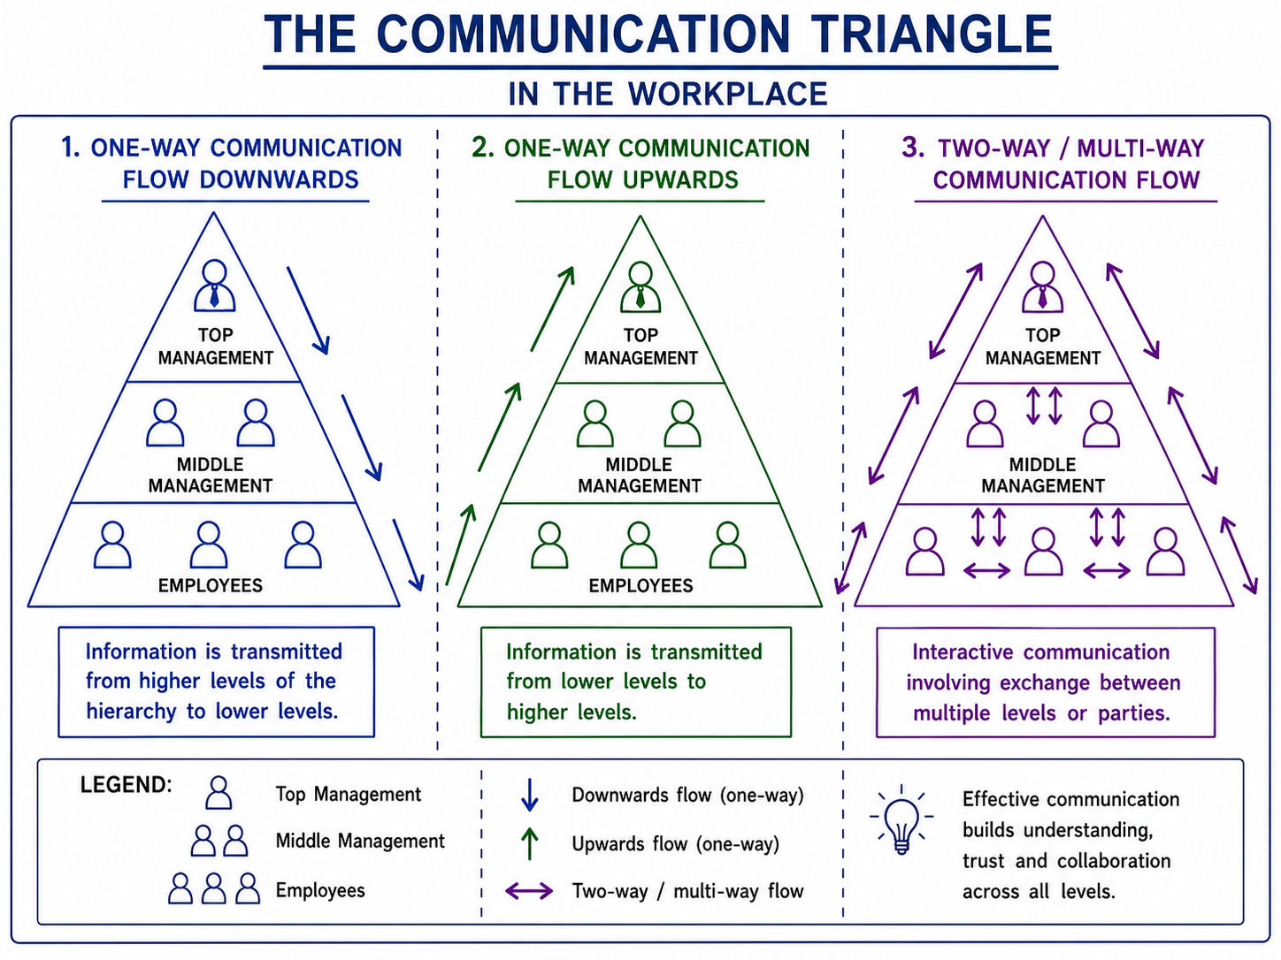
As can be seen from this image, the direction and form of communication in the workplace directly affects how problems are noticed, how they are conveyed, and how solution processes proceed. While problems are often noticed late in environments where information flows only one way, the process of producing solutions becomes faster and more inclusive in structures where mutual communication is strong. Therefore, effective problem solving is closely associated with open communication between employees and managers, sharing feedback, and developing common understanding.

6.c. Learning from mistakes and feedback
Everybody makes mistakes. But not every mistake is learned from to the same extent. What makes a difference is how the error is confronted rather than the magnitude.
Mistakes don't just happen as a technical glitch. Shame, guilt, anger, anxiety - these are reactions that occur very naturally when something goes wrong. These feelings become much more intense when the mistake occurs in the eyes of others. For people with disabilities, this may carry additional weight; The anxiety that every mistake can turn into proof that "you're not good enough" can accompany it. Recognising and naming this emotional load is the first step in the learning process.
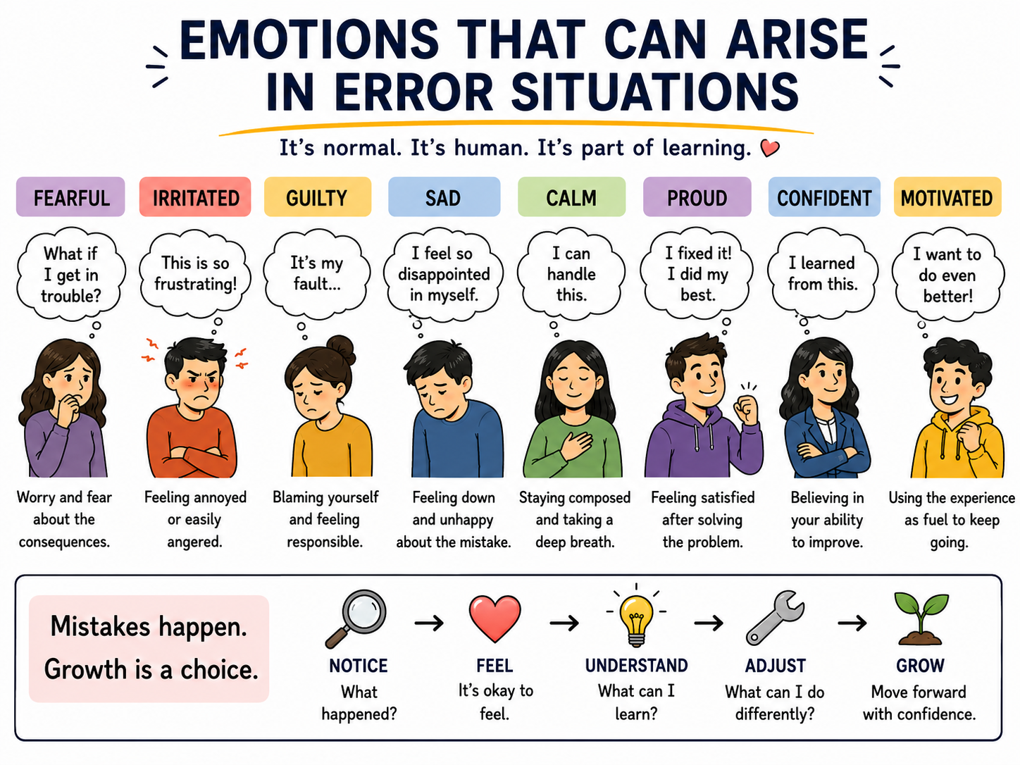
Generally speaking, emotions do not directly affect learning. What determines learning is the coping strategy chosen after a mistake. When a person is preoccupied with blaming themselves or dealing with the reactions of others, the real cause of the mistake is often overlooked. On the other hand, when the question ‘why did this happen?’ is asked - that is, when the background to the mistake is examined in depth - lasting learning takes place. Correcting mistakes quickly is different from truly learning from them.
This process does not work independently of the environment. In a team where making mistakes is condemned or punished, people tend to hide their mistakes; The error is corrected but not understood and will most likely reappear. In environments where team members can speak clearly and do not hesitate to ask questions, learning is much more powerful and permanent. Feedback is also part of this climate. Constructive feedback is not given to judge. It focuses on a particular situation, is concrete, and opens up space to progress.
There are a few simple and practical steps that can be followed to develop a constructive response following a mistake:
- Firstly, the individual should acknowledge the situation without immediately blaming themselves or others, and clearly assess what has happened.
- Next, the extent of the mistake’s impact should be determined, open communication should be established with those affected, and the necessary corrective actions should be taken as soon as possible.
- Once the immediate issue has been resolved, the circumstances leading to the mistake and its root cause should be examined in greater detail.
- Where necessary, constructive feedback should be sought from team members or a manager, and it should be determined what could be done differently in a similar situation in the future.
- Finally, the lessons learnt should be noted down, or a small and practical change should be made to the working process to prevent the same mistake from recurring.
This approach ensures not only that the error is rectified quickly, but also that it is understood and the experience is transformed into lasting learning.
Basically, the essence of learning from mistakes is based on a few simple principles: accepting what is, taking the time to understand why it happened, and being in an environment that makes it possible. None of these conditions has to be perfect - but each, over time, makes a difference.
The skills covered so far in this section (managing resources consciously, setting priorities, approaching problems in a structured way, and communicating effectively within a team) cannot be viewed merely as tools that are useful only when working for an organisation. They form the cornerstones of any professional journey. The next section takes this foundation and applies it to a different question: could using these resources and skills to build your own professional path, rather than working for someone else, be a meaningful and achievable option for you? Entrepreneurship and self-employment offer a structured way to take this question seriously.

`7. Why Self-Employment and Entrepreneurship Can Be Meaningful Opportunities Leading to Professional Success
Beyond the traditional path of professional development, there is an alternative way to build a career: starting your own business. This approach can be an accessible and meaningful direction for many people.
Entrepreneurship and self-employment are not “the right choice" for a particular group of people. They are a great opportunity for everyone, including people with disabilities, because they offer a lot of flexibility and independent control over working conditions, schedule and environment - all important factors that traditional employment cannot always offer, which, as a result, makes many jobs inaccessible.
This module looks at three main aspects of entrepreneurship. First, we will look at why and how starting your own company can be a meaningful professional alternative, and what this path looks like in practice. Then, for anyone who has an idea, a skill, or a hobby they want to turn into a source of income, we will look at what helps a venture succeed and what key mistakes to avoid. In the third part, we will outline what a full business plan looks like, and how you can start building one in a structured way.
This topic was created to give you enough knowledge and practical tools to make an informed choice - whether starting your own company is really the right choice for you, and if you decide to go in this direction, to take your first steps with confidence.

7. a. What Are Self-Employment and Entrepreneurship?
Self-employment means working for yourself, not for an employer. An example would be offering a particular service or product. In this case, you take direct responsibility for managing your time and all other resources key to the work, finding clients, and handling income and expenses. A self-employed person may work alone (for example, as a software engineer, graphic designer, data engineer, translator, seller of handmade goods, and so on), or sometimes hire others to help - but the most important feature is that the person themselves is the business.
Entrepreneurship is used as a broader term. The person the idea comes from creates and runs a business with the intention of realising a project that generates value for others. Not all entrepreneurs start out aiming to build large companies. Some build small but sustainable businesses, often aimed at solving a specific need or challenge in their community. Others start with one service and grow over time, gradually expanding what they offer to clients. Some successfully build large international companies and offer value to society on a global scale. What connects everyone involved in starting a business is recognising an opportunity, taking initiative quickly, and building a working, sustainable venture.

7.b. Benefits and Challenges of Entrepreneurship
Although it sounds like an excellent alternative with many advantages, it is also very important to consider the real challenges that come hand in hand with starting your own business. Understanding both sides well can help you judge whether the path of a founder is really for you.
Area | Advantages | Challenges
Schedule | You set your own working hours and can match them to your energy, medical needs, or the support available to you at a given time | Without a clear structure set by a manager, it can be hard to separate work time from personal time, especially if you have no previous work experience - this can lead to high levels of stress and inner tension
Environment | You choose your own workspace - at home, in a shared office, outdoors - and you can organise it around your personal access needs | Despite the importance of choice and flexibility in your work environment, working from home can sometimes create a feeling of isolation due to the lack of opportunity for direct contact with people
Income | There is no fixed ceiling on income. The more successful the business, the more your income can grow | It takes time and a lot of effort for a business to develop to the point of offering stable, ongoing income, especially at the start. It's important to factor in the time it takes to recover your investment. You have no guaranteed paid sick leave or paid annual leave
Autonomy | You decide what work to take on, which clients to work with, and how to grow your business | All decisions rest with you - there is no manager to hand a problem to, or one to support you at a challenging moment. Finding clients requires building a working strategy and successfully carrying it out
Meaning | Building something of your own can be deeply motivating and personally meaningful | The early stages of a business often require a lot of effort before real impact, visible results and stability appear. Without support from family and loved ones, it can be an extremely difficult undertaking. It is often linked to high levels of stress and tension, and taking on risk
Table comparing the advantages and challenges of self-employment across five areas: schedule, environment, income, autonomy, and meaning.

Real-Life Example: Johan, Self-Employed Data Engineer
Johan is a self-employed data engineer, building and maintaining data pipelines for small and medium-sized businesses. He lives with a chronic pain condition that made a standard 9-to-5, in-office job difficult to sustain over time. Becoming self-employed let him set his own working hours to match his energy levels, and set up a home workspace that he can fully adapt to his own needs.
In his first year, unpredictable income was one of his biggest challenges, so he kept two part-time contracts running until his client base was large enough to rely on his own business alone. He also missed having colleagues to turn to when facing a difficult decision, so he joined a small online peer group of self-employed IT professionals with disabilities, where members exchange advice and support each other once a month.
Johan's example shows that the advantages and challenges of self-employment often sit side by side, and that most challenges can be managed with the right strategy and support, rather than being reasons to avoid this path altogether.
Callout box presenting a real-life example of Johan, a self-employed data engineer, describing his motivations, challenges, and how he addressed them.

7.c. Turning Your Personal Strengths into Opportunities
One of the most effective ways to start considering self-employment is to start with what you already have experience in and already know how to do well. This does not mean finding some ideal passion and turning it into income, because although in some cases this can be a successful venture, more often this approach would be unhelpful and would create unrealistic expectations. The idea here is rather first to stop and objectively look at the skills you have developed in your life so far, the knowledge you have built up, and the things other people ask you for help with. The story of Barbara, who developed strong organisational and administrative skills out of necessity (coordinating her own medical appointments, paperwork, and specialists while managing a chronic condition) is an excellent example. She successfully turned that into a paid service helping other patients navigate the same process.
Skills you have used in paid or unpaid work, such as communication, creating new products, research and analysis, teaching, writing - these are just a small part of the skills that could allow you to start a self-employed venture, and all of them have potential market value. In addition, and even more specifically, in relation to your personal life experience, skills such as navigating the healthcare system, managing a specific condition, using assistive technology, and understanding and having access to a specific community also have the potential to become the basis for creating a service that genuinely helps others while also bringing you stability.
The following reflection exercise can help you start mapping your own strengths.
🎯 Practical Activities for This Section
It's time for creative work, and in a very exciting direction. The first step in this phase is mapping your strengths: think about your strengths and write down ten things you know how to do well. Then mark which three of them other people most often ask you to do. These are your starting points.
As a next step, you can continue with slightly more detailed development of the idea: choose one of the three skills/activities from your strengths map and describe it in more detail - as you would explain it to a potential client, in two sentences, to see how they would react.
Market research: it's time to look for your potential competitors - find two or three people or businesses currently offering something similar. What prices do they charge? How do they describe their service? What could you do differently?
Case study on entrepreneurship: research an entrepreneur with a disability who works in a field that interests you. What was their path, and how did they start? What obstacles did they face? What have they built? Where are they now? Try to get in touch with them.
Callout box outlining a step-by-step practical activity for mapping personal strengths.

8. What to Do - and What to Avoid - When Turning Your Hobby or Skill into a Business
A common practice when starting a new company is for its mission and activity to be based on something the founder already does well and loves - a craft, a skill, a type of service. The shift from doing something for yourself to carrying it out professionally is a very important process, and it involves decisions that affect the work itself, your relationship to it, and your financial stability.
In this section, we will look at the most important things to keep in mind and what to avoid during this period of transition.
✅ DOs | ❌ DON’Ts
As a first step, identify your strengths. Think not just about the things you enjoy doing, but the things you do at a level that other people would pay for | Being good at a hobby does not always mean you can run a successful business around it
Do your own research to understand who your target group is and what your potential clients really need. Enthusiasm is very important and will give you energy and drive to keep going, but it won't be enough on its own | Setting your prices based on your own feeling and judgement of what you think clients will pay, rather than on the actual cost of producing the work and market trends
Research the market: is anyone else already offering something similar? At what prices? Who buys that service/product? | Working to the point of exhaustion to make up for low income - this leads to burnout and often lowers the quality of your work
Think about your financial framework and forecasts, and set realistic income expectations, especially in the first year, when things are expected to be more challenging | Deciding to skip the planning stage because your idea seems clear in your mind - this would not lead to a structured strategy for the future development of the venture
Start with a test phase for your activity - create a test product, go out and tell people what you do, meet real people, get their feedback, analyse the results before committing fully | Ignoring your own needs for full inclusion when designing how you work. Do the opposite - build them in from the very start, so that you feel well and set a positive example
Build clear boundaries between hobby time and work time, so that the pressure of work doesn't wear away what you originally loved about the activity | Relying entirely on content, ideas or business plans generated by artificial intelligence, without contributing your own creative input and drive to your understanding and development of the business
Invest in continuous learning - business skills, marketing and financial management can all be learned, and many free resources can keep developing your knowledge | Isolating yourself - in any activity, and especially in entrepreneurship, you are not on your own. Avoiding joining a professional community is one of the most common mistakes, and it would deprive you of so many new contacts and opportunities
Seek legal advice - it's important to find the most suitable legal structure to register your business correctly, and to understand your tax obligations from the very start | Ignoring feedback from your early clients, even when it's uncomfortable to hear. Often, even when something sounds amazing in our own mind, a product or service may still have room for improvement in the eyes of potential clients - it's important to learn to listen carefully
Seek support - you don't have to figure everything out alone. Find suitable mentors you can trust and who can guide you, and join networks of people in a similar situation. Look for entrepreneurship programmes specifically for people with disabilities, because they can make a real difference | Treating every problem as a permanent failure. It is completely normal, especially in the early stages, for difficulties to come up. They can teach us something new and give us the chance to develop in an even more successful way
Table comparing recommended practices ("DOs") and practices to avoid ("DON'Ts") when identifying strengths and market opportunities.

9. Drafting a Basic Business Plan
A business plan is a written and detailed document presenting your business idea, the strategy for developing it, the target group it's aimed at, the main activities, what marketing tools you'll use to reach a wider group of people, how you'll generate income, and how you'll manage the challenges you're likely to encounter along the way to making it real. It is not a guarantee of success, but it is very important for putting everything into a structured strategy. It also doesn't stay static - quite the opposite; business plans are often revisited many times, as ideas are further developed and refined.
In other words, this plan is a way to think through your idea clearly and systematically, before you commit some of your most valuable resources to it - time, funds, or energy. And even more importantly, it is often required if you decide to seek grant funding, apply for a loan, or a place in a start-up incubator, since all organisations and institutions offering this kind of support are very likely to require some form of business plan from you.
This section presents the main components involved in creating a business plan. Each component is explained in accessible language, illustrated with concrete examples based on our experience and work, along with practical guidance and tasks for you to follow, so that you can write a plan for your own idea.
📋 Key Components of a Business Plan
1. Summary (Executive Summary) - a clear, short description of your business
2. Creating the idea and value proposition - what you offer and why it matters to potential clients
3. Business model and go-to-market strategy - who your ideal clients are, how you'll reach them
4. Marketing strategy and sales - how you'll promote yourself and grow
5. Financial projections and resource planning - income, costs and financing
6. Risk management and sustainability - challenges and how to manage them
7. Presenting and pitching skills - communicating your idea
Callout box listing the key components of a business plan, from the executive summary to the go-to-market strategy.

9.1. Introduction to Business Planning and the Executive Summary
The summary is a very interesting element. Although we start the business plan with it, our advice is to write it last, once you have fully clarified and shaped the idea in your mind. It gives the reader, whether that's a funding organisation, a mentor, or a potential partner, a clear picture of your business within one page or less. It answers the most basic questions: What exactly is the business? Who is it for? What makes it viable?
For your introduction to be impactful and convincing, you don't need to fill it with big promises. Its purpose is to be a short and direct description of what you're building, and why you believe it can succeed. It should be written in simple, understandable language, even for people who aren't experts in your field, so that it can have an impact on every reader.
✏️ What to Include in Your Summary
Your name and the name of your business (or the working title you're using)
What your business does - the product or service you're developing, described clearly in one or two sentences
Who it is for - your target group
What problem it solves, or what need it meets, and why that's needed
How you'll generate income and make the business sustainable over time
Your main goal for the first year
Callout box listing the elements to include when writing a business plan summary.
SAMPLE SCENARIO
Sample summary: Birgit Hofer, founder of Accessible Content Studio. Birgit is a graphic designer from Austria with a hearing impairment, specialising in creating accessible communication materials for non-profit organisations and public bodies. Her business creates visual content - infographics, reports, presentations and social media materials - that meet current accessibility standards, including WCAG 2.2 colour contrast requirements and screen reader compatibility. Her target group is small and medium organisations that need regular communication materials but don't have an in-house design team, and that are increasingly required by their funders and by legislation to meet accessibility standards. Her goal for the first year is to establish ten clients on a retainer basis, at an average monthly value of €800, generating sustainable income while she builds a portfolio that supports further growth.
Callout box presenting a sample business summary scenario for Birgit Hofer, founder of Accessible Content Studio.
This summary works because it gives concrete detail. It doesn't simply present the business as “helping people communicate better” in general terms - it frames the target group in detail, presents the clear service and its measurable goal for the first year. It is precisely this kind of concrete detail that makes a business plan meaningful and gives it the potential to have an impact.

9.2. Creating the Idea and Value Proposition
In this section, it's important to present your value proposition, meaning answering the question: why would someone choose your business over a competing option? This isn't about simply claiming you're the best at everything, but clearly demonstrating the specific added value you provide to the group of people you plan to reach.
A well-defined value proposition is made up of three key components:
- What you offer: the specific service or product
- Who it is for: the specific target group
- Why it is unique or particularly significant: what are the features, approach or quality that set it apart from alternatives already available on the market

Component | Example (targeted to a disability related project)
What you offer | Weekly online coaching sessions focused on career planning and self-advocacy skills
Who it is for | Young people with disabilities up to the age of 25 who are entering the labour market for the first time
What makes it different | Delivered by a coach with personal experience in the field, with a disability and 20+ years of experience in the corporate sector, using clear language and accessible, structured session formats designed specifically for the needs of young people with disabilities
Table showing the value proposition framework applied to a disability-related business example, listing each component alongside a worked example.
The example given is for a service where accessibility matters a great deal. If your ideas follow a similar direction (in language, format, way of delivery, or setting), then the accessibility angle should be very important for you too, right from the early stages, and it's important to describe it explicitly in your value proposition. There is a growing demand for services that genuinely meet accessibility standards, not only from companies, but also from public sector bodies and organisations affected in one way or another by the European Accessibility Act.
The framework is not limited to accessibility-focused or disability-related services - it applies to any kind of business idea. Here is an example from a different sector:
Component | Example ( non-disability-related business)
What you offer | On-demand mobile bike repair and maintenance, carried out at the customer's home or workplace
Who it is for | Urban commuters who rely on their bike every day and don't have time to drop it off at a shop
What makes it different | No need to be without the bike for a day; appointments are available on evenings and weekends, with clear, fixed-price packages instead of unpredictable repair bills
Table showing the value proposition framework applied to a non-disability-related business example, listing each component alongside a worked example.
Reflection: Your Own Value Proposition
Try writing your own value proposition in two or three sentences. What do you offer? Who is it for? What makes it different?
Callout box inviting the reader to write their own value proposition.

9.2.1. Finding Your Ideal Client
Before finalising your value proposition, you need to be able to describe specifically who you're creating it for. The ideal client is a real person/organisation with specific needs, challenges, and current ways of dealing with those problems. The more specifically you can describe this type of client, the more effective everything you do afterwards will be: how you communicate with them, how you set your prices, where you show up to find them, and what you offer them.
The chart below walks you through, step by step, describing your ideal client. Fill it in for the entrepreneurial venture you want to develop.
CHART FOR IDENTIFYING YOUR IDEAL CLIENT
Step 1: WHO has the problem you're solving?
◆ An individual or an organisation?
.............................................................................................................
◆ What age / what stage of life or work are they at?
.............................................................................................................
◆ What environment do they work or live in - online, physical, in a specific sector?
.............................................................................................................
◆ What is their resource context - do they have a budget, access to technology, free time?
.............................................................................................................
Step 2: WHAT is the specific problem or need?
◆ Describe the problem in one sentence, giving context and detail, from the client's point of view, not yours.
.............................................................................................................
◆ How serious is the problem - something inconvenient, or something that blocks an important goal?
.............................................................................................................
◆ How do they currently deal with it, and why isn't the current solution enough?
.............................................................................................................
Step 3: WHY would they choose you?
◆ What do you offer that others don't, or don't offer in an accessible way?
.............................................................................................................
◆ What's the difference between a good and a perfect service for them?
.............................................................................................................
◆ What level of trust do they need before they decide to pay you?
.............................................................................................................
Step 4: WHERE can you find them?
◆ Which online communities, platforms or networks are they active in?
.............................................................................................................
◆ What physical places or events can you meet them at?
.............................................................................................................
◆ Who is already talking to them or serving them, and could connect you to them?
.............................................................................................................
Step 5: CHECK - Write your ideal client profile in three sentences
Sentence 1: Who are they, and what situation are they in?
.............................................................................................................
Sentence 2: What specific problem do they have that you solve?
.............................................................................................................
Sentence 3: Why is your solution better than what they currently use?
.............................................................................................................
Worksheet table guiding the reader step by step through identifying their ideal client.

9.2.2. Understanding Client Needs
The best and most reliable approach to help you prepare an impactful value proposition is to actively seek out and talk directly to people in your target group before finalising your idea. You don't need to carry out a formal study - your approach could include a series of short live conversations, online meetings, or observing how people currently deal with the problem you're trying to solve. But the key is to talk to real potential users, to hear from them, their needs, their challenges, how they currently cope with them, and what they would like to get instead because this is exactly what will help you prepare the foundation for successfully realising your venture.
The questions it's key to answer together with your potential clients are:
- What is the specific difficulty they're facing?
- How are they currently dealing with it?
- What would a better solution look like and feel like for them?
- How much would they expect to pay for it, if anything?
- What would build their trust in a new provider?
Here it's great to get familiar with one specific approach to having this kind of conversation:

📖 THE MOM TEST - Rob Fitzpatrick
This is a practical guide to talking with potential clients. It explains why most of these conversations give misleading answers, and how to have them the right way. The core idea is simple: don't ask people if they like your idea. Ask them about their life.
Why do people lie without meaning to?
When you ask a friend, relative or potential client whether your idea is good, they will often say “yes” just to avoid hurting your feelings, and without meaning to, they will mislead you. Fitzpatrick describes three kinds of unhelpful feedback that entrepreneurs are misled by: compliments (“I love it!”), hypothetical promises (“I would definitely use that!”), and wish lists (“It would be great if you also added X!”). None of these actually tell you whether they will pay for your product/service.
The three rules of the method:
1. Talk about their life, not your idea - don't present your concept, ask questions.
2. Ask about specific things from the past, not the hypothetical future - not what they would do, but what they have actually done.
3. Listen more, talk less.
Callout box introducing "The Mom Test" by Rob Fitzpatrick as a guide to talking with potential clients.
Here are examples of the kind of questions to avoid, and how to structure ones that will give you useful information.
❌ Bad question | ✅ Good question
Do you like my idea? | Tell me how you currently deal with this problem.
Would you use a service like this? | When did you last run into this problem? How did you solve it then?
Do you think other people would pay for this? | How much does dealing with this problem cost you right now? Think in terms of money or lost time.
Do you think the market is big? | What have you tried so far, and why didn't it work?
Does that sound useful to you? | What would make you change how you do this now?
Table comparing examples of ineffective ("bad") and effective ("good") questions to ask potential clients.
💡 Practical Tip
Before asking for a meeting, be honest about why you're meeting: you're researching a problem, not selling anything. People are much more open when they know you're not trying to convince them. Don't ask more than three or four people the same questions at once - instead, learn from each conversation and adjust your next questions based on what you learn.
Callout box with a practical tip on being transparent about the purpose of a client conversation before asking for a meeting.

9.3. Business Modelling and Go-to-Market Strategy
A business model describes how your business creates value, delivers it to clients, and generates income from it. There are many types of business models, but to choose the one that fits you best, it's important to know exactly what you're offering and to whom you're offering it.
Type of business model | How it works | Example
Service model | You provide a service for a fee - per session, per project, or per hour | A physiotherapist offering private consultations to individual clients; a consultant charging corporate clients a daily rate
Product model | You sell physical or digital products | A craftsperson selling handmade items; a developer selling software licences
Subscription / monthly fee | Clients pay a regular fee for ongoing access to your service | A monthly social media management subscription; a membership community
Social enterprise model | Income is generated through trade, but reinvested into a social mission | A café that hires people with disabilities as baristas; a service that subsidises free training places for low-income learners
Freelance / contract model | You are hired for specific projects, for a set period, by different clients | A writer who works with multiple publishers; a graphic designer who takes on short-term contracts
Table listing different types of business models, how each one works, and an example of each.

9.3.1. Exercise: Fill In Your Business Model Canva
The Business Model Canvas is a standard tool used by entrepreneurs around the world to structure a business idea on a single page. It's a great, simplified complement to your detailed plan, made up of nine fields that show exactly how your entrepreneurial idea works. There are two versions - choose the one that matches the type of venture you're developing.
💼 Business Model Canvas | 🌱 Social Business Model Canvas
Best suited if your main goal is steady income from a product or service; you employ people or work alone; success is measured by financial stability and growth. | Best suited for: you have a clear social/environmental mission alongside your commercial activity (a social enterprise, an NGO with commercial activity); the people who benefit from the social value may be different from your paying clients.
Callout box introducing the Business Model Canvas and the Social Business Model Canvas as tools for structuring a business idea.
💼 BUSINESS MODEL CANVAS
Developed by Alexander Osterwalder. Fill in each field for your business idea.
💼 BUSINESS MODEL CANVAS
Key Partners  Who helps you operate?  Which suppliers or networks are key?  What do you get from them?  Write: ...................  ...................  ................... | Key Activities  What do you need to do every day to make the business work?  What is at the core of your service/product?  Write: ...................  ...................  ................... | Value Proposition  What problem do you solve?  What value do you give clients?  Why would they choose you?  Write: ...................  ...................  ................... | Customer Relationships  How do you communicate with clients?  How do you retain them?  Personal, automated, community?  Write: ...................  ................... | Customer Segments  Who are you creating value for?  Who is your ideal client?  Mass market, niche, segmented?  Write: ...................  ...................  ...................
 | Key Resources  What resources do you need?  Physical, intellectual, human, financial?  Write: ...................  ...................  ................... |  | Channels  How do you reach clients?  Online, in person, partners?  How do they learn about you?  Write: ...................  ...................
Cost Structure  What are the most significant costs? Fixed and variable?  Write: .................. .................. .................. |  | Revenue Streams  How do you generate income? One-off sales, subscription, hourly billing, licences?  Write: .................. .................. ..................

Worksheet table with blank fields for completing the Business Model Canvas, including key partners, activities, and other standard sections.

🌱 SOCIAL BUSINESS MODEL CANVAS
🎯 SOCIAL MISSION
What social change do you want to achieve? Who benefits from the social value (this may be different from the paying client)?
Write: ................................................................................
Key Partners  Which partners share the mission?  NGOs, public sector, donors, communities?  Write: ...................  ...................  ................... | Key Activities  What do you do to achieve both the social and the financial goal?  Write: ...................  ...................  ................... | Dual Value Proposition  What SOCIAL value do you create?  What ECONOMIC value do you create?  For whom - they may be different people.  Social: ...................  Economic: ............. | Relationships  With paying clients?  With the beneficiaries of the social mission?  Write: ...................  ................... | Segments  Paying clients: who are they?  Beneficiaries: who are they?  (they may overlap or be different groups)  Write: ...................  ...................
 | 🏗️Key Resources  What resources do you need for both goals?  Funding, volunteers, networks?  Write: ...................  ................... |  | 📢 Channels  How do you reach clients?  How do you reach the beneficiaries?  Write: ...................  ...................
Cost Structure and Surplus Allocation  What are the main costs? What share of income is reinvested in the mission?  Write: .................. .................. .................. |  | Revenue Streams and Social Value  Financial income: sales, grants, subsidies, donations?  Social value: how do you measure the impact of the mission?  Write: .................. .................. ..................
Adapted from the Social Business Model Canvas - Alex Osterwalder & Yves Pigneur (Business Model Generation) and the Flourishing Business Canvas.
Worksheet table with blank fields for completing the Social Business Model Canvas, including the social mission and related sections.

9.4. Go-to-Market Strategy
Once you've completed the exercises and filled in all the fields in the table relevant to your idea, you have the chance to think a bit more specifically about your approach to entering the market, and how exactly you'll reach your first clients.
For small businesses, the most effective routes to first clients are usually direct ones: personal networks of contacts, word-of-mouth recommendations, gaining entry and building trust within specific communities where your target group is active, and working directly with potential clients.
Think specifically about where your target group can already be found, through which communication channels (online, in professional networks, in communities), and how you can become visible and earn trust there.

9.4.1. Exercise: Build Your Go-to-Market Strategy
Fill in the following exercise step by step. It will help you create a concrete action plan for the first eight weeks of developing your venture.

STEP 1 - Who is your first client, and where are they?
Once you've completed the previous few exercises, start this one by describing just the first two or three specific people or organisations you could work with this very week.
Who is your ideal first client?
(A specific type of person or organisation, not a general category) .............................................................................................................
Who are three specific people or organisations you know, or can reach?
1. .............................................2. .............................................3. .............................................
Where does your target group gather online?
(LinkedIn group, Facebook community, forum, platform, email newsletter) .............................................................................................
Where do they gather offline, or in specific contexts?
(Event, organisation, network, association, local community) .............................................................................................................
Worksheet table for Step 1 of the action-plan exercise, prompting the reader to describe their first client and where to find them.
STEP 2 - What will you say to them, and how?
Don't ask if they like your idea. Explain what problem you solve, and invite them to a short conversation.
One sentence describing what you do and who it's for:
(E.g. I help small organisations communicate more accessibly, without hiring a designer) .............................................................................................
How will you contact your first potential clients?
(In person, email, a message on a network, a referral from a mutual contact) .............................................................................................................
What specifically do you want from them as a next step?
(A 15-minute conversation? Feedback? A test order? Be specific.) .............................................................................................
Worksheet table for Step 2 of the action-plan exercise, prompting the reader to draft what to say to their first client and how.
STEP 3 - Action Plan: Your First 8 Weeks
Section heading table introducing Step 3, an eight-week action plan.
Write down one specific action for each two-week phase. The action should be something you can actually carry out that week.

Phase | Phase Goal | Your Specific Action
Weeks 1-2 | Research and Validation | Have 3 conversations with potential clients using the Mom Test method. Write down what you learned.  My action: .....................................................
Weeks 3-4 | Visibility | Take one visibility action: a post, a social media profile, or direct contact with your target community.  My action: .....................................................
Weeks 5-6 | First Offer | Offer your service/product to at least one real client - even for free or at a reduced price, in exchange for feedback.  My action: .....................................................
Weeks 7-8 | Review and Next Step | What worked? What didn't? What will you do differently from week 9 onwards?  My action: .....................................................
Table for planning an eight-week action plan, listing each two-week phase, its goal, and space to write a specific action.
STEP 4 - Two Barriers, One Solution
As an entrepreneur with a disability, there may be specific ways in which standard go-to-market approaches don't work well for you. Name them, and find an alternative.
Which standard approach to finding clients is difficult for you, and why?
(E.g. networking events, cold calls, travel) .............................................................................................................
What alternative works better for your situation?
(E.g. online communities, written messages, partnerships with organisations, working through intermediaries) .............................................................................................
Who already knows your target group and could connect you with them?
(An organisation, a colleague, a mentor, an association) .............................................................................................................
Worksheet table for Step 4 of the action-plan exercise, prompting the reader to identify two barriers and a solution as an entrepreneur with a disability.

9.5. Marketing Strategy and Sales
Advertising and marketing help people learn that you exist, exactly what you do, how you can help them, and get to know your business better. Small businesses and freelancers don't need large budgets or complex campaigns. If you have a clear picture of the aspects described above, the next step is to start communicating them in a structured way through channels where your target group is already active and uses daily.

9.5.1. Digital Marketing Basics
Digital marketing is a subset of standard marketing, and it is key for small businesses; it mainly follows this logic: creating a clear and accessible online presence, actively using one or two social media channels, and providing an easy way for potential clients and interested people to contact you or book your service. Right from the start, it's important to create:
- Website: even a simple, one-page site in the early stage of the project, presenting who you are, what you offer, and how to contact you, is enough to start.
- Email marketing newsletter: building a simple email list of people who have shown interest in your work is one of the most reliable and low-cost marketing tools.
- Social media: having a strong social media presence is very key to reaching and informing users; choose one or two channels based on where your target group spends their time, and be consistent in using them. For most professional services, LinkedIn is a good starting point. For businesses in a visual or creative field, Instagram and Pinterest may be more suitable. For community-focused services, Facebook groups and local networks can be very effective.

9.5.2. Exercise: Monthly Social Media Communication Strategy Table
You can use the table below to plan your content month by month. Fill in at least 2 or 3 posts per week. Each post should serve a specific communication goal, which could include informing, engaging, or building trust.
Before filling in the table: choose one or two platforms suited to your target group. Don't try to be everywhere at once.
Week | Content Theme | Post Type | Platform | Day / Time | Accessibility Check
 | What are you talking about? (e.g. a solved problem, a case study, a tip, behind the scenes) | Text / image / video / carousel / stories / live | LinkedIn / Instagram / Facebook / other | When are you planning to post? | Alt text/subtitles/contrast / plain language
Week 1 Post 1 | Introducing your venture - who you are and what problem you solve | Text + photo | ................... | ................... | □ Alt text □ Contrast □ Plain language
Post 2 | Your personal story or motivation behind the venture | Video/text | ................... | ................... | □ Subtitles □ Plain language
Week 2 Post 3 | A useful tip or information related to your topic | Carousel/infographic | ................... | ................... | □ Alt text □ Contrast
Post 4 | A question for your audience, or a poll | Text / Stories | ................... | ................... | □ Plain language □ Contrast
Week 3 Post 5 | A case study or result from your work / a client story | Text + photo / video | ................... | ................... | □ Alt text □ Subtitles □ Plain language
Post 6 | A partnership, a recommendation, or behind the scenes | Photo / Stories | ................... | ................... | □ Alt text □ Contrast
Week 4 Post 7 | Monthly wrap-up - what you learned or achieved | Text/video | ................... | ................... | □ Subtitles □ Plain language
Post 8 | A call to action - get in touch, sign up, learn more | Text + button / Stories | ................... | ................... | □ Alt text □ Contrast □ Plain language
End-of-month review | Which post got the most engagement? ...............................................  Which type of content worked best? ...............................................  What will you change for next month? ...............................................
Worksheet table for planning social media content, including the week, content theme, post type, platform, timing, and an accessibility check.

9.5.3. Business Development
Business development is an additional activity that falls under marketing, and it represents an ongoing process of building relationships with potential clients, which in the long run leads to opportunities for new projects and work for your company. For most start-up ventures, this happens through conversations, presentations at conferences and business events, and, of course, building a good reputation over time, rather than through formal sales processes. It's precisely a good image and word-of-mouth recommendation that remains valid over time, despite the constant development of technology.
It's also important to have the main commercial terms in writing before you start working with a given partner. Over time and with experience, you'll see in practice that sometimes there are mismatches between what people agree verbally and what's actually carried out. This is why it's very important to have a written, legal framework of agreed terms, covering what you'll deliver, by when, for what fee, and what happens if something changes. This protects both you and the client.

9.6. Financial Projections and Resource Planning
Financial planning for a new business, especially in the early stage of the venture, doesn't require deep accounting knowledge. For now, it's important to think through three things: how much income you'll generate, what your running costs will be, and whether the difference (your profit) is enough to live on.

9.6.1. Basic Budgeting: Income and Expenses
Start by estimating your monthly expenses. They fall into two categories: fixed costs, which you pay regardless of how much work you do, and variable costs, which depend on the results you achieve with the company and the sales of your products/services.
Type of expense | Examples
Fixed costs | For example: internet connection, phone, software subscriptions, insurance, accounting, workspace costs
Variable costs | Materials for products, delivery or postage, specific equipment for a project, travel for client meetings
One-off start-up costs | Building a website, professional registration, initial equipment, branding and design of marketing materials
Table listing types of business expenses, fixed and variable costs, with examples of each.
Next, estimate your income. How many clients or sales could you realistically achieve in the first month? The third month? The sixth month? At what price? Multiply these, and you'll get a projection of your potential income. Subtract your costs, and you'll get a projection of your profit.
These are projections, not predictions, and sometimes they can turn out to be wrong. But the process of making them forces you to face the question of whether your business idea can generate enough income to be viable. If the numbers don't add up at a realistic scale, that's important information to have before you invest significant resources, such as time, energy, funds, commitment, and so on.

EXERCISE: FINANCIAL PROJECTION - EXCEL TABLE
A separate Excel file is attached to this exercise:
Module 2_Financial_Projections.xlsx
Open it and fill in the data for your business idea. Follow the instructions on the "Instructions" sheet.
Callout box directing the reader to an attached Excel file for completing financial projections.
 | Steps to Fill It In
1 | Open the Excel file and read the “Instructions” sheet.
2 | Fill in the Revenue sheet - enter your services, prices, and expected number of clients for Month 1, 3 and 6.
3 | Fill in the Costs sheet - fixed (internet, phone, subscriptions) and variable (materials, travel).
4 | Go to the Summary sheet - see your net result and work out your break-even point.
5 | Answer the 4 reflection questions in the Summary sheet. They help you judge how financially realistic your idea is.
Table listing step-by-step instructions for completing the financial-projections Excel file.
✅ IMPORTANT
These projections are a tool to help you judge whether, at a realistic scale, your business idea can generate enough income for you to live on and grow your business. If the answer is no, that's important information to have, so you can refine the idea before investing significant resources in carrying it out.
Callout box with an important note on how to interpret financial projections.

9.6.2. Identifying Funding Opportunities and Support Programmes
Starting or growing a business often requires an initial investment, which is often spent on equipment costs, professional registrations, marketing and other items. It's important to keep in mind that, especially in the early stages of the company, when it's not yet well recognised and doesn't generate enough income, it will be important to have financial security and a way to support yourself through alternative sources for the period before the business generates reliable income. We recommend looking into the following mechanisms and tools available for support in EU countries:
Type of support | What it provides
EU Structural Funds (ERDF, ESF+) | Funding for business development in priority regions, including support for social enterprises and vulnerable groups. Available through national or regional managing authorities.
National employment programmes for people with disabilities | Many EU countries have specific grants, subsidies or support programmes for entrepreneurs with disabilities. EURES and national employment agencies can point you towards them.
Support for social enterprises | Organisations such as Social Economy Europe and national social economy networks provide both funding information and practical business support.
Microfinance | Institutions such as the European Investment Fund's EaSI Microfinance programme provide small loans to micro-enterprises that cannot access conventional bank credit.
Local business support agencies | Most EU countries have regional business development agencies, entrepreneurship support offices, and chambers of commerce, offering free advice and sometimes small grants for new businesses.
Crowdfunding | Platforms such as Startnext (for social enterprises) and Kickstarter (for creative and product-based businesses) let you raise small amounts from a large number of backers, which also tests market interest at the same time.
Table listing types of funding and support available to entrepreneurs, such as EU Structural Funds and national employment programmes, with a description of what each provides.

💡 Practical Tips for Applying for Funding
Start by researching what's specifically available for entrepreneurs with disabilities in your country, through your national organisation for people with disabilities or employment agency. There are many additional funding options, such as venture capital funds, angel investors, grants/loans from companies and banks, entrepreneurship competitions and pitching events. The key here is to do thorough research based on your individual business idea and its geographic focus, and then look into what's currently available, as well as what will be available over the next 3 to 6 months.
Many funding programmes require a basic business plan, which is why completing the exercises in section 9.6.1 of this module gives you a starting point.
Keep a record of all business expenses from day one, even before you register officially.
A local accountant or business advisor can often help you identify funding you weren't aware of.
Callout box with practical tips for applying for funding.

9.7. Presenting and Pitching Skills
Just as your marketing efforts matter, so does making an impactful presentation of your venture, and it carries a lot of weight in its successful development. The more often you have the chance to present your company, the better, because more people will find out about it. This could be to a potential client, a funding body, a mentor, a partner organisation, or a friend who could become a collaborator, and it could also be at a big conference with hundreds, or even thousands, of people. That's why it's very valuable to be able to communicate your idea clearly, confidently and briefly, with ease, charisma and impact. All of this is, simply put, a practical skill that can be developed.

9.7.1. What Is a Pitch?
A pitch is widely used in front of a range of audiences, including investors. In entrepreneurial circles, it's common to create a structured, short presentation of your business idea, based on a few slides. This kind of presentation aims to give the audience a clear understanding of what you're building, why it should matter to them specifically, and how it can make their everyday life easier.

9.7.2. Pitch Deck Structure
Here we share a good basic structure for a pitch deck, which you can follow and further adapt when creating one for your own start-up idea. Use the following sample slides, inspired by Guy Kawasaki's concept of 10 slides.
To make this more concrete, here is a short example of what a one-minute pitch could sound like, following this structure, based on Johan's data engineering business:
“Small businesses often can’t afford a full-time data team, but still need reliable, well-organised data to make good decisions. I’m Johan, a data engineer with over ten years of experience, and I help small and medium companies set up and maintain data pipelines, without the cost of hiring in-house. I started this business after adapting my own career to a chronic health condition, and I know first-hand the value of flexible, expert-led services. In the past year, I’ve worked with six clients, and every one of them is still with me. This year, I’m looking to grow to fifteen ongoing clients, and I’d love to talk about how this could work for your business too.”
It can also help to study a real example. Uber's original pitch deck, the one used to raise its first $200,000 in funding, is publicly available here, and is a widely studied example of a clear, simple structure: it states the problem, the solution, the market, and what the founders were asking for, in plain, concise slides.

9.7.2. Storytelling in a Pitch
The most effective presentations combine factual information with a clear narrative.
Your own story carries a lot of weight. Tell them why you started this business, what led you to this particular business idea, and what you know about the problem from personal experience. Very often, this is actually the most compelling part of your presentation for your audience. You don't need to share personal medical details or present your experience with disability as a disadvantage. What matters is showing that you genuinely understand the problem you're solving, and that you have real commitment to the work. Investors invest in people, in the founder and the team, first and foremost.
🎤 Practical Tips for Presenting with Different Communication Needs
- If presenting to people is still challenging for you, you can start by first preparing a written version. Share it with someone you trust and ask for feedback, with specific comments and ideas for improvement. Start practising speaking with that trusted person.
- If visual materials are hard to prepare: a well-structured one-page summary can be just as effective as a slide presentation for many audiences. Focus on clarity and specificity, rather than on visual design.
- If handling questions from the audience is stressful, prepare a slide in advance with answers to the three or four questions you most expect to be asked, and practise them until answering feels natural. It's always acceptable to say “I'll get back to you on that” for something you're not ready to answer right away. If your personal health condition affects your memory, bring notes. This isn't a weakness; it's simply good preparation.
Callout box with practical tips for presenting according to different communication needs.

🎤 Practice Exercise: Record Your Pitch
Before presenting to others, try recording a short video of yourself on your phone, giving a one-minute version of your pitch. Watch it back afterwards, and notice what feels clear and natural, and what you might want to change - your pace, the words you use, your body language and eye contact, or the parts that need more practice. Repeating this exercise a few times, even alone, is one of the simplest ways to build real confidence before presenting to someone else.
Callout box with a practice exercise for recording and reviewing a personal pitch.

10. Summary
The two sections of this module address the same fundamental question from different angles: how do you build a professional life that suits you, on your own terms, in a sustainable way? The module worked through this step by step. It started with understanding and managing the resources you already have. Then it looked at how to handle problems at work in a calm, structured way, instead of feeling overwhelmed by them. For those who want to go further, it also looked at self-employment as a viable path, and showed how to turn an idea into the first solid pieces of a business plan. By working through these parts, you should now have a clearer view of what you have to work with, a steadier way of dealing with things that go wrong, and an actual sense of what starting something of your own would actually involve.
The first section laid the foundations for this question. Conscious management of resources is the capacity that makes everything else possible. Human resources, time, energy, financial resources, digital tools, knowledge and skills, and accessibility systems: each of these comes into play in different ways in daily and professional life. For people with disabilities, managing these resources carries particular significance; energy expenditure begins even before the working day starts, and the presence or absence of accessibility systems directly affects participation, performance, and quality of life.
The concepts of well-being and sustainable productivity addressed in this section of the module also take on meaning within this framework. High output achieved by depleting resources may appear to be a gain in the short term; in the long term, however, it weakens capacity. Human capital and social capital are the two fundamental pillars of sustainable productivity. Self-management, meanwhile, is the most concrete practical tool emerging from this analysis: recognising one’s own energy patterns, setting priorities realistically, establishing daily routines, and utilising digital tools to reduce the burden of decision-making. Problem-solving also forms the unifying axis of this section. Mind mapping, team communication strategies and the process of learning from mistakes; all of these are concrete tools for tackling challenges in a structured and self-assured manner.
The second section, meanwhile, took these foundations in a specific direction. Entrepreneurship and self-employment are, in many respects, a practical form of resource management: assessing what you have at your disposal, identifying where genuine demand lies, constructing a plan that reflects both your goals and your actual constraints, and developing the skills to communicate that plan clearly. Starting one’s own business cannot be positioned as an option exclusive to a particular group of people; the flexibility and independent control over working conditions offer opportunities that traditional employment cannot always provide, making entrepreneurship a particularly meaningful alternative for people with disabilities.
Turning an idea, a skill or a hobby into a source of income rarely follows a straight path. Defining a value proposition, creating a business model, planning a go-to-market strategy, forecasting income and expenditure, considering sustainability and developing pitching skills; all these steps transform a general ambition into manageable, concrete steps. A business plan cannot be viewed merely as a document presented to funding bodies; it is the most concrete tool for testing whether you have thought things through clearly before committing resources you cannot afford to spare. This module has provided a structured path to exploring that process, along with the knowledge and tools needed to evaluate your choices with confidence.
What links the two sections is a shared commitment to autonomy. The tools, frameworks and practical exercises presented throughout the module aim to make existing pathways clearer and more accessible. Whether you apply what you have learnt within an established organisation, in your own small business, or in both at different stages of your career, the core capability remains the same: managing what you have, resolving the challenges you face, and building what you need.

11. References
Stenmark, C. K., Antes, A. L., Thiel, C. E., Caughron, J. J., Wang, X., & Mumford, M. D. (2011). Consequences identification in forecasting and ethical decision-making. Journal of Empirical Research on Human Research Ethics, 6(1), 25-32.
Rausch, A., Seifried, J., & Harteis, C. (2017). Emotions, coping and learning in error situations in the workplace. Journal of Workplace Learning, 29(5), 374-393.
Rausch, A. (2025). Artificial intelligence for informal workplace learning: a problem-solving perspective. Frontiers in Organizational Psychology, 3.
Igwe, A., Onwumere, J. U. J., & Egbo, O. P. (2014). Effective human resource management as tool for organizational success. Human resource management (HRM), 6(39).
Miller, J. (2016). The well-being and productivity link: a significant opportunity for research-into-practice. Journal of Organizational Effectiveness: People and Performance, 3(3), 289-311.
Bubonya, M., Cobb-Clark, D. A., & Wooden, M. (2017). Mental health and productivity at work: Does what you do matter?. Labour economics, 46, 150-165.
Hagemann, V., & Kluge, A. (2017). Complex problem solving in teams: the impact of collective orientation on team process demands. Frontiers in psychology, 8.
Hesse, F., Care, E., Buder, J., Sassenberg, K., & Griffin, P. (2014). A framework for teachable collaborative problem solving skills. In Assessment and teaching of 21st century skills: Methods and approach, 37-56.
Goswami, A. (2018). Human resource management and its importance for today’s organizations. Journal of Advances and Scholarly Researches in Allied Education, 15(3), 128-135.
Dayshape. (2021). What is resource management? Benefits, importance & techniques. Retrieved July 27, 2026, from https://dayshape.com/insights/what-is-resource-management.
Karo-Karo, S., Restuati, M., & Silaban, R. (2017). The effects of problem-based learning with mind mapping to enhance students’ creative thinking skills and learning outcomes. Journal of Education and Practice, 8(27), 180-185.
Osterwalder, A., & Pigneur, Y. (2010). Business Model Generation: A Handbook for Visionaries, Game Changers, and Challengers. Wiley.
Kawasaki, G. (2015). The Only 10 Slides You Need in Your Pitch. Guy Kawasaki (blog). Available at: https://guykawasaki.com/the-only-10-slides-you-need-in-your-pitch/
Directive (EU) 2019/882 of the European Parliament and of the Council of 17 April 2019 on the accessibility requirements for products and services. Official Journal of the European Union, L 151, 70-115.
Fitzpatrick, R. (2013). The Mom Test: How to Talk to Customers and Learn if Your Business Is a Good Idea When Everyone Is Lying to You.
Guillebeau, C. (2012). The $100 Startup: Reinvent the Way You Make a Living, Do What You Love, and Create a New Future. Crown Business.
Uber. (2008). Uber Pitch Deck 2008 [Presentation]. SlideShare. Available at: https://www.slideshare.net/slideshow/uber-pitch-deck-2008/79075025
Kitching, J. (2014). Entrepreneurship and self-employment by people with disabilities. Background Paper for the OECD Project on Inclusive Entrepreneurship. Available at: https://www.oecd.org/en/publications/entrepreneurship-and-self-employment-by-people-with-disabilities_a1ef5b0b-en.html
National Disability Institute. (2022). Small Business Ownership by People with Disabilities: Challenges and Opportunities. Retrieved July 31, 2026, from https://www.nationaldisabilityinstitute.org/press/report-finds-entrepreneurship-an-increasing-employment-option-for-adults-with-disabilities/
U.S. Small Business Administration. Plan your business: Write your business plan. Retrieved July 31, 2026, from https://www.sba.gov/business-guide/plan-your-business/write-your-business-plan
Harvard Business School Online. How to Develop a Go-to-Market Strategy for Your Tech Venture. Retrieved July 31, 2026, from https://online.hbs.edu/blog/post/go-to-market-strategy-framework
European Commission. Funding opportunities for small businesses. Retrieved July 31, 2026, from https://commission.europa.eu/funding-and-tenders/how-apply/eligibility-who-can-get-funding/funding-opportunities-small-businesses_en
HubSpot. Digital Marketing Made Simple. Retrieved July 31, 2026, from https://www.hubspot.com/digital-marketing

