


ARISE Project Work Package 2

Module 1: Workplace Integration
OÜ Vestifex, Estonia

Funded by the European Union. However, the views and opinions expressed are solely those of the author(s) and do not necessarily reflect those of the European Union or OeAD-GmbH. Neither the European Union nor the OeAD-GmbH can be held responsible.


This work is licensed under a Creative Commons Attribution-NonCommercial 4.0 International License. In addition, an acknowledgement of the authors of the document and all applicable portions of the copyright notice must be clearly referenced. All rights reserved.

MODULE 1: Workplace Integration
Aim | - To prepare job seekers with disabilities for a successful start in a new workplace  - To help learners understand their workplace integration needs  - To help learners understand how to communicate professionally  - To teach learners how to use AI as a career support tool  - To help learners prepare for their first month at work.
Learning Outcomes | By the end of this module, learners will:  - identify their strengths, workplace support needs, and preferred ways of working;  - prepare for effective communication with their manager/team leader during their first weeks at work;  - use AI tools to support workplace integration and prepare for important workplace conversations;  - create a realistic Workplace Integration Plan for their first 30 days of employment.

1. Introduction
Starting a new job can be exciting, but it also brings many new questions and challenges. This is especially true for people with disabilities, who may need to think not only about their future job tasks but also about workplace support, communication with colleagues and supervisors, and the conditions that will help them perform successfully.
For this reason, the ARISE course begins with the topic Workplace Integration. Before exploring other employment-related topics, it is important for learners to understand their own workplace needs, recognise their strengths, and prepare for the first weeks in a new working environment. This provides a foundation for the rest of the course and helps learners make meaningful use of the knowledge and tools introduced in the following modules.

Why workplace integration matters
Successful workplace integration involves much more than learning new job tasks. During the first weeks of employment, employees are often expected to understand workplace routines, build professional relationships, communicate effectively with colleagues and supervisors, and adapt to a new organisational environment.
According to the ARISE project research, many job seekers with disabilities do not identify professional tasks as their main concern when starting a new job. Instead, they are more concerned about how to communicate their workplace support needs, whether to disclose disability-related information, and how to adapt to a new working environment. These challenges may reduce confidence and make the transition into employment more difficult, even when a person has the necessary qualifications.
For this reason, this module most of all focuses on practical preparation for workplace integration. By helping learners understand their own support needs, communicate them professionally and anticipate common workplace situations, the module aims to increase confidence and support a smoother transition into employment.
Each section of the module builds on the previous one. Rather than presenting isolated topics, the module gradually guides learners from self-understanding to practical action, helping them prepare for a successful transition into employment.
The module combines self-assessment, practical planning, authentic workplace scenarios and AI-supported learning activities. Throughout the module, learners work with practical worksheets, analyse realistic situations and use AI as a tool to organise their ideas, prepare for workplace conversations and develop personalised solutions. Rather than providing ready-made answers, the activities encourage learners to critically evaluate AI-generated suggestions and adapt them to their own circumstances.

Theoretical foundation and guidelines for using AI in this module
The distinction between a medical diagnosis and workplace support needs, on which this module is built, is grounded in the social model of disability (Oliver, M. Social Work with Disabled People. Macmillan, 1983) and the International Classification of Functioning, Disability and Health (ICF) developed by the World Health Organization (2001).
According to these approaches, the main limiting factor is often not the diagnosis itself, but the mismatch between the work environment or job demands and the individual's characteristics. This module therefore helps learners identify these mismatches and prepare to discuss practical workplace needs with their employer.

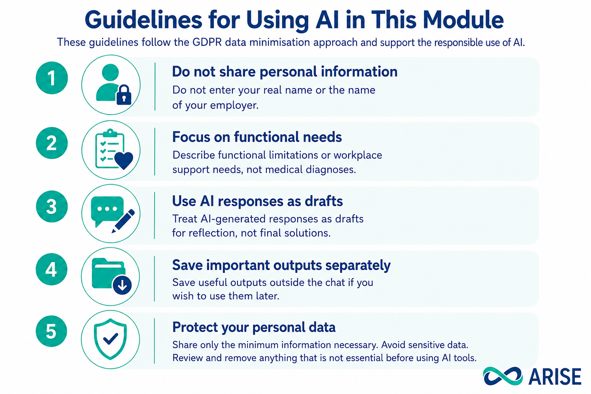2. Understanding Workplace Integration
The first step towards successful workplace integration is understanding that starting a new job involves more than learning new tasks. It also means becoming familiar with a new environment, understanding expectations, building working relationships, and recognising the conditions that help you perform at your best.
Many workplace challenges can be anticipated and prepared for before the first working day. This section encourages learners to think about workplace integration in a structured way and to identify the factors that may influence their own adaptation. To support this process, the module introduces the Three Layers of Workplace Integration model.

2.1 The Three Layers of Workplace Integration
The model helps learners look at workplace integration from three different perspectives:
- The functional layer focuses on work tasks, responsibilities, workplace routines and the practical skills needed to perform the job.
- The social layer focuses on communication, professional relationships, workplace culture and identifying people who may provide information or support.
- The personal layer focuses on individual working preferences, strengths, support needs and the conditions that help the learner work effectively and maintain well-being.
Considering all three layers helps learners prepare for workplace integration in a realistic and personalised way.

Practical activities
In this section, you will:
- Complete the Three Layers of Workplace Integration Worksheet to identify your strengths, possible challenges and workplace support needs.
- Use an AI Prompt to explore your ideas, identify additional considerations and generate practical suggestions.
- Review Marta's Case Study to see how these activities can be completed in a real-life workplace situation.
Together, these activities will help you better understand your strengths, workplace support needs and the factors that can support your successful workplace integration.

Worksheet 1: My Three Layers of Workplace Integration
Think about your future workplace and answer the questions below.

Functional Adaptation
What work tasks would you like to do well?

What do you need to learn?
(For example: workplace tasks, tools or routines.)

What support would help you do your job well?

Social Adaptation
What helps you communicate with other people?

What situations may be difficult for you?

What support from your manager or colleagues would help you?

Personal Adaptation
What helps you feel confident at work?

What routines help you work well?

What is important for your manager and colleagues to know about you?

AI-supported activity
Learners use AI Prompt A to analyse their completed worksheet. AI helps identify possible adaptation risks, personal strengths and practical strategies that may support successful workplace integration. Learners are encouraged to review the AI suggestions critically and decide which recommendations are useful for their own situation.
AI Prompt A: “Act as a career coach who supports people with disabilities in adapting to a new workplace. Here are my notes about my three layers of workplace integration: Functional Adaptation: [paste your notes]. Social Adaptation: [paste your notes]. Personal Adaptation: [paste your notes]. I also have the following disability or health condition(s): [briefly describe anything that may affect your work, such as hearing loss, chronic fatigue, anxiety, ADHD, mobility impairment, etc.]. Please help me:
- Identify 3-5 possible challenges I may face during my workplace integration.
- Identify 3-5 personal strengths or resources that can support me.
- Suggest one practical strategy for each challenge, taking my situation into account.
- Point out anything I may have overlooked when preparing for my first weeks at work.”
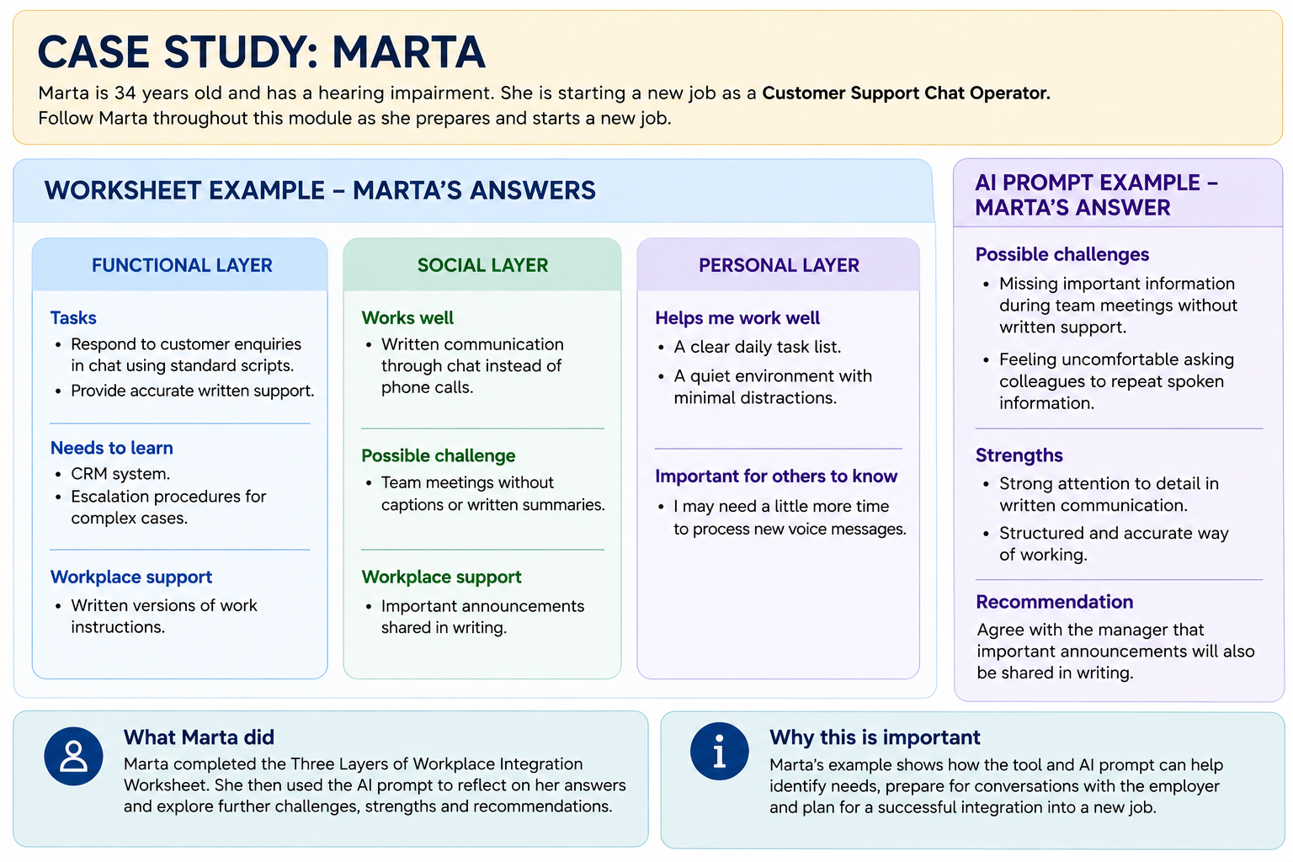

3. Preparing for Workplace Communication
Starting a new job means learning not only new tasks but also new ways of communicating. During the first days or weeks, learners may need to:
- introduce themselves to colleagues and their manager;
- discuss workplace expectations;
- ask questions or request clarification;
- request workplace support when needed;
- explain how they work most effectively.
For many people with disabilities, these conversations can be one of the most challenging parts of workplace integration. Some may be unsure how much information to share, worry about being misunderstood, or find it difficult to explain their needs in a professional way. Research conducted within the ARISE project also showed that learners often feel uncertain about discussing workplace support and would like practical guidance before entering employment.
This section helps learners prepare for these conversations by shifting the focus from disability to workplace success. Instead of concentrating on limitations or medical information, learners learn how to communicate what they can contribute, how they work best, and what practical conditions help them perform successfully.

3.1 Creating a Professional Workplace Profile
The Professional Workplace Profile is a practical communication tool developed to help learners organise the information that is most relevant when starting a new job.
Rather than preparing a description of themselves, learners prepare information that helps an employer understand how to support successful collaboration. The profile is built around three simple questions:
- What can I contribute?
- How do I work best?
- What support helps me do my job successfully?
This structure encourages learners to focus on strengths, practical working preferences and solutions. It also reflects one of the key messages of this module: workplace conversations are most effective when they focus on how work can be organised successfully rather than on personal circumstances.

Practical activities
In this section, you will:
- Complete the Professional Workplace Profile Worksheet to describe what you can do well, how you work best and what workplace support helps you succeed.
- Apply an AI Prompt to organise your ideas, improve clarity and create a short professional introduction while preserving your own voice.
- Review Marta's Case Study to see how these activities can be completed in a real-life workplace situation.
Together, these activities will help you create a clear and practical Professional Workplace Profile that you can use during job interviews, onboarding discussions, meetings with managers and conversations in the first weeks of employment.

Worksheet 2: My Professional Workplace Profile
This worksheet will help you prepare a short professional profile. It can help you introduce yourself and explain how you work best.

1. What I Can Do Well
What are your skills, strengths and experience? What can you contribute to your team?

2. How I Work Best
What helps you do your best work? Think about your communication style, work environment or daily routines.

3. What Support Helps Me Succeed
What support or workplace adjustments help you work successfully?

AI-supported activity
Learners use AI Prompt B to review and improve their profile. AI helps organise the information, improve clarity and suggest more professional wording while preserving the learner's own ideas, preferences and communication style.
Learners are encouraged to review the AI suggestions critically, adapting them where necessary so that the final profile reflects their own voice and individual circumstances.
AI Prompt B
“Act as an experienced career coach specialising in inclusive employment. Based on my notes below, write a short professional introduction (100–150 words) that I could use when meeting my manager or introducing myself in a new workplace. Please make it:
- positive and professional;
- focused on my strengths and what I can contribute;
- clear about how I work best;
- natural and respectful when mentioning any workplace support that helps me work effectively.
Here are my notes:
What I can do: …
How I work best: …
What support helps me succeed: …”
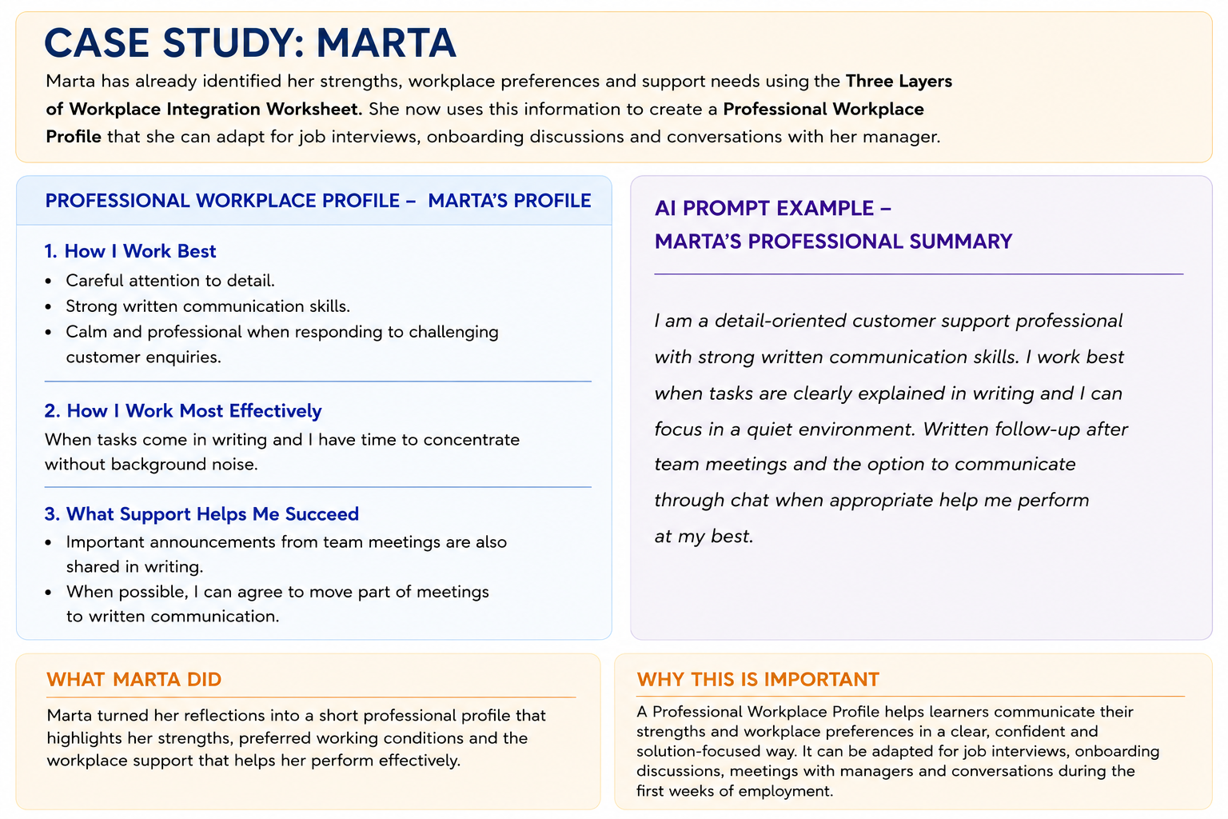

3.2 Preparation for the First Meeting
The first meeting with a manager is an important step in workplace integration. It is an opportunity to understand what will be expected during the first weeks of work, clarify responsibilities, discuss practical arrangements and establish open communication from the beginning.
Many people prepare for this meeting by thinking about what they should say. However, successful communication is not only about giving information - it is also about asking the right questions. Understanding expectations early can help prevent misunderstandings, reduce uncertainty and make workplace adaptation easier.
For many people with disabilities, preparing questions in advance can also reduce anxiety and increase confidence. It allows learners to focus on the information they need rather than trying to remember questions during the conversation.
Before the meeting, it is also helpful to think about four practical questions:
- What personal information to share,
- When is the best time to share it,
- Who should receive it,
- Why is sharing it helpful?
Preparing to Discuss Workplace Support
What to share | In many situations, it is not necessary to disclose a medical diagnosis. Instead, it is often more helpful to explain the functional support needs that enable effective job performance.  Example:  Instead of "I have multiple sclerosis."  Consider saying: "I work most effectively when I receive written task instructions and can use noise-cancelling headphones when needed."
When to share | The best time to discuss workplace support depends on individual circumstances. Some people may need adjustments during recruitment or onboarding, while others may decide to discuss them after starting work.
Who to share with | Different people have different roles.  - HR professionals may help arrange workplace adjustments and ensure organisational procedures are followed.  - Managers often need practical information that supports day-to-day collaboration.
Why to share | The purpose of sharing information should always be practical and solution-focused. The goal is to identify the workplace adjustments or support that will help the learner perform their job successfully.

Practical activity
In this section, you will:
- Complete the My First Meeting Worksheet to identify the questions and topics that are most important for your first meeting with your manager.
- Use an AI Prompt to generate additional questions and improve your list while keeping it relevant to your own situation.
- Review Marta's Case Study to see how these activities can be completed in a real-life workplace situation.
Together, these activities will help you prepare for your first meeting with your manager, reduce uncertainty and communicate more confidently during your first weeks at work.

Worksheet 3: First Meeting with the Manager
Your first meeting with your manager is an opportunity to ask questions, clarify expectations and discuss any workplace support that may help you succeed. Complete this worksheet before your meeting.
1. What would I like to understand?  Tick the topics that are important for you. | ☐ What will be expected from me during my first weeks?  ☐ What are my main responsibilities?  ☐ How will I receive tasks and instructions?  ☐ How is feedback usually given?  ☐ What are the team's communication preferences?  ☐ What are the daily routines and priorities?  ☐ Who should I contact if I need help?  ☐ How can workplace support or reasonable accommodations be discussed?  ☐ Other:.....
2. My questions  Write the questions you would like to ask. | - …….  - …….  - …….
3. Information I Would Like to Share  Think about what information may help your manager support you successfully. | I may want to explain:  ☐ How I work best  ☐ What helps me stay productive  ☐ Any workplace adjustments that support my work  ☐ My preferred communication style  ☐ Other:....
4. My goal for this meeting | After the meeting, I would like to feel that:  ☐ I understand what is expected from me.  ☐ I know who to ask for help.  ☐ I feel comfortable communicating with my manager.  ☐ We have discussed any workplace support that may be helpful.  ☐ Other:.............

AI-supported activity
Use AI Prompt C to generate additional questions and improve your list. AI can suggest questions, organise ideas and help you prepare for a respectful and productive conversation with their manager.
Review the AI suggestions critically, select the questions that are most relevant to your own situation and adapt them where necessary so that the final list reflects your own priorities and communication style.
AI Prompt C: “Act as an experienced career coach specialising in inclusive employment. I am preparing for my first meeting with my manager. Based on my professional profile and the fact that I have [briefly describe your disability or health condition if relevant], suggest 10 clear and practical questions that will help me:
- understand what is expected from me during my first 30 days;
- learn about the team, communication, and ways of working;
- discuss any workplace support that may help me work effectively;
- feel more prepared and confident for my first weeks at work.
Use simple, respectful language.”
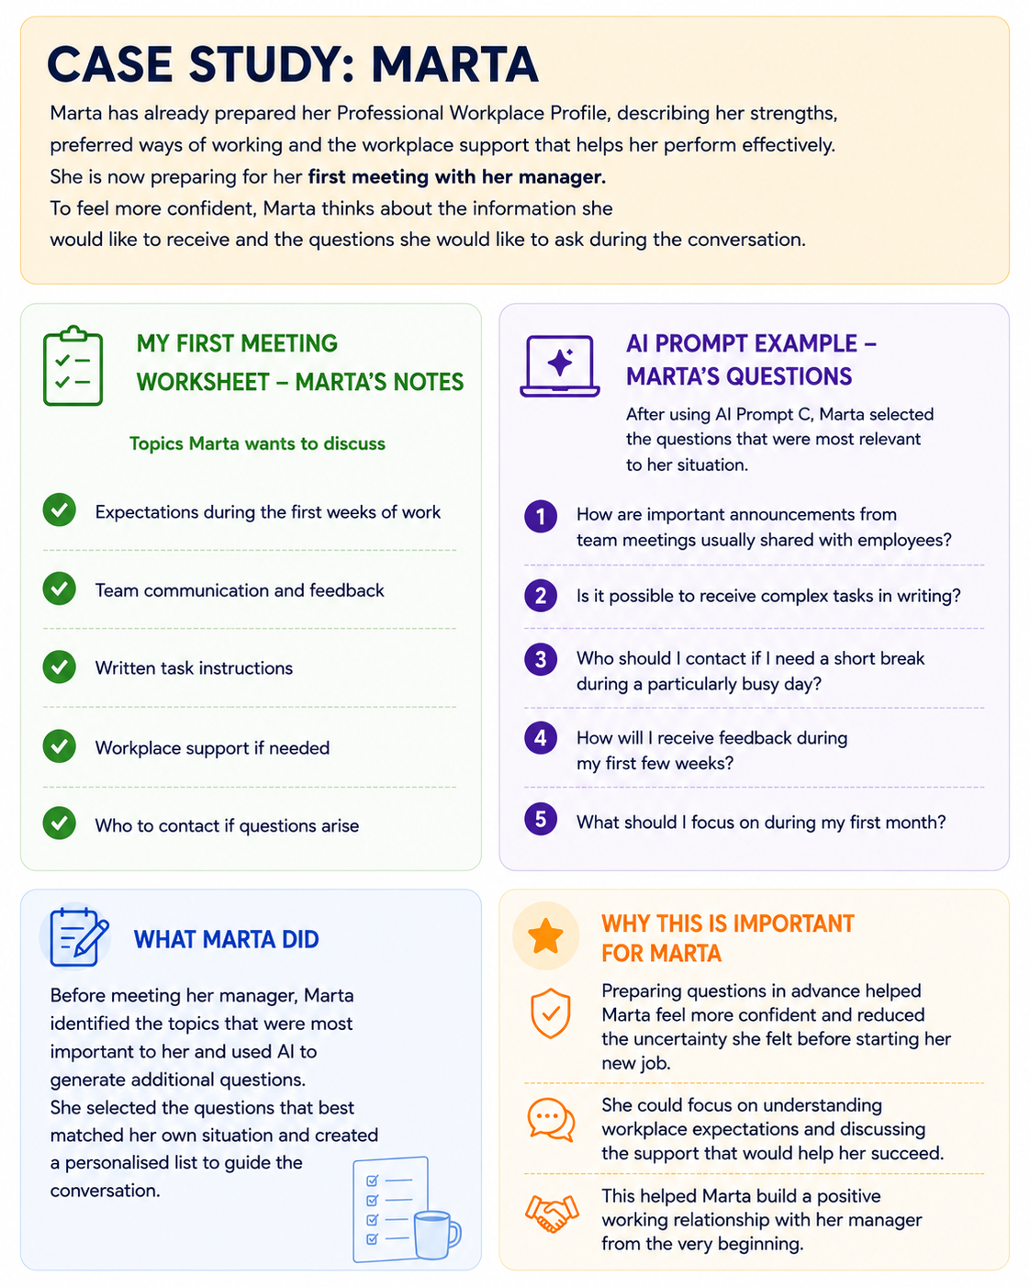

4. Understanding Your Workplace Support Network
After preparing for the first workplace conversation, it is helpful for learners to identify the people who may support them during workplace integration.
Starting a new job involves learning new tasks, adapting to a different environment and building professional relationships. Knowing who can provide information, answer questions or offer support can make this process easier and reduce unnecessary stress.
Every workplace has its own structure, so the people involved in workplace integration may differ from one organisation to another. In smaller organisations, one person may perform several roles, while larger organisations often have separate managers, HR representatives, mentors or support professionals. Learners should understand that they do not need to manage every challenge independently. Identifying appropriate sources of support is an important part of successful workplace integration.
Typical members of a workplace support network may include:
- Manager or Supervisor – explains work responsibilities, priorities and expectations, provides feedback and supports day-to-day work.
- HR Representative – may assist with employment procedures, onboarding processes, workplace policies or reasonable workplace adjustments, depending on the organisation.
- Colleagues – help new employees understand everyday workplace routines, informal practices and team communication.
- Mentor or Buddy – in some organisations, an experienced colleague supports new employees during their first weeks and helps them become familiar with the workplace.
- Career Counsellor, Job Coach or Support Professional – may continue supporting learners after employment begins by helping prepare workplace conversations, discuss challenges and identify possible solutions.
Understanding these different roles helps learners communicate more confidently and identify appropriate sources of support when questions or difficulties arise. Asking questions, requesting clarification and seeking guidance are normal parts of workplace integration and demonstrate a willingness to learn and perform well.

Practical Activities
In this section, you will:
- Complete the My Workplace Support Network Worksheet to identify the people who may support you during your first weeks at work.
- Use an AI Prompt to explore whether there are additional sources of support you may not have considered.
- Review Marta's Case Study to see how these activities can be completed in a real-life workplace situation.
Together, these activities will help you recognise who can support you in different workplace situations and feel more confident about asking for help when you need it.

Worksheet 4. My Workplace Support Network
Who can support me during my first weeks at work? (If you do not yet know who performs these roles in your workplace, leave the space blank and complete it after you start your new job)
Person/Role | How can this person help me? | When might I contact them?
Manager/Supervisor
HR Representative
Colleagues
Mentor/Buddy
Career Counsellor/
Support person
Other

AI-Supported Activity
Sometimes there are more people who can support you than you might expect. AI can help you think about who may be able to assist you in different workplace situations. Copy your completed worksheet into your preferred AI assistant and use the prompt below.
AI Prompt D: Act as an experienced career coach specialising in inclusive employment. “I am preparing to start a new job. Based on my Workplace Support Network below:
- identify any important sources of support I may have overlooked;
- explain how each person could help me;
- suggest when it would be appropriate to contact them.
Keep your suggestions practical and suitable for my workplace.”
Review the AI suggestions carefully. Keep only the people and ideas that are relevant to your own workplace. Every organisation is different, so your support network may look different from someone else's.
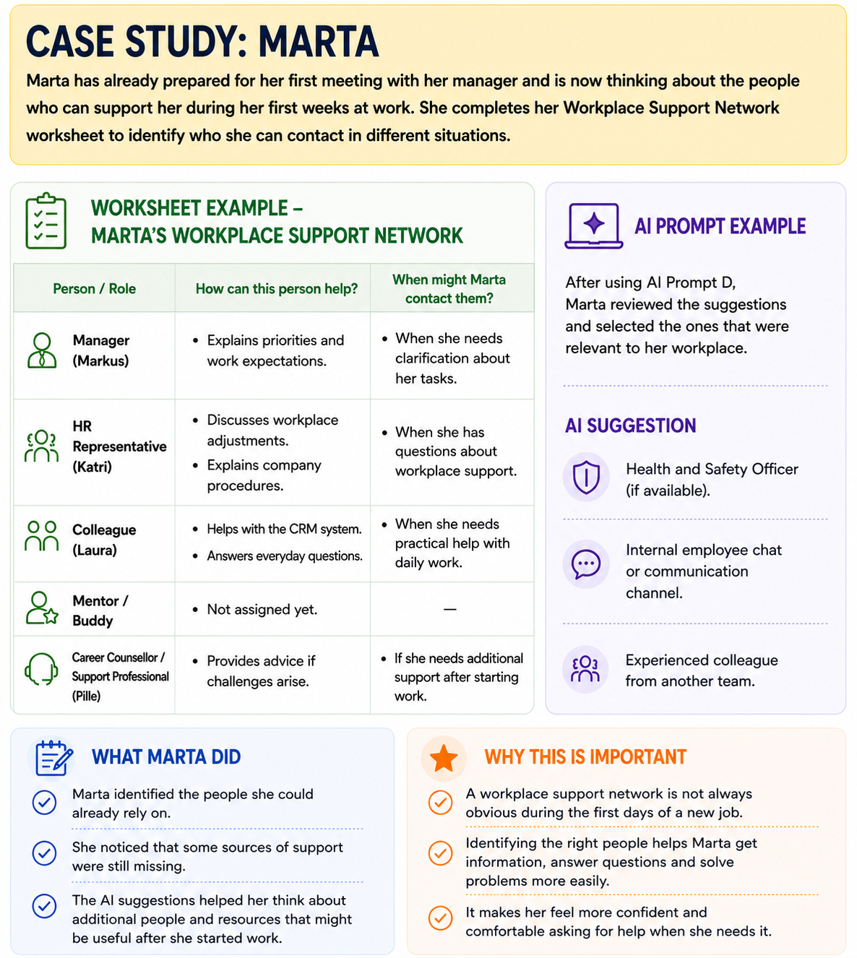
Even with good preparation and appropriate support, challenges may still arise during workplace integration. The next section explores common workplace situations and practical strategies for responding to them.

5. Recognising and Addressing Early Workplace Integration Challenges
Workplace integration is a process that is different for every person. Some may have many years of work experience, while others may be returning to work after a career break, changing careers, entering employment for the first time or looking for work after previous unsuccessful experiences.
Workplace difficulties are often related to communication, unclear expectations, insufficient support, inaccessible work environments or the need for reasonable workplace adjustments rather than a person's abilities.
Recognising challenges early is an important part of successful workplace integration. Many difficulties can be addressed through open communication, appropriate support and timely problem-solving before they become more significant barriers.
The first step in solving workplace challenges is recognising them early. Paying attention to small warning signs makes it easier to address difficulties before they become bigger problems. The following examples can help learners recognise situations where additional support or action may be needed.
Early signs that workplace integration may not be going well
- Work tasks or expectations are unclear or change frequently.
- There is little or no feedback from the manager, making it difficult to understand what good performance looks like.
- Colleagues avoid communication or do not include the employee in discussions or team activities.
- Agreed workplace adjustments have not been provided or are not working in practice.
- Health or well-being is getting worse because of the work environment, schedule or workload.
- Persistent stress, anxiety or feelings of being overwhelmed begin to affect everyday work.
- Disrespectful comments, disability-related jokes, unfair treatment or other forms of discrimination occur.

Reflection Activity

How is your workplace integration going? (Tick the statements that describe your current situation.)
☐ My work tasks or expectations are unclear.
☐ I receive little feedback or find it difficult to understand.
☐ Communication with colleagues is difficult.
☐ The workplace support or adjustments I need are missing or not working well.
☐ My health or well-being has become worse since starting work.
☐ My stress or anxiety is increasing.
☐ I have experienced unfair treatment or discrimination.
☐ Other:................

What do your answers suggest?
Score | Explanation
✅ 0–1 statements | Your workplace integration seems to be progressing well. Continue observing how things develop and ask questions whenever you need clarification.
⚠️ 2–3 statements | Some aspects of your workplace integration may need attention. Consider talking with your manager or HR representative to discuss your concerns and possible solutions.
🟠 4 or more statements | Several areas may require additional support. Consider contacting your manager, HR representative, career counsellor or another trusted support person as soon as possible.
🔴 If you experienced unfair treatment or discrimination
Do not ignore the situation. Talk to someone you trust, such as your manager, HR representative, career counsellor or another support professional. Seeking support early often makes it easier to resolve workplace difficulties.

5.1 Understanding Different Types of Workplace Challenges
Not every workplace challenge has the same cause. Identifying the type of challenge makes it easier to choose an appropriate response.
Type of challenge | Typical signs | Possible first step
Role and task expectations | Work tasks are different from what was discussed during recruitment. Responsibilities or priorities are unclear. Success is difficult to measure. | Discuss responsibilities, priorities and expectations with the manager. Clarify what successful performance looks like during the first months.
Communication | Instructions are unclear or inconsistent. Communication channels are confusing. Feedback is limited or mainly negative. | Prepare questions before the conversation. Ask for clarification and agree on the most effective way to communicate.
Workplace adjustments | Agreed adjustments have not been provided, no longer meet current needs or do not work in practice. Health or productivity is affected. | Describe the specific difficulty and discuss possible workplace adjustments or alternative solutions.
Social integration | Feeling isolated, excluded or unsure whom to trust. Difficulty understanding informal workplace rules or team dynamics. | Identify supportive colleagues or mentors and gradually build positive working relationships.
Health and well-being | Fatigue, stress or health symptoms are increasing. Recovery time is insufficient. Work is becoming difficult to sustain. | Review workload and daily routines. Consider discussing possible changes with the manager or another support person.
Rights and fair treatment | Disrespectful behaviour, discrimination, pressure or unfair treatment related to disability. | Record facts and seek advice through appropriate workplace or external support services.

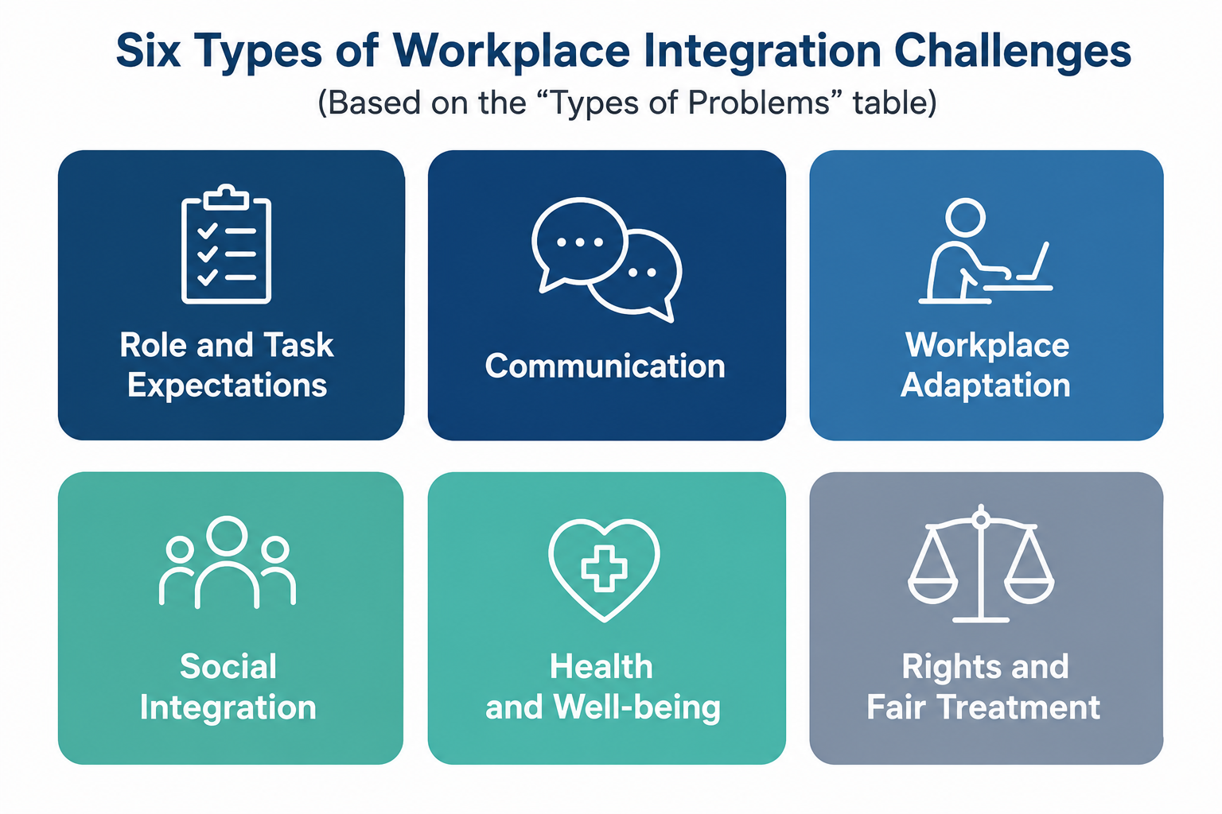

5.2 Action Ladder: Responding to Workplace Integration Challenges
Use the Action Ladder to organise the situation and decide on the next step.
Step | What to do
1. Describe the problem | Summarise the main challenge in one sentence.  Example: "The agreed workplace adjustment has not been provided."
2. Identify the type of challenge | ☐ Role and task expectations  ☐ Communication  ☐ Workplace adjustments  ☐ Social integration  ☐ Health and well-being  ☐ Rights and fair treatment
3. Decide on the next action | ☐ Adjust the personal work plan or daily routine.  ☐ Discuss the situation with the manager or HR.  ☐ Request or review workplace adjustments.  ☐ Contact a mentor, job coach or career counsellor.  ☐ Use formal support mechanisms if rights may have been violated.
4. Prepare the facts | • What happened?  • When did it happen?  • Who was involved?  • How does it affect work or health?  • What support or change is needed?
5. Choose where to seek support | Within the organisation: Manager, HR representative, mentor or buddy, trusted person.  Outside the organisation: Employment Service, disability support organisation (NGO), Labour Inspectorate, Equality Body/Ombudsperson, Trade Union (if applicable).

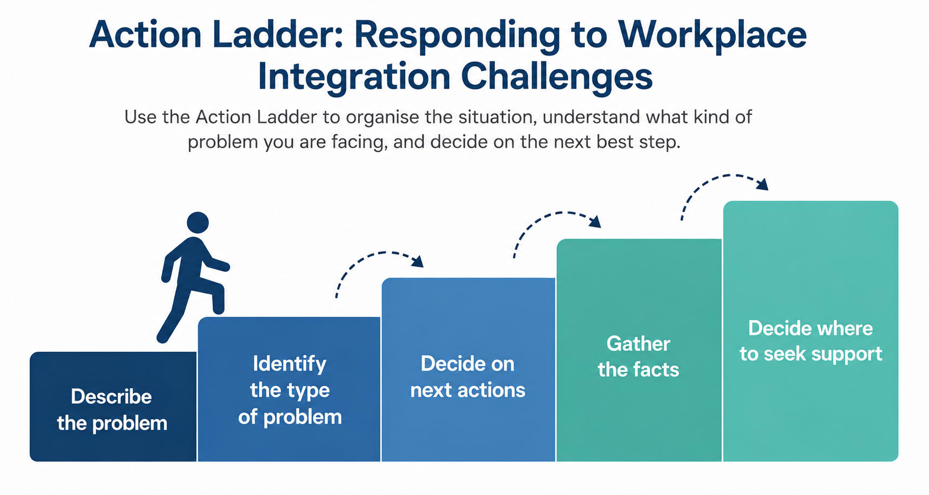

Remember
Experiencing challenges during workplace integration does not mean that you are failing. Many difficulties can be solved by discussing them early and finding the right support.

6. Planning the First 30 Days
Workplace integration does not happen in a single day. It is a gradual process that develops over time as learners become familiar with their new role, colleagues, responsibilities and working environment.
Having a realistic plan for the first month can make this process more manageable. Instead of trying to remember everything or solve every challenge at once, learners identify a small number of practical priorities and organise them into achievable steps. This helps reduce uncertainty, build confidence and create a stronger sense of control during the first weeks of employment.
This section brings together the ideas, worksheets and practical activities completed in the previous sections. Learners use these to create a realistic 30-Day Workplace Integration Plan that can guide their first weeks in a new job.

6.1 Creating a 30-Day Workplace Integration Plan
A successful start at work does not happen by chance. Planning your first month can help you feel more confident, stay organised and adapt to your new workplace step by step.
The 30-Day Workplace Integration Plan is a flexible planning tool. It is not a fixed schedule and can be updated as you gain experience during your first weeks at work.
Your plan focuses on four simple questions:
- What do I want to learn during my first month?
- Who do I need to meet or talk to?
- What workplace support will help me succeed?
- What habits will help me stay healthy and manage stress?
Together, these questions bring together everything you have learned throughout this module and help you prepare for a successful workplace integration.
Although self-care is included as one element of the plan, it is not explored in detail within this module. Learners will develop this topic further in a dedicated ARISE module focusing on self-management.

Practical activities
In this section, you will:
- Complete the 30-Day Workplace Integration Plan to organise your priorities for your first month at work.
- Use an AI Prompt to turn your ideas into a concrete and practical action plan.
- Review Marta's Case Study to see how these activities can be completed in a real-life workplace situation.
Together, these activities will help you start your new job with greater confidence, clear priorities and a plan for your first month. The emphasis is on creating a plan that is realistic, flexible and personally meaningful rather than trying to anticipate every possible situation.

Worksheet 5: My 30-Day Workplace Integration Plan
This worksheet will help you plan your first month at work.

1. My Learning Goals
What do you want to learn during your first month?

2. Important Conversations
Who would you like to meet or talk to during your first month?

3. My Workplace Support
What support or workplace adjustments will help you do your job well?

4. My Healthy Work Habits
What habits or routines will help you work without unnecessary stress?

AI-supported activity
Use AI Prompt E to organise your ideas into a realistic 30-Day Workplace Integration Plan.
AI can help you:
- prioritise the most important tasks;
- organise meetings and learning activities;
- plan a realistic pace of adaptation;
- include workplace support and healthy work habits in your plan.
Review the AI suggestions carefully. Keep the ideas that fit your own workplace and personal circumstances, and adapt or remove those that do not.

AI Prompt E
Act as an experienced career coach specialising in workplace integration.
Here is my draft 30-Day Workplace Integration Plan:
My learning goals: …
Important conversations: …
My workplace support: …
My healthy work habits: …
Please help me create a realistic plan for my first 30 days at work.
- Suggest which activities I should prioritise first.
- Recommend a realistic order for meetings and learning activities.
- Suggest ways to avoid unnecessary overload while staying productive.
- Identify any important actions or conversations I may have overlooked.
Keep the plan practical, realistic and easy to follow.

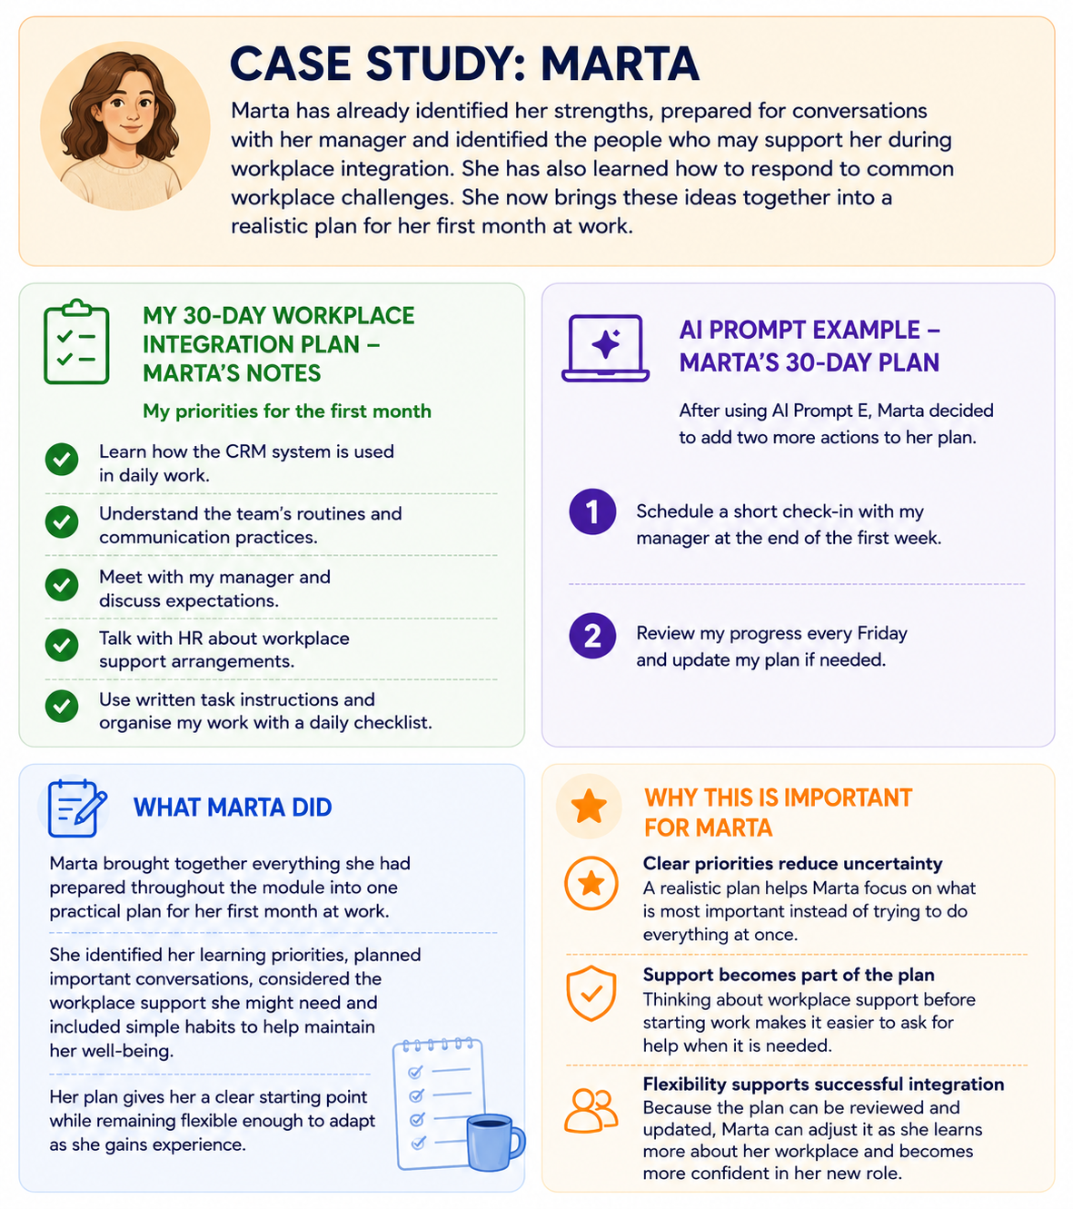

7. Summary

Moving Forward with Confidence
Starting a new job is a learning process for everyone. Learners do not need to know everything on their first day, nor do they need to solve every challenge on their own.
Throughout this module, learners have explored practical tools to prepare for workplace integration. They have identified their strengths and workplace support needs, practised introducing themselves professionally, prepared for conversations with a manager, mapped their workplace support network, and learned how to recognise and respond to common workplace challenges.
Successful workplace integration develops over time. Asking questions, requesting support when needed, and communicating openly are all signs of professionalism, self-awareness and a willingness to learn.
The worksheets and AI prompts included in this module can be revisited whenever learners start a new job, take on new responsibilities or prepare for important workplace conversations. These resources are designed to support continuous learning and workplace adaptation.
Every positive step towards understanding personal needs, communicating effectively and using available support contributes to greater confidence, independence and long-term success at work.

8. References and Resources

Disability, Inclusion and Workplace Integration
European Union of Supported Employment (EUSE). (2010). European Toolkit for Supported Employment. https://www.euse.org/
Lindsay, S., Cagliostro, E., Leck, J., Shen, W., & Stinson, J. (2018). Disability disclosure and workplace accommodations among youth with disabilities. Disability and Rehabilitation, 40(25), 2971–2980.
Oliver, M. (1983). Social work with disabled people. Macmillan.
Santuzzi, A. M., Waltz, P. R., Finkelstein, L. M., & Rupp, D. E. (2014). Invisible disabilities: Disclosure decisions and workplace implications. Industrial and Organizational Psychology, 7(2), 204–219.
Schur, L., Kruse, D., & Blanck, P. (2013). People with disabilities: Sidelined or mainstreamed? Cambridge University Press.
Wehmeyer, M. L. (2005). Self-determination and individuals with disabilities: Examining meanings and misinterpretations. Research and Practice for Persons with Severe Disabilities, 30(3), 113–120.
World Health Organization. (2001). International Classification of Functioning, Disability and Health (ICF). World Health Organization.

Employment, Onboarding and Workplace Support
Bauer, T. N. (2010). Onboarding new employees: Maximizing success. SHRM Foundation Effective Practice Guidelines Series.
Cornell University, Yang-Tan Institute on Employment and Disability. (n.d.). Yang-Tan Institute on Employment and Disability. Cornell ILR School. https://www.ilr.cornell.edu/yti
EARN – Employer Assistance and Resource Network on Disability Inclusion. (n.d.). Disability@Work Resources. https://askearn.org/page/disability-at-work-resources
EARN – Employer Assistance and Resource Network on Disability Inclusion. (n.d.). Job Seeker Resources. https://askearn.org/page/job-seeker-resources
Job Accommodation Network (JAN). (n.d.). Job Accommodation Network. https://askjan.org/
Job Accommodation Network (JAN). (n.d.). Workplace Accommodation Toolkit. https://askjan.org/publications/
PARE – Estonian Association for People Management. (n.d.). Sisseelamise toetamine. https://pare.ee/
Society for Human Resource Management. (n.d.). Understanding Onboarding: The 4 Cs. https://www.shrm.org/
Accessibility, AI and Data Protection
Eesti Puuetega Inimeste Koda (EPIKoda). (n.d.). Infomaterjalid ja juhendid. https://epikoda.ee/
Information Commissioner's Office (ICO). (n.d.). Generative AI and data protection. https://ico.org.uk/
UNESCO. (2023). Guidance for generative AI in education and research. UNESCO.
World Wide Web Consortium (W3C). (2023). Web Content Accessibility Guidelines (WCAG) 2.2. https://www.w3.org/TR/WCAG22/
World Wide Web Consortium (W3C). (n.d.). Web Accessibility Initiative (WAI): WCAG Overview. https://www.w3.org/WAI/standards-guidelines/wcag/

Legal Framework
Council of the European Union. (2000). Council Directive 2000/78/EC of 27 November 2000 establishing a general framework for equal treatment in employment and occupation. https://eur-lex.europa.eu/
European Parliament and Council of the European Union. (2016). Regulation (EU) 2016/679 of the European Parliament and of the Council of 27 April 2016 (General Data Protection Regulation). https://eur-lex.europa.eu/eli/reg/2016/679/oj
Republic of Estonia. (n.d.). Võrdse kohtlemise seadus. Riigi Teataja. https://www.riigiteataja.ee/
United Nations. (2006). Convention on the Rights of Persons with Disabilities. https://www.un.org/disabilities/

Additional Resources
Job Accommodation Network (JAN). (n.d.). Accommodation Process Webinar. https://www.youtube.com/watch?v=eL7vDhAIGmM
Miserandino, C. (2003). The Spoon Theory. https://butyoudontlooksick.com/
Peaasi.ee. (n.d.). Mental health resources and self-help materials. https://peaasi.ee/

